AGENDA 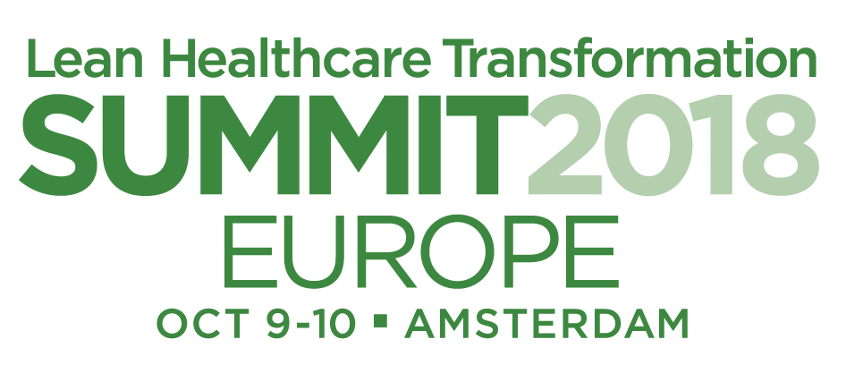
Monday, October 8 | 09:00 – 16:30 | (Optional) Pre-Summit Workshops
 | 17:00 – 18:30 | Speaker reception
Tuesday, October 9 | 08:00 – 09:00 | Registration
 | 09:00 – 09:15 | Welcome and Opening Remarks
 | 09:15 – 10:15 | Opening Keynote: John Toussaint, Catalysis
 | 10:15 – 10:45 | Break
 | 10:45 – 11:30 | Keynote: Rob Dillmann, CEO Isala
 | 11:30 – 12:45 | Learning Sessions Day 1 (+ CEO Forum)
 | 12:45 – 13:45 | Lunch
 | 13:45 – 15:00 | Learning Sessions (same as above)
 | 15:00 – 15:30 | Break
 | 15:30 – 16:30 | Physician Panel: Moderated by Patrick DeCoster
 | 16:30 – 16:45 | Wrap Up
 | 16:45 – 17:30 | (optional) Walking Tour or Open Discussion
 | 17:30 – 19:00 | Attendee Reception
Wednesday, October 10 | 07:00 – 08:00 | Registration
 | 08:00 – 08:15 | Welcome Day 2
 | 08:15 – 09:15 | Keynote: Mr. Yoshino
 | 09:15 – 09:30 | Short Break
 | 09:30 – 10:15 | Keynote: Elaine Mead
 | 10:15 – 10:45 | Break
 | 10:45 – 12:00 | Learning Sessions Day 2 (+ CEO Forum)
 | 12:00 – 13:00 | Lunch
 | 13:00 – 14:15 | Learning Sessions (same as above)
 | 15:00 – 15:30 | Break
 | 15:30 – 16:15 | Closing Keynote: Ken Snyder
 | 16:15 – 16:30 | Wrap Up
Thursday, October 11 | 08:00 | Meet (at Doubletree lobby?) for:
 |  | - (optional) Post-Summit Gemba visits
 |  | - Gemba for Discover Excellence Workshop
 |  | - CEO Forum gemba visit
 | 15:00 | Return to Doubletree lobby

