4th Radboud Aesthetic & Reconstructive Rounds -
Advances in head & neck reconstruction
September 28th, 2017
Radboud University Medical Center, Nijmegen

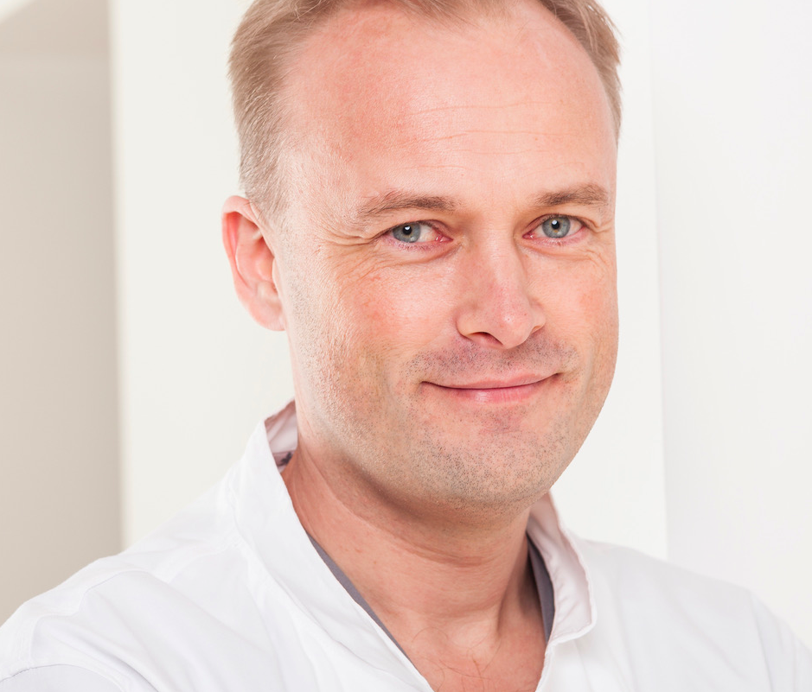

Prof. Patrik Lassus

Helsinki, Finland

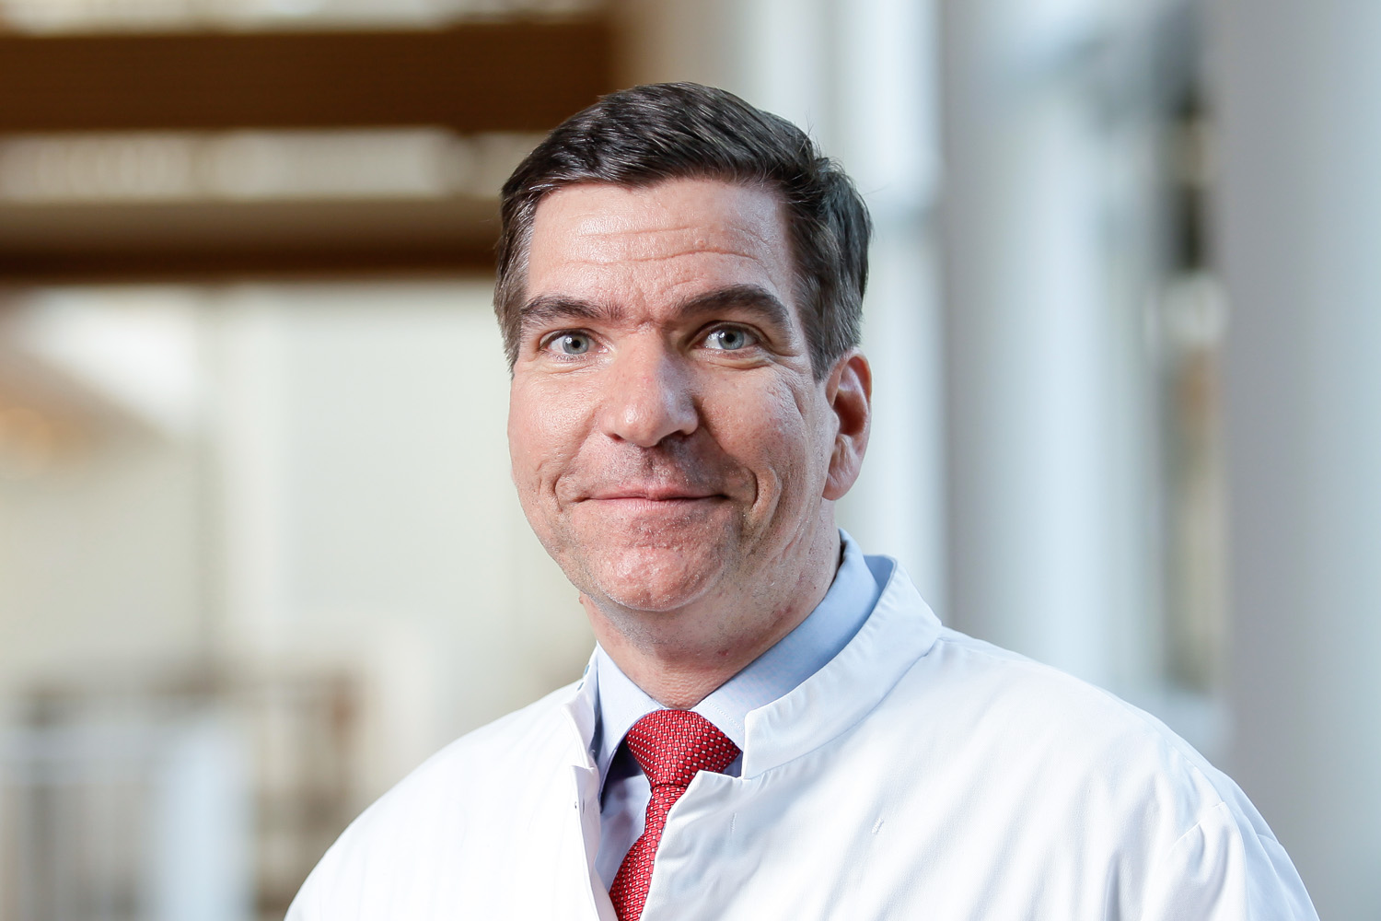

Dear esteemed colleagues,

I am proud to invite you to join the 4th Radboud Aesthetic & Reconstructive Rounds on September 28th, 2017 in Nijmegen with the topic ‘Advances in head & neck reconstruction’.

The concept of the Radboud Aesthetic & Reconstructive Rounds is to get hands-on training and lectures on selected topics in plastic surgery from national and international experts. At the same time, an open and frank discussion among the attending colleagues about our own problem cases and failures is strongly encouraged. The content is suitable for residents, but also for experienced plastic surgeons who want to expand and refine their surgical armamentarium.

It gives me great pleasure to welcome Prof Patrik Lassus from Helsinki, Finland, to our department.
He is head of the department of Plastic Surgery of the Helsinki University Hospital. Since 2011 he has been the leader of the Finnish facial allotransplantation team and performed the first Finnish facial transplantation in 2016.

Recent scientific activity includes studies on different techniques in head & neck reconstructive surgery and in facial allotransplantation. Numerous publications and lectures illustrate his unique expertise in the area of head and neck reconstruction.

I look forward to welcoming you in Nijmegen to join exciting state-of-the-art lectures!

Kind regards,

Dietmar Ulrich

Program

18:00 Welcome: Prof. Dietmar Ulrich

18.05 Prof. Patrik Lassus: ‘The Helsinki face transplantation’

18.45 Discussion

19:00 Prof. Patrik Lassus: ‘Free flaps from the ear’

19:30 Discussion

19:45 Presentation of problem cases by the participants

20:00

Closure and borrel

Venue
The lectures will take place at the restaurant of the Radboud university medical center in Nijmegen – Oranjezaal (route 607)

Accreditation
Credits will be requested by the NVPC (Dutch society for plastic surgeons).

Submission of cases
Please submit a 3 minutes PowerPoint presentation with a problem case of head & neck reconstruction you want to discuss with the attendees of the 4th Radboud Aesthetic and Reconstructive Rounds via email: dietmar.ulrich@radboudumc.nl

Registration
You can register yourself for these lectures on www.radboudrounds.nl

Fee
The lectures are free of charge.

Contact
Radboud university medical center
Department of Plastic and Reconstructive Surgery
T +31 (0)24 36 17639
E doortje.moors@radboudumc.nl

