Program QCMR course 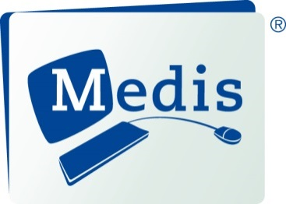
Leiden, October 9 & 10, 2018
DAY 1
09.00 am Welcome / Introduction - Johan H.C. Reiber, Ph.D.
09.15 am Basics of CMR – Overview of CMR as a single, comprehensive non-invasive imaging solution – Kayleigh Dukker, MSc
09.45 am Cardiovascular anatomy, slice planning and indications for CMR -
David Hautemann, MSc
10.00 am Hands-on Medis Suite workflow and viewing - Faculty
10.30 am Coffee / tea break
10.45 am Ventricular volumetry – LV and RV function - Kayleigh Dukker, MSc
11.15 am Hands-on LV/RV function - Faculty
12.15 pm Lunch
01.15 pm PC flow – valvular heart disease and flow assessment -
Kayleigh Dukker, MSc
01.45 pm Hands-on PC Flow - Faculty
02.45 pm MR as a tool to guide ablation procedures - Rob van der Geest, PhD
03.15 pm Coffee / tea break
03.30 pm Myocardial perfusion - Rob van der Geest, PhD
04.15 pm Hands-on myocardial perfusion - Faculty
05.15 pm Adjourn
06.00 pm Social evening (including dinner) in Leiden

DAY 2
09.00 am Recap and questions day 1 - Faculty
09.15 am Tissue characterization (TC 1.0): quantification using T2w, and LGE methods -David Hautemann, MSc
09.45 am Hands-on on Tissue characterization (TC 1.0) - Faculty
10.30 am Coffee / tea break
10.45 am Tissue characterization QMap (TC 2.0): Quantitative CMR methods: T1, T2 mapping and ECV - Kayleigh Dukker, MSc
11.15 am Hands-on on Tissue characterization TC 2.0 - Faculty
12.00 pm Lunch

01.00 pm QStrain - David Hautemann, MSc

01.30 pm Hands-on QStrain - Faculty

02.30 pm Coffee / tea break
02.45 pm Ischemic or non-Ischemic cardiomyopathy – Tim Leiner, MD, PhD
03.30pm Written examination
04.00 pm Hands-on cases - Faculty
04.30 pm Final discussion / hand-out of certificates - Johan H.C. Reiber, Ph.D.
04.45 pm End of Course / Adjourn

