17TH EUROPEAN MEETING ON HIV & HEPATITIS - PROGRAM
 | DAY 1 - WEDNESDAY, 22 MAY
 | 9.00 | Opening of the workshop  Tribute to Andrea De Luca and Ricardo Camacho
 | 9.15 | 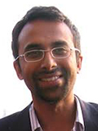Andrea De Luca Lecture:  The top 10 important observations of the last year affecting clinical management  Ravindra Gupta, MD, PhD  University College London, United Kingdom
 | 9.45 | 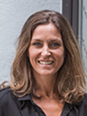Resistance to integrase inhibitors  Anne-Genevieve Marcelin, PharmD, PhD  UPMC, France
 | 10.15 | COFFEE BREAK
Session 1: The role of the reservoir on clinical decision making
Chair: t.b.c
 | 10.45 | 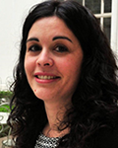How to measure the reservoir  María José Buzón, PhD  Vall d'Hebron Research Institute, Spain
 | 11.15 | 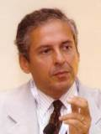How does the reservoir influence the clinician's decisions  Carlo Federico Perno, MD, PhD  University of Milan, Italy
 | 11.45 | Discussion
 | 12.00 | SPECIAL SESSION
 | 13.00 | LUNCH
Session 2: Role of STI management in HIV prevention
Chairs: t.b.c.
 | 14.00 | New approaches to STI management  Gary Whitlock, MD  Dean Street Clinic, Chelsea & Westminster Hospital  United Kingdom
 | 14.20 | Interplay between PrEP and STI  Cécile Bébéar, MD, PhD  University of Bordeaux, France
 | 15.00 | Abstract - driven presentations
 | 15.30 | Panel Discussion
 | 15.50 | COFFEE BREAK
Session 3: Clinical management of HIV
Chair: t.b.c.
 | 16.20 | Abstract-driven presentations
 | 16.20 | Guided poster tour 1
 | 17.20 | Welcome Reception & Poster Viewing
 | DAY 2 - THURSDAY, 23 MAY
Session 4: What's in the pipeline? Presentations from scientists from the industry
Chair: t.b.c.
 | 8.30 | Harmony P. Garges, MD, MPH  Vice President and Head, Global Medical Affairs, ViiV Healthcare, USA
 | 8.45 | Luisa Stamm, MD, PhD  Executive Director, HIV and Emerging Viral Infections, Gilead Sciences, USA
 | 9.00 | Kathleen Squires, MD  Global Director Scientific Affairs-ID/HIV, Merck, USA
 | 9.15 | 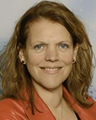Hanneke Schuitemaker, PhD  Vice President, Head Viral Vaccine Discovery and Translational Medicine, Janssen, The Netherlands
 | 9:30 | Q&A, discussion
 | 10.00 | Guided poster tour 2
 | 10.30 | COFFEE BREAK & Poster Viewing
 | 11.00 | SPECIAL SESSION
 | 12.00 | LUNCH
Session 5: Management of viral hepatitis I
Chair: t.b.c.
 | 13.00 | 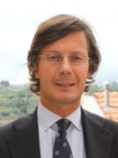Novel compounds for HBV therapy  Pietro Lampertico, MD, PhD  Fondazione Policlinico - University of Milan, Italy
 | 13.30 | 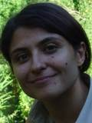Novel markers on HBV / HDV co-infection  Valentina Svicher, PhD  University of Rome Tor Vergata, Italy
 | 14.00 | Abstract-driven presentations
 | 14.45 | Discussion
 | 15.00 | COFFEE BREAK
Session 6: Management of viral hepatitis II
Chair: t.b.c.
 | 15.30 | 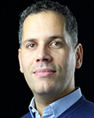Clinical relevance of HCV rare subtypes  Slim Fourati, MD, PhD  University of Paris Est, France
 | 16.00 | Abstract-driven presentations
 | 16.45 | End of Program day 2
 | DAY 3 - FRIDAY, 24 MAY
Session 7: Clinical management challenges
Chair: t.b.c.
 | 8.30 | 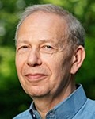The new patient - with what & when  Peter Reiss, MD, PhD  UMC Amsterdam, The Netherlands
 | 9.00 | The aging patient  Eugenia Negredo, PhD  Hospital Universitari Germans Trias i Pujol, Badalona, Spain
 | 9.30 | The pregnant woman - update  Laurent Mandelbrot, MD  Hôpitaux Universitaires Paris Nord, Paris, France
 | 10.00 | Abstract - driven presentations
 | 10.30 | COFFEE BREAK and Guided poster tour 3
Session 8: Progress in cure / elimination approaches
Chair: t.b.c.
 | 11.30 | 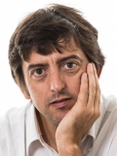Update on HIV cure research  Linos Vandekerckhove, MD, PhD  University of Gent, Belgium
 | 12.00 | Hepatitis C elimination research  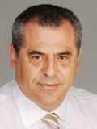  Angelos Hatzakis, MD, PhD  University of Athens, Greece
 | 12.30 | 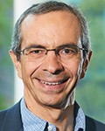Perspectives in HBV cure research  Fabien Zoulim, MD  INSERM, France
 | 13.00 | Discussion
 | 13.15 | Ricardo Camacho Award ceremony
 | 13.30 | Closure of the meeting

