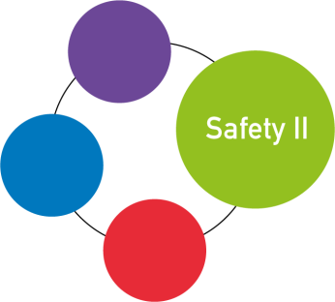
Program FRAM training

Date: March 30th & 31st 2020
Location: to be announced

Time | Program March 30th
08.30 – 09.00 hr. | Welcome
09.00 – 09.30 hr. | Introduction pilot & training  Brief introduction to the pilot
09.30 – 10.45 hr. | Changing the approach  Insight in the differences in approach between the traditional view of safety called Safety I an the view on safety based on resilience engineering called Safety II
10.45 – 11.00 hr. | Break
11.00 – 12.30 hr. | The ETTO principle  The ETTO principle refers to the fact that people (and organisations) as part of their activities frequently have to make a trade-off between the resources) they spend on preparing to do something and the resources (primarily time and effort) they spend on doing it.
12.30 – 13.15 hr. | Lunch
13.15 – 14.30 hr. | Work-as-imagined versus Work-as-done  We talk about the differences between WAI and WAD. How the blunt end believes work happens or should happen and what the people have to do to get the job done in the actual situation
14.30 – 14.45 hr. | Break
14.45 – 15.30 hr. | The method FRAM  Introduction to the Functional Resonance Analysis Method or FRAM. It provides a way to describe outcomes using the idea of resonance arising from the variability of everyday performance.
15.30 – 16.15 hr. | Experiences from a Dutch FRAM project  Anne te Lindert en Rozemarijn van Erp, advisors quality & safety at Medisch Spectrum Twente participated in the pilot FRAM, putting safety-II into practice. They will share their experiences with Safety-II and FRAM and their efforts to spread the principles of Safety-II in their hospital.
16.15 – 16.30 hr. | Wrap up for the day

Time | Program March 31st
08.30 – 09.00 hr. | Welcome
09.00 – 10.00 hr. | FRAM and the pilot  Lessons learned & tips from Jeanette Hounsgaard based on the implementation of FRAM in the hospitals of Southern Denmark. Discuss the next steps for the pilot.
10.00 – 11.00 hr. | Working with the FMV Visualizer  Tips & tricks how to get the most out of working with the FRAM Model Visualizer
11.00 – 11.15 hr. | Break
11.15 – 12.30 hr. | FRAM, let’s put it into practice  We put the theory into practice and build our first FRAM
12.30 – 13.15 hr. | Lunch
13.15 – 14.30 hr. | FRAM, let’s put it into practice  We put the theory into practice and build our first FRAM
14.30 – 14.45 hr. | Break
14.45 – 15.30 hr. | Insights after building a FRAM  What do you see in the FRAM model and how do you make the variability visible
15.30 – 16.15 hr. | Time for remaining questions  Time to get remaining questions answered, problems addressed and solved
16.15 – 16.30 hr. | Wrap up

