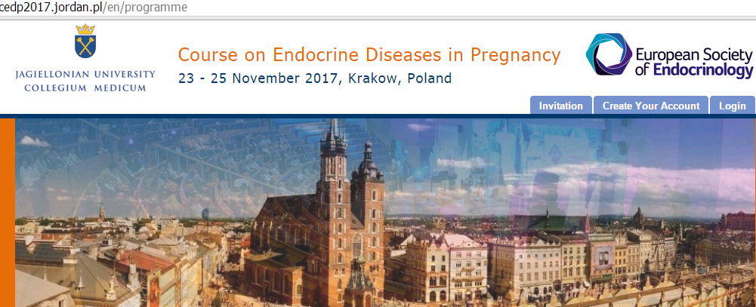

Thursday 23rd November
8.30 - 8.45 |  | Opening

SESSION 1
Chairmen: Alicja Hubalewska-Dydejczyk, Marek Ruchała​
8.45 - 9.15 |  | Endocrine disruptors and pregnancy  Josef Koehrle  (Charité Universitätsmedizin Berlin, Germany)
9.15 - 9.45 |  | Placenta as the endocrine organ  Małgorzata Karbownik-Lewińska  (Polish Mother’s Memorial Hospital Research Institute, Łódź, Poland)
9.45 - 10.15 |  | Prenatal screening for endocrine disorders  Krystian Jażdżewski  (Medical University of Warsaw, University of Warsaw, Poland)
10.15 - 10.45 |  | Perspectives in gestational diabetes mellitus – is there any alternative to diet and insulin?  Maciej Małecki​  (Jagiellonian University Medical College, Krakow, Poland)
10.45 - 11.00 |  | Coffee break

SESSION 2
Chairmen: Andrzej Lewiński, Rodrigo Moreno-Reyes, Grzegorz Kamiński
11.00 - 11.30 |  | How to define TSH normal range in pregnant and pregnancy planning women  Peter Taylor  (School of Medicine, Cardiff University, UK)
11.30 - 12.00 |  | Neonatal thyroid screening. Interpretation of thyroid tests in newborns and neonates  Andrzej Lewiński  (Polish Mother’s Memorial Hospital Research Institute, Łódź, Poland)
12.00 - 12.30 |  | How to interpret adrenal tests in pregnancy  Tomasz Bednarczuk/Urszula Ambroziak​  (Medical University of Warsaw, Poland)
12.30 - 13.00 |  | Selenium and pregnancy  Leonidas Duntas​  (Evgenideion Hospital, University of Athens, Greece)
13.00 - 14.00 |  | Lunch

SESSION 3
Chairmen: Rodrigo Moreno-Reyes, Marek Niedziela, Aldona Kowalska
14.00 - 14.30 |  | Thyroid dysfunction in pregnancy: to screen or not to screen  Alicja Hubalewska-Dydejczyk  (Jagiellonian University Medical College, Krakow, Poland)
14.30 - 15.00 |  | Hyperthyroidism in pregnancy  Bijay Vaidya  (Royal Devon & Exeter Hospital, Unversity of Exeter Medical School, UK)
15.00 - 15.30 |  | Fetal and neonatal thyroid dysfunction  Marek Niedziela  (Poznan University of Medical Sciences, Poland)
15.30 - 16.00 |  | Hypothyroidism in pregnancy  Roberto Negro​  (V. Fazzi Hospital, Lecce, Italy)
16.00 - 16.20 |  | Management of clotting factor deficiencies in pregnancy  Joanna Zdziarska​  (University Hospital in Krakow, Poland)
16.20 - 16.35 |  | A new era in endocrinology: selective steroid receptor modulators  Stanisław Radowicki​  (Princess Anna Mazowiecka Clinical Hospital in Warsaw, Poland)
16.35 - 16.50 |  | Coffee break

SESSION 4
Chairmen: Roman Junik, Ashley Grossman
16.50 - 17.20 |  | Cushing’s disease/syndrome in pregnancy  Ashley Grossman​  (Unversity of Oxford, UK)
17.20 - 17.50 |  | Adrenocortical carcinoma and pregnancy  Massimo Terzolo  (San Luigi Hospital - University of Turin, Italy)
17.50 - 18.20 |  | Pheochromocytoma in pregnant women  Henri Timmers​  (Radboud University Medical Centre, Nijmegen, The Netherlands)
18.20 - 18.50 |  | Primary adrenal insufficiency in pregnancy  Jerome Bertherat​  (Hôpital Cochin, Paris, France)
19.15 |  | Welcome party

Friday 24th November

SESSION 5
Chairmen: Błażej Męczekalski, Katarzyna Ziemnicka
8.30 - 9.00 |  | Mild hyperprolactinaemia in a couple with infertility– whom to treat?  Dominique Maiter​  (Université Catholique de Louvain, Brussels, Belgium)
9.00 - 9.30 |  | Prolactinoma and pregnancy  Marta Korbonits​  (William Harvey Research Institute Barts and the London School of Medicine, Queen Mary University of London, UK)
9.30 - 10.00 |  | Autoimmune hypophysitis. Pregnancy-related hypopituitarism  John Wass  (Oxford University Hospitals, NHS Foundation Trust, UK)
10.00 - 10.30 |  | Pregnancy in acromegalic patients. Other pituitary tumours in pregnant women  Catherine Williamson  (King's College, London, UK)
10.30 - 11.00 |  | How pregnancy impacts normal pituitary? Pituitary testing in pregnancy  TBA
11.00 - 11.20 |  | Coffee break

SESSION 6
Chairmen: Anhelli Syrenicz, Jerzy Tarach, Elwira Przybylik-Mazurek
11.20 - 11.50 |  | Parathyroid diseases in pregnancy  Renate de Jongh​  (VU University Medical Center, Amsterdam, The Netherlands)
11.50 - 12.20 |  | Diabetes insipidus in pregnancy  Marek Ruchała​  (Poznan University of Medical Sciences, Poland)
12.20 - 12.50 |  | Osteoporosis related to pregnancy and breastfeeding  Marek Bolanowski  (Wroclaw Medical University, Poland)
12.50 - 13.20 |  | Vitamin D deficiency in pregnancy. Vitamin D deficiency and fertility  Renate de Jongh​  (VU University Medical Center, Amsterdam, The Netherlands)
13.20 - 14.00 |  | Lunch

SESSION 7
Chairmen: Marta Korbonits, Małgorzata Trofimiuk-Müldner
14.00 - 14.30 |  | The consequences of mild-to-moderate iodine deficiency in pregnant women and women of reproductive age  Michael Zimmermann​  (ETH Zurich, Switzerland)
14.30 - 15.00 |  | Thyroid autoimmunity and fertility  Kris Poppe  (University Hospital CHU St-Pierre UMC, Université libre de Bruxelles ULB, Belgium)
15.00 - 15.30 |  | The role of the male in couple infertility  Eberhard Nieschlag​  (Universitätsklinikum Münster, Germany)
15.30 - 16.00 |  | Maternal and neonatal metabolic consequences of intrahepatic cholestasis of pregnancy  Catherine Williamson​  (King's College, London, UK)
16.00 - 16.30 |  | Obesity phenotype and its impact on reproduction in women  Andrzej Milewicz​  (Wroclaw Medical University, Poland)
16.30 - 16.50 |  | Coffe break

SESSION 8
Chairmen: Andrzej Milewicz, Mirosław Wielgoś
16.50 - 17.20 |  | Endometriosis and pregnancy  Mirosław Wielgoś​  (Medical University of Warsaw, Poland)
17.20 - 17.50 |  | Hyperandrogenemia and metabolic issues in PCOS  Renato Pasquali​  (University Alma Mater Studiorum, S. Orsola-Malpighi Hospital, Bologna, Italy)
17.50 - 18.20 |  | Hormone producing ovarian tumors in pregnant and pregnancy-attempting women  Błażej Męczekalski​  (Poznan University of Medical Sciences, Poland)
18.20 - 18.50 |  | Endocrine surgery in pregnant women  Marcin Barczyński  (Jagiellonian University Medical College, Krakow, Poland)

Saturday 25th November

SESSION 9
Chairmen: Lene Ringholm, Krzysztof Sworczak, Dorota Pach
8.30 - 9.00 |  | Pregestational diabetes and pregnancy: The role of glycemic control and gestational weight gain  Lene Ringholm  (Steno Diabetes Center Copenhagen, Rigshospitalet, University of Copenhagen, Denmark)
9.00 - 9.30 |  | Future health consequences of GDM  Tomasz Klupa  (Jagiellonian University Medical College, Krakow, Poland)
9.30 - 10.00 |  | Pregnancy planning in patients with hereditary endocrine diseases  Mirosław Bik-Multanowski  (Jagiellonian University Medical College, Krakow, Poland)
10.00 - 10.30 |  | Progress in insulin treatment in pregnancy – insulin pumps  Helen Murphy
10.30 - 10.50 |  | Coffee break

SESSION 10
Chairmen: Hubert Huras,
10.50 - 11.20 |  | Monogenic diabetes: management in pregnancy  Ali Chakera  (Royal Sussex County Hospital, UK)
11.20 - 11.50 |  | The evolution of criteria for gestational diabetes mellitus diagnosis  Jan Skupień​  (Jagiellonian University Medical College, Krakow, Poland)
11.50 - 12.20 |  | Prediabetes and obesity in pregnancy attempting women and pregnancy  Roman Junik  (Poland)
12.20 - 12.50 |  | ​Neonatal hypo-and hypercalcaemia  Jerzy Starzyk​  (Jagiellonian University Medical College, Krakow, Poland)
12.50 - 13.30 |  | Lunch

SESSION 11
Chairmen: Małgorzata Gietka-Czernel, Małgorzata Karbownik-Lewińska
13.30 - 14.00 |  | How to interpret thyroid tests results in pregnancy  Tim Korevaar  (Erasmus University Medical Center, Rotterdam, The Netherlands)
14.00 - 14.30 |  | Hypothyroxinaemia in pregnancy – treat or not to treat  Robin Peeters  (Erasmus University Medical Center, Rotterdam, The Netherlands)
14.30 - 15.00 |  | Congenital adrenal hyperplasia – fetal and maternal aspects  Helena Gleeson​  (Queen Elizabeth Hospital, Birmingham, UK)
15.00 - 15.30 |  | Small for gestational age child  Maria Kalina  (Medical University of Silesia, Poland)
15:30 - 16.00 |  | Fertility and pregnancy in relation to hypogonadotropic hypogonadism  Nelly Pitteloud  (CHUV, Lausanne, Switzerland)
16.00 - 16.20 |  | Coffee break

SESSION 12
Chairmen: Marek Dedecjus, Robert Jach, Agata Bałdys-Waligórska
16.20 - 16.50 |  | Thyroid cancer and pregnancy  Barbara Jarząb  (Maria Sklodowska-Curie Memorial Cancer Centre and Institute of Oncology, Gliwice Branch, Poland)
16.50 - 17.20 |  | Fertility preservation in endocrine neoplasia  Antoni Basta  (Jagiellonian University Medical College, Krakow, Poland)
17.20 - 17.35 |  | Neuroendocrine tumours in pregnancy - a presentation of cases  Beata Kos-Kudła​  (Medical University of Silesia, Poland)
17.35 - 17.55 |  | Imaging of endocrine disorders in the foetus  Mariola Ropacka-Lesiak​  (Poznan University of Medical Sciences, Poland)
17.55 - 18.10 |  | Closing

