Year in Review 2019
Pulmonary Rehabilitation, Physical Activity, Self-Management, Respiratory Failure and Palliative Respiratory Care

Organized by:

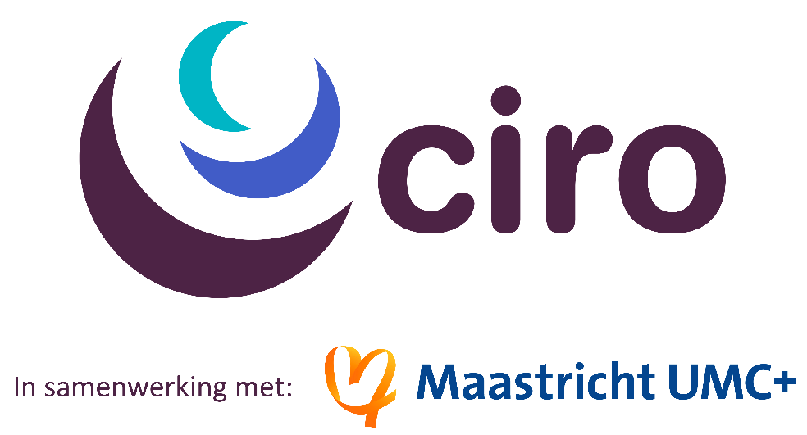

YiR 2019 Day 1 - Pulmonary Rehabilitation and Physical Activity
Wednesday, December 18, 2019

Chairs: Martijn A. Spruit and Frits M.E. Franssen
08.30 hrs. Registration + coffee/tea
08.50 hrs. Welcome by Martijn A. Spruit
09.00 hrs. Pulmonary rehabilitation and exercise training by Matthew Maddocks (UK)
09.45 hrs. Questions and Answers
10.00 hrs. Physical activity by Fabio Pitta (Brazil)
10.45 hrs. Questions and Answers

11.00 hrs. Coffee/tea break

11.30 hrs. Oxygen supplementation and/or NIV in combination with exercise training by Enrico Clini (Italy)
12.15 hrs. Questions and Answers

12.30 hrs. Lunch
13.30 hrs. Nutritional modulation with(out) exercise training by Annemie Schols (NL)
14.15 hrs. Questions and Answers
14.30 hrs. Early rehabilitation during and after ICU admission by Rik Gosselink (B)
15.15 hrs. Questions and Answers
15.30 hrs. Break
16.00 hrs. Keynote lecture: Personalized pulmonary rehabilitation in 2030 by Caroline Rochester (USA)
16.45 hrs. Closure by Frits Franssen
17.00 hrs. Reception

17.30 hrs. Buffet

19.30 hrs. End of buffet

YiR 2018 Day 2 – Self-management, Respiratory Failure and Palliative Respiratory Care
Thursday, December 19, 2019

Chairs: Daisy J.A. Janssen and Bita Hajian
08.30 hrs. Registration + coffee/tea
08.50 hrs. Welcome by Daisy J.A. Janssen
09.00 hrs. Self-management in chronic lung disease by Paula Meek (USA)

09.45 hrs. Questions and Answers
10.00 hrs. Informal caregiving in chronic lung disease by Alda Marques (Portugal)
10.45 hrs. Questions and Answers
11.00 hrs. Coffee/tea break
11.30 hrs. Management of acute and chronic respiratory failure by Michael Dreher (Germany)
12.15 hrs. Questions and Answers
12.30 hrs. Lunch
13.30 hrs. End-of-life care in chronic lung disease by Daisy J.A. Janssen (NL)
14.15 hrs. Questions and Answers
14.30 hrs. Keynote lecture: Respiratory palliative care in 2030 by Randall J. Curtis (USA)
15.15 hrs. Closure and goodbye by Bita Hajian + handing out of certificate of attendance

