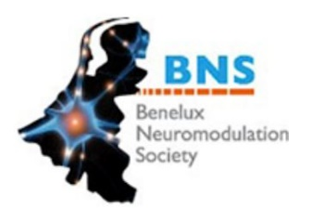
BNS scientific meeting
October 11th Antwerp, Belgium

PRELIMANARY PROGRAM

13.00 – 14.00 Welcome and lunch + exhibition
14.00 – 15.30 Plenary speakers
14.00 – 14.30 dr. Lisa Goudman - Objective measurements in SCS treatment
Lisa Goudman is first author of several peer-reviewed papers about the need and availability of objective measurements in SCS treatment. She focused her work on (neuro)imaging e.g. qEEG, fMRI, VBM; qualitatitive sensory testing and heart rate variability in patients with failed back surgery syndrome treated with spinal cord stimulation.
14.30 – 15.00 Professor dr. Lieven Annemans - Update on the Societal Burden of pain and the current HTA environment
Lieven Annemans is worlds most honored expert in health economics with a very large expertise and insights about the societal burden of (chronic) pain in Europe and beyond. He will talk about health technology assessments and how they contribute to lessen the economic burden of pain in Europe.
15.00 – 15.30 Professor dr. Frank Huygen óf Dr. Jan-Willem Kallewaard - Update on reimbursementsrules for SCS in The Netherlands; does clinical evidence still play a role?
Neuromodulation as a treatment option for specific chronic pain entities is already reimbursed for more than 40years in Belgium and in The Netherlands. In 2018, the reimbursements rules changed dramatically in Belgium. In the Netherlands, the clinical evidence of SCS in specific chronic pain entities has been investigated and updated in order to change also the reimbursement rules.

15.30 – 16.00 Coffee break + exhibition
16.00 – 18.30 Science café
Young investigators in neuromodualtion from the BENELUX are invited to present their work based on the "science café" principle.

18.30 Celebration of the Award-winners & Closure

