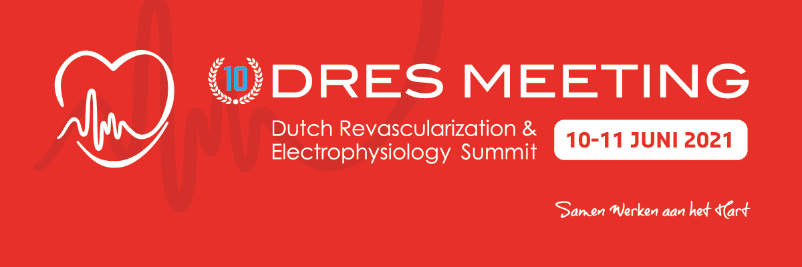

Program Thursday, June 10, 2021

The main language on this conference day is English

08.00 – 09.00 hrs Welcome & Registration
Efficient /Cardiac Care
Moderators: Harry Crijns – Michiel Rienstra
Discussants: Lieselot van Erven – Martin Hemels – Marcoen Scholten –
Peter-Paul Delnoy

09.00 – 09.05 hrs Welcome
Peter Smits – cardiologist – Maasstad Ziekenhuis – Rotterdam

09.05 – 09.25 hrs Efficient care in ICD therapy
Lieselot van Erven – cardiologist – LUMC – Leiden

09.25 – 09.40 hrs Taped Case: Hisbundel Pacing
Stefan Timmer – cardiologist – Noordwest Ziekenhuisgroep, Alkmaar

09.40 – 10.00 hrs Development of the most efficient treatment method for PVI
Marcoen Scholten – cardiologist – Medisch Spectrum Twente, Enschede

10.00 – 10.20 hrs Left ventricle reconstruction: clinical presentations and approach in the era
of primary PCI
Jan Grandjean - cardiacthoracic surgeon, Medisch Spectrum Twente – Enschede

10.20 – 10.40 hrs 30 years of purposeful therapy in heartfailure
Dirk Jan van Veldhuisen – cardiologist – UMCG, Groningen

10.40 – 11.00 hrs Coffee break

Left main treatment
Moderators: Robert-Jan van Geuns – Massimo Mariani
Discussants: Giovanni Amorose – Rik Hermanides – Eric Lipsic – Sjoerd Hofma -
Maarten van Leeuwen – Johanna Wykrzykowska
11.00 – 11.30 hrs Live case: Unprotected LM PCI
Noordwest Ziekenhuisgroep, Alkmaar

11.30 – 11.50 hrs.20 – The final word in left main treatment ? The surgeon perspective
Robert Klautz – cardiothoracic surgeon – LUMC, Leiden 1.40
11.50 – 12.20 hrs The final word in left main stenting ? The cardiologist perspective
Gregg Stone, cardiologist – Mount Sinai Heart Health System, New York – USA
12.20 – 12.30 hrs Discussion

12.30 – 14.00 hrs Lunch
13.00 – 13.55 hrs Satellite Meeting Abbott |
When the patient and the angiogram tell different stories.
Why diagnosing CMD matters!

Treatment of chronic coronary syndrome
Moderators: José Henriques – Lennaert Kleijn
Discussants: Richard Vijn – Rohit Oemrawsingh – Arthur Liqui Lung –
Daan de Waard – Janneke Wittekoek – Karin Arkenbout

14.00 – 14.20 hrs Results from the Orbita trial: what is the value of PCI in chronic coronary syndromes?
Rasha Al-Lamee – cardiologist – Imperial College, London – UK
14.20 – 14.40 hrs My perspective of ORBITA and ISCHEMIA
Gregg Stone – cardiologist – Mount Sinai Heart Health System, New York – USA
14.40 – 15.00 hrs Discussion
15.00 – 15.30 hrs Live case: Multivessel stable
Rijnstate Ziekenhuis, Arnhem
15.30 – 16.00 hrs Coffee break

Meetings
16.00 – 17.15 hrs 00. WIC Member Meeting .
M.45
19.00 – 23.00 hrs Netwerk Meeting including buffet
Care

