An International Neonatal Intensive Care Unit (NICU)
Music Therapy Training Model:
First Sounds: Rhythm, Breath, Lullaby (RBL)

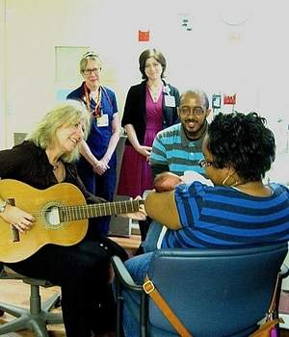

Joanne Loewy DA, LCAT, MT-BC
& NICU Team
The Louis Armstrong Center for Music & Medicine,
Mount Sinai Beth Israel, NYC

The course will be held in English.
It lasts from 9 a.m. - 18 p.m. and includes food and drinks.

Description:
A range of philosophical and theoretical stances frame the application of music in the NICU and Special Care Nurseries. The First Sounds model is a 3-part method, which includes a live music psychotherapy approach that addresses medical and musical interventions. The method is developed by a team of music therapists with input based on research inclusive of a diversity of music therapists, NICU’s, in consultation with neonatologists and nurses.
Our focus includes EMT (Environmental Music Therapy) developed in NICUs & Special Care Nurseries with evidence-based live music interventions oriented within a neuropsychological developmental music context for premature infants.
This course focuses on the training of step 1 in a 3 step program which includes music psychotherapy support for caregivers informed by theories of healthy dyadic, triadic development, and trauma theory embracing culturally sensitive applications. Step 1 also provides a diversity of clinical music therapy approaches as representative of neonatal care being instituted using the Rhythm, Breath & Lullaby First Sounds approach that is developing and adapted in NICU’s globally.

This course provides the following:

Learner objectives:
- Attendees will design live music applications of the preferred fetal environment focused on rhythm, timbre and tonal inter-uterine elements to foster comfort, stability, nurturance, safety, increasing opportunities for entrainment and self-regulation for the premature infant.
- Attendees will demonstrate knowledge and application of the First Sounds model-contingent singing and evaluation of applicative sounds & music to increase respiratory, sleep, feeding and quiet-alert opportunities with proficiency.
- Attendees will demonstrate and develop the blanket of sound applications: tonal-vocal holding, with competence to develop lullabies catered to address the developmental, physical, emotional and cultural needs of the infant & family.
- Attendees will effectively evaluate the caregivers’ level of trauma and identify music anchors whereby families of NICU infants will entrust music therapy support to enhance the caregiver-infant bonding process.
- Attendees will explicate, through trauma theory, music’s process in Environmental Music Therapy, providing a tangible means of coping where professional & personal caregivers can connect to infants through song of kin. Live music interventions, modulating noise, where the family's music can be honored will support the infant-caregiver bonds and subsequent attachment.

