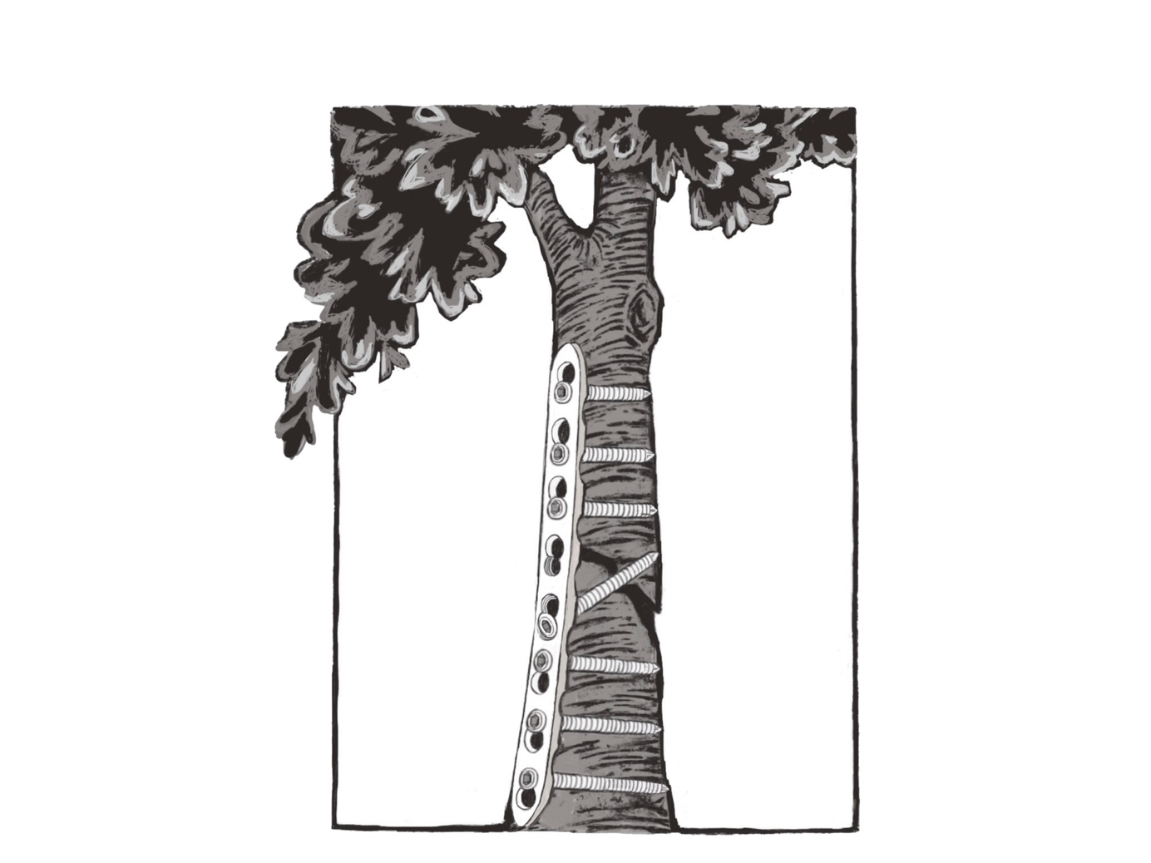
4th Biennial Traumaplatform Symposium
Friday September 13th 2019

Leeuwarden, the Netherlands
Committee Members 2019:

Chef 2019 Nine de Planque - Erasmus MC, Plastics
cadeplanque@gmail.com
Chefs Symposium Lars Brouwers, Radboud MC, Surgery
l.brouwers@etz.nl
Caroline Selles – Maasstad & AMC, Surgery
sellesc@maasstadziekenhuis.nl

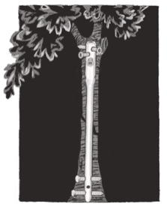
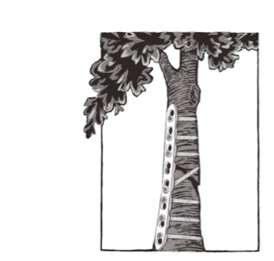
4th Biennial Traumaplatform Symposium
Friday September 13th 2019

Scientific Program
08:00 - Arrival, Breakfast and Good Coffee @ Vliegbasis Leeuwarden

4th BiennialTraumaplatform Symposium 2018 @ Vliegbasis Leeuwarden
PhD Elevator Pitches – Pitch now, feedback follows over the day to make it better
– Moderators Professor Michiel Verhofstad & Nine de Planque
08:30 - Opening: 4th Bienniel Traumaplatform Symposium – Koen Lansink, MD PhD
08:40 - PhD elevator pitch I
08:52 - PhD elevator pitch II
09:04 - PhD elevator pitch III
09:16 - PhD elevator pitch IV
09:28 - PhD elevator pitch V

09:40 - Coffee/Tea Break
– Key Note dr Sven Meylaerts & dr Peer van der Zwaal
Multidisciplinary Trauma Unit: Just DO it

Completed PhDs – So What? Or did it change practice…?!
– Moderators dr. Obdeijn and dr. Vermeulen
10:00 - PhD Change of Practice Pitch I – 3D Printing in Orthopaedic Trauma
drs Lars Brouwers, Radboud MC – Trauma Surgeon in Training
10:12 - PhD Change of Practice Pitch II – Complication in Distal Radius Fractures
drs Minke Bergsma, Amsterdam UMC – Plastic Surgery
10:24 - PhD Change of Practice Pitch III – Steps & Gaps in Intra-Articular Fractures
drs Batur Hayat, Amsterdam UMC – Orthopaedics
10:36 - PhD Change of Practice Pitch IV
10:48 - PhD Change of Practice Pitch V
11:08 - PhD Change of Practice Pitch VI

4th Bienniel Traumaplatform Symposium
Friday September 13th 2019

Old Fashioned Key Note Lectures with Trauma Circuit in Academic Quarterly Hour

– Moderators dr Rutger van Zuurmond & drs Caroline Selles
Paediatric Trauma, Essentials and how to stay out of trouble…
11:30 - Dr Arnold Besselaar, Trauma & Paediatric Orthopaedic Surgery, MMC
12:00 - Skills RACE 1: Austofix Distal no-worries Locking?

The Mental aspects of flying on the Helicopter (MMT)
12:30 - dr. van Wageningen
13:00 - Skills RACE 2:

13:30 - Lunch Break

Hip Fractures – Essentials You Need to Know, and THA vs HA
14:00 - Skills RACE 3:
14:30 - dr. Vermeulen and dr. Van Nieuwenhoven

Open Tibial Shaft Fractures – Direct Nailing in an Open Wound?
15:00 - dr Rutger van Zuurmond, Isala klinieken, the Netherlands
15:30 - Skills RACE 4: Tibial Nail: SureShotSuper?

15.55 - Coffee Break – Grab good coffee and move on…

Key Notes – My Messages for the Young Generation
– Commandeur Blom

Being a doctor, there can be much more to it…
16:00 - Professor Michiel Verhofstad, Erasmus MC – My Life as a Doctor, and…
Executive Committees, Steering Committees, Chair Person & Board Memberships

16:20 - Professor van Zuijlen, Amsterdam UMC – That one patient – Burns and Scars

16:40 - dr. Koen Lansink, ETZ – Trauma surgery and Management – leading a regional trauma network

My Passion in Trauma
17:00 - dr Guus Vermeulen, Xpert Clinic - Datamanagement

17:20 - dr Dennis den Hartog, Erasmus MC - Good RCTs and the Elbow

HANDS ON – Everything you need to know about hand trauma!
17:40 - Associate Professor Miyam Obdeijn, Amsterdam UMC

18:00 - Drinks

----------------------------4th Bienniel Traumaplatform Symposium Adjourns-----------------------------

------------------------------------AO Young Generation Symposium Begins-------------------------------

19:00 - DINNER + Key Note Lecture AO Young Generations

