925

Aan de deelnemers van
De Senectute

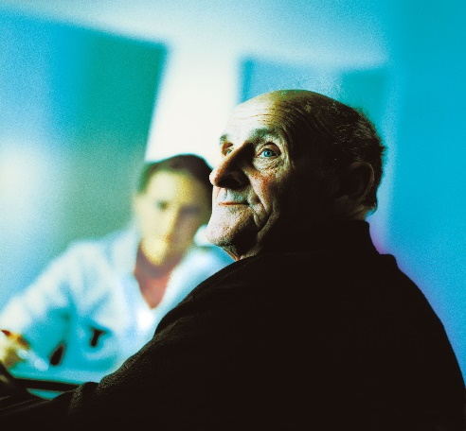
Secretariaat Opleiding Klinische Geriatrie Cluster Zuidoost Nederland

Huispost 925
Postbus 9101
6500 HB Nijmegen
Radboudumc oost, route 925
Reinier Postlaan 4

T (024) 361 67 72
F (024) 361 74 08
gemma.bruins-vandersterren@radboudumc.nl
www.klinischgeriater.nl

Opleidingscoördinator
Mw. dr. D.Z.B. van Asselt

Datum | 20 juni 2019
Ons kenmerk | GB

UITNODIGING
REFEREERAVOND DE SENECTUTE.
Donderdag 20 juni 2019, 19.30-21.30 uur,
Locatie: Radboudumc, G. Padbergzaal, route 924, ingang oost, Reinier Postlaan 4, Nijmegen

Thema: Visusproblematiek
Organisatie: Rijnstate ziekenhuis
Panel: Pro Persona
Inleiding: Geriater RSZ

Artikelen
Arenda Dado, aios RSZ. Imaging, Genetic, and Demographic Factors Associated With Conversion to Neovascular Age-Related Macular Degeneration. Joelle A. Hallak, MS, PhD; Luis de Sisternes, PhD; Aaron Osborne, MBBS, MRCOphth; Brian Yaspan, et.al. JAMA Ophthalmol. doi:10.1001/jamaophthalmol.2019.0868

Esther Hamoen, anios RSZ. Association of Intravitreal Anti–Vascular Endothelial Growth Factor Therapy With Risk of Stroke, Myocardial Infarction, and Death in Patients With Exudative Age-Related Macular Degeneration. Lauren A. Dalvin, MD; Matthew R. Starr, MD; et.al. JAMA Ophthalmol. 2019;137(5):483-490. doi:10.1001/jamaophthalmol.2018.6891

20.15 pauze en welkom nieuwe geriaters

Anniek van der Aalst, anios RSZ. Long-Term Effects of Vitamins C, E, Beta-Carotene and Zinc on age-Related Macular Degeneration. Emily Y. Chew, Traci E. Clemons, et.al. AREDS Report No. 35. Ophthalmology. 2013 August ; 120(8): 1604–1611.e4. doi:10.1016/j.ophtha.2013.01.021.

