DUTCH SPINE SOCIETY
18th annual meeting

Pediatric Spine

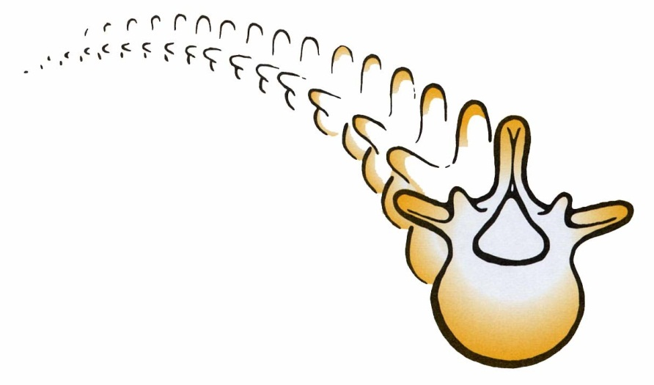

09 NOVEMBER 2018

Rotterdam

2001 The herniated disc of the thoracic and lumbar spine
2002 New developments in spinal surgery
2003 The aging spine
2004 Revision spinal surgery
2005 Spinal metastasis
2006 Trauma of the spine
2007 Infectious diseases of the spine
2008 The lumbar disc
2009 Spinal deformities
2010 Pediatric spine
2011 Controversies in spine-surgery
2012 Minimal Invasive spine surgery: New standard or transient fashion?
2013 Spinal tumours
2014 Spinal Trauma
2015 Revision Spinal Surgery
2016 The Aging Spine
2017 Spinal Infections
Accreditation

Nederlandse Orthopedische Vereniging (NOV)
Nederlandse Vereniging voor Neurochirurgie

GENERAL INFORMATION

NHOW hotel Rotterdam
Wilhelminakade 137
3072 AP Rotterdam

www.dutchspinesociety.nl

Mrs. Marjon den Biesen
Secretary Dutch Spine Society
Tel: +31 (0)24 – 365 92 96
Fax: +31 (0)24 – 365 93 17
E-mail: info@dutchspinesociety.nl

Dear colleagues,

On behalf of the board of the Dutch Spine Society, I would like to invite you to the 18th annual DSS scientific meeting, called “ Pediatric spine”, in Rotterdam.

It concerns an update of the annual meeting in 2010 (Paediatric spine ) with special attention to the cervical spine, rheumatoid arthritis and spinal trauma. We will incorporate the knowledge and experiences of our Dutch experts as well as input of our international speaker.

Our children are our future. As spinal surgeons we need to be well aware of several paediatric spinal conditions that can cross our daily and sometimes specialized spinal practice.

To pursue an optimal discussion concerning the state of the art diagnostic and therapeutic options for paediatric spinal conditions, we have composed a diverse program not only for paediatric spinal specialists but also for the majority of our DSS members.

We are looking forward to welcome you at Friday the 09 th of November in Rotterdam.

Sincerely,

Willem-Bart Slooff
Chairman of the Dutch Spine Society

WB Slooff, neurosurgeon
Chairman Dutch Spine Society

DUTCH SPINE SOCIETY
Nederlandse Orthopedische Vereniging
Nederlandse Vereniging voor Neurochirurgie

Scientific program annual meeting Dutch Spine Society

November 09th 2018
“Pediatric spine”

TIME | ITEM | SPEAKER
08.30 uur | Registration and coffee
08.55 uur | Opening 18 th annual meeting Dutch Spine Society | Willem-Bart Slooff
 | I  Cranio-cervical junction | Moderator:
09.00 - 09.20  09.20- 09.40  09.40 – 09.55 | The cranio-cervical junction: Developmental anomalies.  The cranio-cervical junction:  Surgical decision making and treatment.  Discussion | Thompson  Brockmeyer
09.55 – 10.20  10.20 – 10.50 | II  Scoliosis  The pediatric / adolescent spine: Congenital scoliosis.  Coffee break | Moderator  Yazici
10.50 – 11.10 | A new screening tool for adolescent idiopathic scoliosis. | Van West

 | III  Cervical pediatric trauma | Moderator:
11.15 - 11.35  11.35 – 11.50 | - Pediatric cervical trauma, how to handle.  C1-C2 subluxation What to or not to do? | Brockmeyer  Thompson
11.50 – 12.00 | Discussion
12.00– 13.00 | Lunch
13.00– 14.40 | Dutch Spine Society member meeting.
 | IV  Lumbar spine | Moderator:
14.45 – 15.10  15.10 - 15.20  15.20 – 15.10  15.10 - 15.20  15.20 - 15.30 | The lumbo-sacral junction: Adolescent spondylolytic spondylolisthesis Work up and treatment.  Discussion  Introduction pediatric herniated lumbar disc.  Battle of wisdom  Pediatric lumbar disc herniation:  Case 16 year old adolescent with a symptomatic herniated disc L4-5 on the left side.  Red Corner Conservative  Blue Corner Surgical | Yazici  Pakvis  Brockmeyer  Thompson
15.35 – 15.55  15.55 – 16.20 | Coffee break  What’s hot from Holland  15.55-16.00 1  16.00-16.05 2  16.05-16.10 3  16.10-16.15 4
16.20 – 16.35 | V  DSS Award ceremony | Moderator:
16.35 – 16.40  16.40– 17.30 | Discussion  Closing remarks and Happy Hour

FACULTY

Douglas Brockmeyer
Pediatric Neurosurgery
Professor of Neurosurgery
Marion L Walker Endowed Chair
Division Chief, Pediatric Neurosurgery
University of Utah
100 N Mario Capecchi Dr. #3850
Salt Lake City, UT 84113
douglas.brockmeyer@hsc.utah.edu
(801) 662-5340

Dominic Thompson
Pediatric neurosurgery
Great Ormond Streest Hospital for Children
Great Ormond Street Hospital for Children NHS Foundation Trust
Great Ormond Street
London WC1N 3JH UK

Muharrem Yazici
Professor of Orthopedics and traumatology
Hacettepe University Faculty of Medicine Dep. of Orthopedics and Traumatology
Bülten Sokak No:44
Kavaklıdere, Ankara, Turkce

