Provisional Program Symposium ‘New Imaging Techniques for Guidance of Therapy’.
On June 12th, prior the inaugural lecture of Hugo de Jong, a symposium will be organized. The venue for this will be the Catharijneconvent, a museum of religious art. It is located in the medieval center of Utrecht, in a former convent. Until the 15th century this monastery housed the predecessor of the current University Hospital.
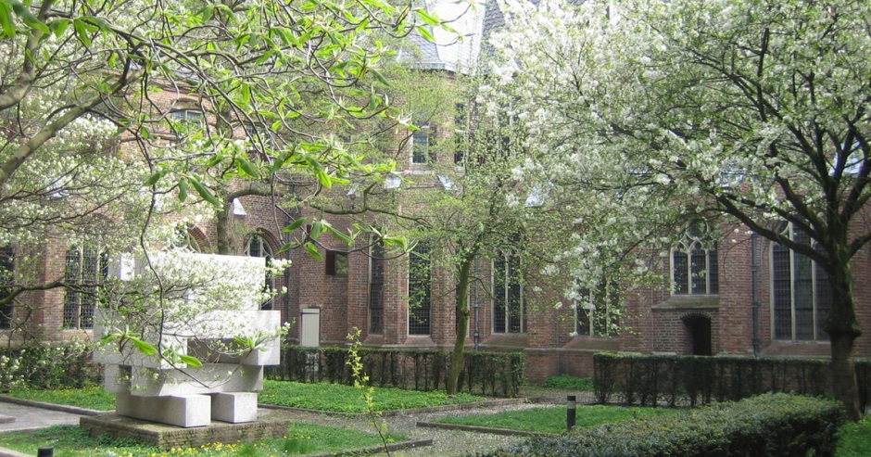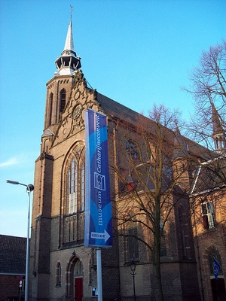

Start time | Title
10.30 | attendees are welcomed with coffee
11.00 | start – introduction by chairman | Marnix Lam, Welcome by Peter Luijten
11.05 | Dynamic Whole Body PET/CT | dr. Anne Smith, Siemens Knoxville, US
11.30 | Total Body PET | prof. Stefaan Vandenberghe, Ugent, Belgium
11.55 | Development of a wide bore PET/MRI | prof. Volkmar Schulz, RWTH Aachen, Germany
12.20 | Lunch and coffee
13.20 | CT imaging techniques in acute stroke | dr. Henk Marquering, Amsterdam UMC
13.45 | Imaging and Lutetium dosimetry | prof. Mark Lubberink, Uppsala University, Sweden
14.10 | Hybrid Interventional Imaging | Dr. Casper Beijst, UMC Utrecht
14.45 | Closure, coffee and information about museum, possibility to shortly visit highlight museum
15.30 | Walk to the Academy Building (5 min)
16.15 | Inaugural Lecture at the Academy Building (be there 16.00 latest) | Hugo de Jong

