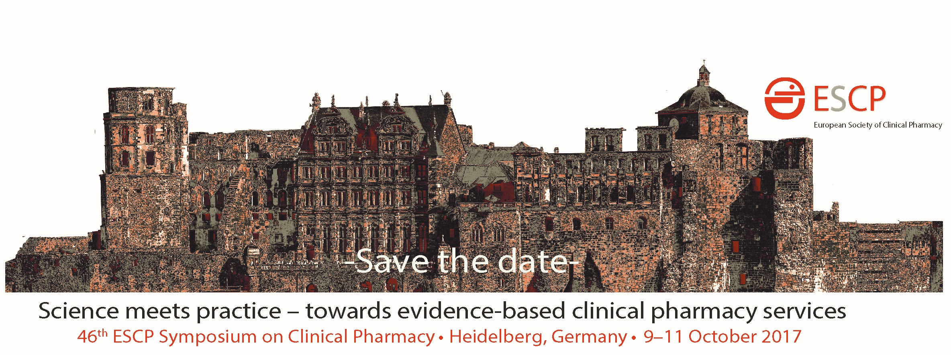

Masterclass of Excellence on Design and Implementation of Pharmacist-led Randomized Clinical Trials!
Organized by the ESCP Research Committee (ResCom)
in co-operation with the Department of Clinical Pharmacology and
Pharmacoepidemiology, University of Heidelberg.
Sunday, 8 October 2017, 09:00-16.30 (the day before the Symposium)
“Achieving the highest evidence: How to run a RCT?”

Program:
09:00 - 09:45 Why we need RCTs – Levels of evidence and contemporary examples of successful RCTs
09:45 - 10:15 No alternative!? – Research questions where per patient RCTs are NOT first choice
10:15 - 10:30 Coffee Break
11:00 - 12:00 Designing a RCT – trials and tribulations in outcomes research
12:00 - 13:00 Lunch
13:00 - 14:30 Your choice:
Group work A: Implementation and sustainability of RCTs – share your experiences including barriers, and facilitators or
Group work B: Case studies/research questions: Design your own RCT
14:30 - 15:00 Practical issues eg, recruitment, motivation, monitoring, data gathering …
15:00 - 16:00 My next study will be a RCT – presentations by the different groups and plenary discussion
16:00 - 16:30 Evaluation, final comments, and farewell: Good luck with your next RCT!
Your tutors
Marcel Bouvy, PharmD, PhD, FESCP, is Professor of Pharmaceutical Care and Research Manager at the SIR Institute for Pharmacy Practice and Policy in Leiden, in cooperation with Utrecht University, the Netherlands. He is the past president of the Scientific Section of Dutch Community Pharmacists (WSO), founding member of the European Society for Patient Adherence, Compliance and Persistence (ESPACOMP). His research focus on patient adherence, medication safety, including observational methods and evaluation of pharmacy interventions with a wide experience in RCTs. Marcel has attended ESCP conferences for >20 years and is a member of the ESCP ResCom.
Martin Schulz, RPh, PhD, FFIP, FESCP, is an Adjunct Professor at Goethe-University Frankfurt and Lecturer Dept. of Clinical Pharmacy, Freie Universitaet Berlin, Germany. He is the Director, Dept. of Medicine at ABDA and Chairman of the Drug Commission of German Pharmacists. His research focus on medication adherence and safety and evaluation of pharmacy-based interventions. Martin is a member of the ESCP ResCom and Co-Principal Investigator (PI) of the first pharmacy-based per patient RCT in Germany (PHARM-CHF, ClinicalTrials.gov-#: NCT01692119).
Ross T. Tsuyuki, BSc(Pharm), PharmD, MSc, FCSHP, FACC, is a Professor of Medicine (Cardiology) and Director of the Epidemiology Coordinating and Research (EPICORE) Centre (a health research coordinating centre), Faculty of Medicine and Dentistry, University of Alberta, Edmonton, Canada. His research interests include: improving public health through engaging community pharmacists as primary care providers (interventional pharmacy practice research). He is the PI of major randomized clinical trials studying pharmacists’ interventions, such as RxING (BMJ Open 2013), RxACTION (Circulation 2015), and RxEACH (JACC 2016). Ross is is the Editor-in-Chief of the Canadian Pharmacists Journal (www.cpjournal.ca).
Venue Heidelberg University Hospital, Im Neuenheimer Feld 400, 69120 Heidelberg, Germany.
Registration http://www.escpweb.org/Heidelberg Maximum 30 participants
Registrations fees
Additional fee for registration if also registered with ESCP Symposium, ESCP member: EURO 130
Additional fee for registration if also registered with ESCP Symposium, ESCP non-member: EURO 150 Masterclass only, ESCP member: EURO 160
Masterclass only, non-ESCP member: EURO 200

