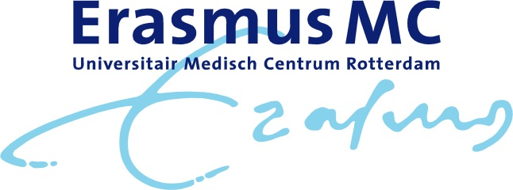
Program Symposium High Precision Radiotherapy on the occasion of the inauguration of prof. dr. M. S. Hoogeman
December 14th 2018
Location: Het Nieuwe Instituut, Museumpark 25, 3015 CB Rotterdam

09.30-10.00h Welcome with coffee
Moderator: prof. dr. B. Heijmen, medical physics, Erasmus MC Rotterdam
10.00-10.05h Opening by prof. dr. P. Sonneveld, acting head of Department of Radiotherapy Erasmus MC Rotterdam
10.05-10.30h Molecular Radiomics by Imaging Mass Spectroscopy for visualizing intra-tumor heterogeneity: correlation with clinical outcome parameters by prof. dr. ir. B.P.F. Lelieveldt , LUMC Leiden
10.30-10.35h Discussion
10.35-11.00h Biological Image Guided Radiotherapy by dr. S. Petit, Erasmus MC Rotterdam
11.00-11.05h Discussion
11.05-11.30h Automation in radiotherapy – successes, challenges and future by prof. dr. B. Heijmen, Erasmus MC Rotterdam
11.30-11.35h Discussion
11.35-12.00h Valuation of Proton Therapy in the Netherlands by prof. dr. M. van Vulpen, head of HollandPTC, Delft
12.00-12.05h Discussion
12.05-13.00h Lunch
Moderator: prof. dr. M. van Vulpen, head of HollandPTC, Delft
13.00-13.25h Artificial intelligence – opportunities for radiotherapy by prof. dr. ir. A.L.A.J. Dekker, Maastro Maastricht
13.25-13.30h Discussion
13.30-13.55h Robust Proton Therapy by dr. Z. Perko, Delft University of Technology
13.55-14.00h Discussion
14.00-14.25h High Precision Radiotherapy; what should we be aiming for? By prof. dr. S. Senan, VUmc Amsterdam
14.25-14.30h Discussion and closing remarks
14.30h Departure to Erasmus University, Burgemeester Oudlaan 50, 3062 PA Rotterdam
16.00h Inauguration of prof. dr. M. S. Hoogeman

