International Neurologic Music Therapy Training Institute Schedule
20 – 23 September 2020, ArtEZ Enschede, The Netherlands

Sunday, Sep 20, 2020
8:45-9:15 Registration/Refreshments
9:15-9:30 Spaulding CEO
9:30-11:15 Introduction to Principles of Neurologic Music Therapy: Scientific and Clinical Models
11:15-11:30 Break
11:30-13:30 Speech/Language
13:30-14:30 Lunch
14:30-16:00 Speech/Language
16:00-16:15 Break
15:15-18:15 Speech/Language Clinical Practice

Monday, Sep 21, 2020
9:00-11:00 Research, and the Role of Music in Therapy and Medicine /
11:00-11:15 Break
11:15-12:15 Neuropathology Disease Review
12:15-13:30 Break/Lunch
13:30-14:15 Rethinking the Role of Music in Neurodevelopmental Disorders
14:15-16:00 Cognitive Techniques
16:00-16:15 Break
16:15-17:45 Cognitive Techniques

Tuesday, Sep 22, 2020
9:00-11:00 Cognitive Techniques
11:00-11:15 Break
11:45-13:00 Cognitive Techniques
13:00-14:00 Lunch
14:00-15:00 Patterned Sensory Enhancement (PSE)
15:00-15:45 Therapeutic Instrumental Music Performance (TIMP)
15:45-16:00 Break
16:00-16:45 Sensorimotor Practice Session II (PSE, TIMP)
16:45-17:30 Sensorimotor Practice Session I (PSE, TIMP)
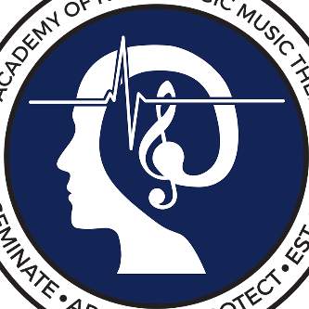
17:30-18:15 NMT Techniques with Developmental Disabilities

Wednesday, Sep 23, 2020
9:00-12:00 Gait Assessment/RAS Gait Training
12:00-12:30 Wrap Up, Q&A, Test, Course Evaluation

