2-day Rescue Team course Paris *** FULL SESSION ***
Come learn all you need to know on ECPR and REBOA during a 2-day course in the beautiful city of Paris ! For in and prehospital care !

Objective :
Based on the literature learn who can benefit from ECPR/REBOA
Learn how to set up an ECPR/REBOA program
Learn the different techniques about how to put a patient under ECPR/REBOA with all around the world experts
Learn how to deal with these patients during the first four hours from the prehospital setting to their ICU bed
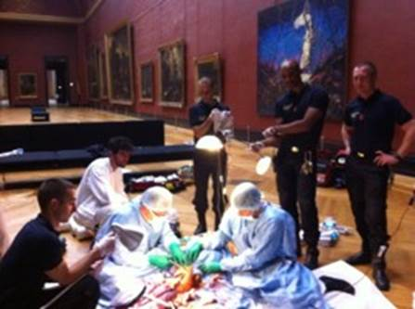

How :
Short classroom lectures
Hands-on device handling
Mannequin training
Cadaver lab
High fidelity simulation
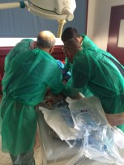 ... 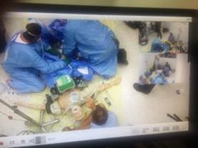

For who ?
Physicians or trainees from emergency medicine, intensive care, cardiologist or anesthesia interested in resuscitation and seeking knowledge on ECPR + REBOA
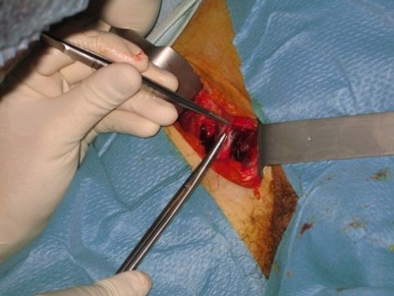 ... 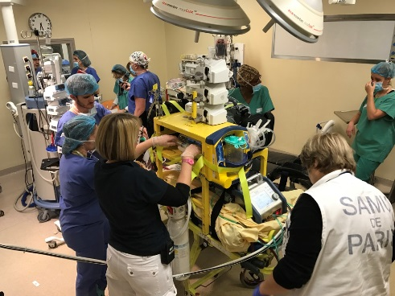

PRE PROGRAM :

You can find below the link to the pre-program of our 2 day course
Registration will be available online very shortly!
For any questions, please contact Dr Lionel Lamhautat the following email address contact@paris-rescue-team.com

Price : 1500 €uros *** FULL SESSION ***
Price for resident, nurse : 1000 €uros *** FULL SESSION ***
Paris Rescue Team Course
Preliminary program

Monday October 15 *** FULL SESSION ***
○ 19:00 : Welcome drink
Tuesday October 16 *** FULL SESSION ***
○ 07:30 : Coffee
○ 08:00 – 08:15 : Global optimal CPR strategy
○ 08:15 – 08:25 : Discussion
○ 08:30 – 09:30 : ECPR Session, what does the literature say ?
08:30 – 08:45 : ECPR Indications ?
08:45 – 09:00 : When ?
09:00 – 09:15 : Where ?
09:15 – 09:30 : Discussion
○ 09:30 – 10:00 : Coffee Break
○ 10:00 – 11:00 : ECPR Session, what are the different cannulation techniques ?
10:00 – 10:10 : Surgical
10:10 – 10:20 : Percutaneous
10:30 – 10:40 : Hybrid
10:40 – 10:50 : Circuit priming and connecting
10:50 – 11:00 : Discussion
○ 11:00 – 11:50 : Training on mannequin (Percutaneous + hybrid)
○ 11:50 – 12:00 : Morning recap
○ 12:00 – 13:00 : Lunch and transfer to the cadaver lab
Tuesday October 16 afternoon *** FULL SESSION ***
○ 14:00 – 16:00 : Cadaver Lab for hybrid technic teaching
○ 16:00 – 16:40 : Transfer to the Hotel and coffee break
○ 16:40 – 17:00 : First 4 hours after ECPR implementation: Interactive clinical cases

......Post-resus care
......What can go wrong ?
......Which diagnostic exams ?

○ 17:00 – 17:30 : Global Code organization
......Optional: 18:00: SAMU and ECMO team Visit
○ 19:00 : Departure from Hotel to the GALA Dinner

Wednesday October 17th morning *** FULL SESSION ***
○ 07:30 : Coffee
○ 08:00 – 08:40 : REBOA / SAAP Session
......08:00-08:20 : Trauma indication
......08:20-08:30 : Medical indication
......08:30-08:40 : Discussion
○ 08:40 – 09:30 : DEVICE Session, “hands on”
......Group 1 : ECMO machine priming / Group 2 : REBOA and SAAP
○ 09:30 – 10:10 : ECLS / VA-ECMO (Without cardiac arrest)
...... 09:30-9:50 : Indication and results of ECLS in emergency
...... 09:50-10:00 : Others assistance
...... 10:00-10:10 : Discussion
○ 10:10 - 10:40 : Coffee Break
○ 10:40 - 11:10 : VV-ECMO
...... 10:40-10:50: Indication in emergency
...... 10:50-11:00: Technics and canulae
...... 11:00-11:10: Discussion
○ 11:10 – 11:40 : Secondary patient transfer under ECPR/ECMO
○ 11:40 – 12:00 : Morning Recap
○ 13:00 – 13:20: Trauma indication
○ 13:20 – 13:30: Medical indication
○ 13:30 – 13:40 Discussion
......Group 1 : ECMO machine priming / Group 2 : REBOA and SAAP
○ 14:30 - 14:50 : Indication and results of ECLS in emergency
○ 14:50 - 15:00 : Others assistance
○ 15:00 - 15:10 : Discussion
......Indication in emergency
......Technics and canulae
......Discussion

Wednesday October 17th afternoon *** FULL SESSION ***
○ 12:00 – 13:00: Lunch
○ 13:00 – 14:00: REBOA/SAAP Simulation on mannequin
○ 14:00 – 14:40: Code session
......14:00-14:15: ECPR on Cath lab
......14:15-14:30: ECPR on ER /ICU
......14:15-14:30: ECPR on prehospital
......14:30-14:40: Discussion

○ 14:40 – 15:00: Coffee Break
○ 15:00 – 16:30 : High fidelity Simulation
○ 16:30 – 17:00: 2 days Recap

