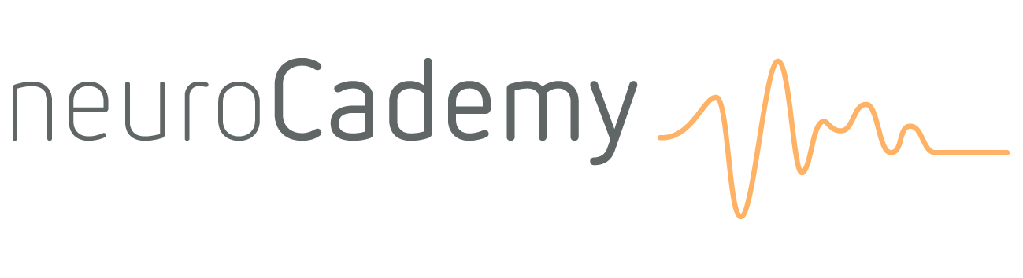

rTMS Training course:
rTMS in Depression, OCD and new Developments

Presenters: Dr. Martijn Arns, Dr. Kerstin Mayer & drs. Vera Kruiver

Day 1: Thursday

9.15-9.30 hr. | Welcome and introduction
9.30-11.00 hr. | rTMS Background: Physics, history, equipment, parameters and safety
11.00-11.15 hr. | Coffee Break
11.15-12.30 hr. | rTMS in depression and OCD: Past and Present
12.30-13.30 hr. | Lunch
13.30-15.00 hr. | rTMS and other treatments in Depression
15.00-16.00 hr. | Group 1: Hands-on rTMS: Practice finding MT  Group 2: Hands-on actigraphy and sleep assessments
16.00-16.30 hr. | Coffee break
16.30-17.45 hr. | Group 1: Hands-on actigraphy and sleep assessments Group 2: Hands-on rTMS: Practice finding MT
17.45 hr. | Review, questions and closing of the day

Day 2: Friday

9.15-9.30 hr. | Evaluation previous day
9.30-11.30 hr. | Combined rTMS and Psychotherapy I: Vera Kruiver
11.30-11.45 hr. | Coffee Break
11.45-12.30 hr. | Combined rTMS and Psychotherapy II: Vera Kruiver
12.30-13.30 hr. | Lunch
13.30-14.00 hr. | rTMS in Tinnitus, Parkinson’s and other disorders
14.00-14.30 hr. | Review of other Neuromodulation techniques
14.30-15.30 hr. | Personalizing and optimizing rTMS treatment and use of EEG
15.30-16.00 hr. | Coffee break
16.00-16.45 hr. | Group 1: Hands-on rTMS: Depression and OCD Protocol  Group 2: Hands-on actigraphy sleep scoring
16.45-17.30 hr. | Group 1: Hands-on actigraphy sleep scoring  Group 2: Hands-on rTMS: Depression and OCD Protocol
17.30 hr. | Review, questions and closing of the day

