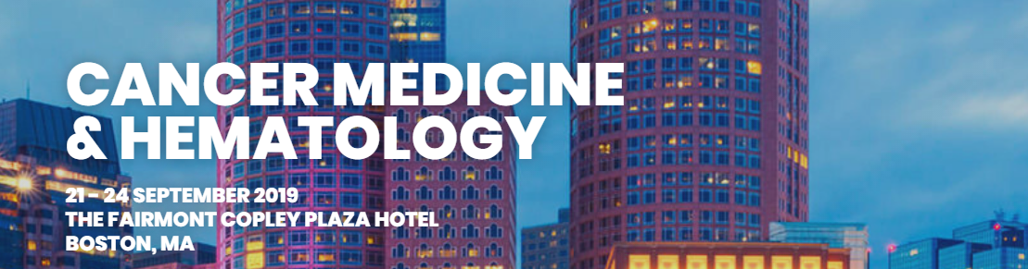

Zaterdag 21 september

7:00am
Registration and Continental Breakfast
8:00am - 8:15am
Welcome
Dr. Mayer
Track Leader / Moderator: Dr. Connors
8:15am
Hemophilia and Von Willebrand Disease
Dr. Neufeld
9:00am
Venous Thromboembolism and Hypercoagulability
Dr. Bauer
9:45am
Erythroid and Myeloid Growth Factor Support
Dr. Lee
10:15am
Refreshment Break
10:30am
Thrombocytopenia and Thrombotic Microangiopathies
Dr. McCrae
11:30am
Transfusion for the Clinician
Dr. Dzik
12:00pm
Challenging Benign Hematology Cases
Dr. Fogerty
12:45pm - 1:30pm
Lunch on Your Own
Moderator: Dr. Mayer
1:30pm
Disorders of Red Blood Cells
Dr. Connors
2:20pm
Disorders of Hemoglobin
Dr. Heeney
3:10pm
Marrow Failure States
Dr. Brodsky
4:00pm
Panel Discussion
Drs. Brodsky, Connors and Heeney
4:15pm
Day One Adjournment
4:30pm - 6:30pm
Networking Reception
Fairmont Hotel - St. James Room

Zondag 22 september

7:00am
Continental Breakfast
Track Leader: Dr. Freedman
Moderator: Dr. Ebert
8:00am
Low Grade Lymphoma
Dr. Freedman
8:40am
High Grade Lymphoma – DLCL, Mantle, Burkitt
Dr. Jacobsen
9:20am
Hodgkin Lymphoma
Dr. LaCasce
10:00am
Refreshment Break
10:15am
Chronic Lymphocytic Leukemia
Dr. Abramson
10:55am
Redefining the Indications for Stem Cell Therapy in Hematologic Malignancies
Dr. Cutler
11:35am
Emerging Role of CAR-T Cell Therapy
Dr. Jacobson
12:15pm
Panel Discussion
Drs. Abramson, Cutler, Jacobsen and Jacobson
12:45pm - 1:45pm
Lunch on Your Own
Moderator: Dr. DeAngelo
1:45pm
Myelodysplastic and Other Preleukemic Syndromes
Dr. Steensma
2:20pm
Acute Myeloid Leukemia
Dr. Stone
2:55pm
Chronic Myeloid Leukemia and Acute Lymphoid Leukemia
Dr. DeAngelo
3:30pm
Refreshment Break
3:45pm
Myeloproliferative Syndromes
Dr. Tefferi
4:20pm
Multiple Myeloma
Dr. Anderson
4:55pm
Macroglobulinemia and Amyloidosis
Dr. Treon
5:15pm
Panel Discussion
Drs. Anderson, DeAngelo, Steensma, Stone, Tefferi and Treon
5:45pm
Day Two Adjournment

Maandag 23 september

7:00am - 8:00am
Continental Breakfast
Track Leader: Dr. Johnson
Moderator: Dr. Michaelson
8:00am
Neuro-Oncology
Dr. Batchelor
8:45am
Head and Neck Cancer Including Thyroid
Dr. Haddad
9:45am
Refreshment Break
10:00am
Early Stage Lung Cancer, Targeted Therapies, Small Cell Lung Cancer
Dr. Johnson
11:00am
Advanced Lung Cancer, Immunotherapy and Mesothelioma
Dr. Sequist
12:00pm
Panel Discussion
Drs. Haddad, Johnson and Sequist
12:30pm - 1:30pm
Lunch on Your Own
Moderator: Dr. Johnson
1:30pm
Sarcoma
Dr. Thornton
1:50pm
Prostate Cancer
Dr. Taplin
2:50pm
Refreshment Break
3:05pm
Kidney, Bladder and Testicular Cancers
Dr. Michaelson
4:05pm
Panel Discussion
Drs. Michaelson and Taplin
4:30pm
Melanoma and Skin Cancer
Dr. Hodi
5:15pm
Day Three Adjournment

Dinsdag 24 september

7:00am - 8:00am
Continental Breakfast
Track Leader: Dr. Burstein
Moderator: Dr. Ryan
8:00am
Palliative Care
Dr. Abrahm
8:30am
Survivorship
Dr. Partridge
9:00am
GYN Onc I: Cervical, Endometrial and Trophoblastic
Dr. Spriggs
9:30am
GYN Onc II: Ovarian Cancer
Dr. Matulonis
10:00am
Refreshment Break
10:15am
Breast Cancer I: Genetics/Surgery/RT/ER+
Dr. Burstein
11:00am
Breast Cancer II: Neoadjuvant/HER2+/TNBC
Dr. Winer
11:45am
Women’s Cancers Panel
Drs. Burstein, Matulonis, Spriggs and Winer
12:15pm - 1:15pm
Lunch on Your Own
Track Leader: Dr. Mayer
Moderator: Dr. Burstein
1:15pm
Neuroendocrine Tumors
Dr. Kulke
1:45pm
Genetics and Screening
Dr. Yurgelun
2:15pm
Esophageal and Gastric
Dr. Enzinger
3:00pm
Refreshment Break
3:15pm
Pancreas and Hepatobiliary
Dr. Ryan
4:00pm
Colorectal and Anal
Dr. Mayer
5:00pm
Panel Discussion
Drs. Enzinger, Kulke, Mayer, Ryan and Yurgelun
5:30pm
Course Adjournment

