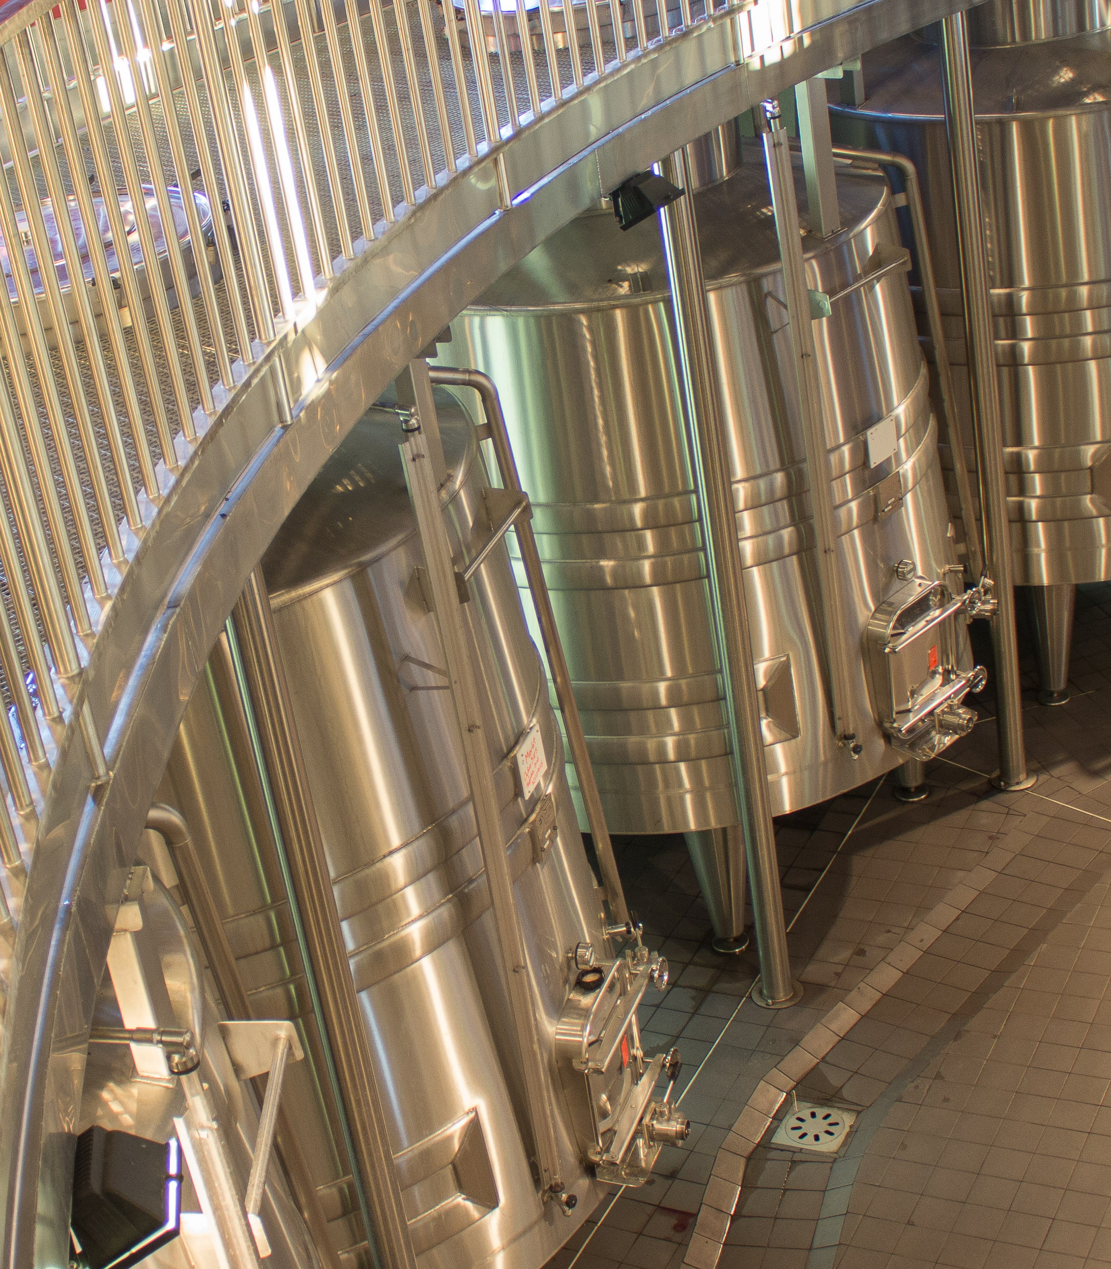
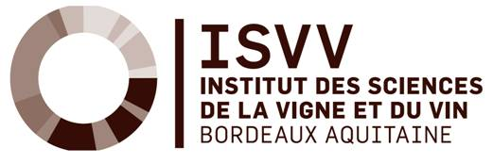

BORDEAUX WINEMAKING SPECIFICITIES

From February 7th to 9th 2018
Course conducted in English

BORDEAUX WINEMAKING SPECIFICITIES

February 7th to 9th 2018

Bordeaux wines are among the most famous of the world. This is not due to chance but to the implementation of adapted techniques which lead to the Bordeaux style. This course aims to help you update your knowledge regarding winemaking processes, used for Bordeaux red and white wines.
The course includes various wine tastings and a visit to a “Grand Cru”.

COURSE GOALS  Updating your knowledge on Bordeaux winemaking techniques  Adjusting your enological practices according to the wine characteristics  Illustrating the sensory impact of key practices  WHO IS IT FOR ?  Students, wine estate managers, consultants in enology and vineyard management, international wine consultants, wine company directors, enology lab directors, researchers, etc.  FEES  3 days, total length 21 hours, from 9 am to 5 pm  1,500€ TTC, including 3 lunches and tasting sessions. Accommodation remains at your charge.  Discount for trainees attending to Burgundy University : short course second part in Burgundy more information on the following link  REGISTRATION  For online registration please visit the following link | CONTENTS  Wednesday 1st:  9.00 am-12.00 pm  Dr. Isabelle Masneuf-Pomarède : Bordeaux white wines elaboration  12.00 pm-14.00 pm  Lunch with lecturers  2.00 pm-5.00 pm  Dr. Jean-Christophe Barbe : Wines from noble rot.  Thursday 2nd  9.00 am-12.00 pm  Dr. Hervé Romat : Bordeaux red wines elaboration  12.00 pm- 2.00 pm  Lunch with lecturers  2.00 pm- 5.00 pm  Dr. Marie-Laure Badet-Murat : Wine and wood.  5 .00 pm-10.00 pm Estate visit and dinner  Friday 3rd  9.00 am-12.00 pm  Dr. Marie-Laure Badet-Murat : Management of red wines ageing.  12.00 pm- 2.00 pm  Lunch with lecturers  2.00 pm- 5.00 pm  Dr. Hervé Romat : Red wines blending.

CONTACT

Jean-Christophe BARBE
Teaching manager
Tel : +33 (0)5 57 35 38 73
jean-christophe.barbe@agro-bordeaux.fr

REGISTRATION

Continuing Education Department
formco@agro-bordeaux.fr
+33 (0)5 57 35 86 28

MORE INFORMATION
For further information, please contact us.
Or see our website.

ACCOMMODATION
You will need to book and pay for your own accommodation.
We will provide you with a list of variously priced hotels.

Using its Education, Research and Technology transfer know-how to solve tomorrow’s agronomic, food and environmental needs.

BORDEAUX SCIENCES AGRO
As a public institution under the authority of the French Ministry of Agriculture, Bordeaux Sciences Agro collaborates with various institutions in France and abroad through a network of higher agronomic institutes, and has developed close partnerships with the university and scientific campuses in Bordeaux (the University of Bordeaux, IPB, INRA, CNRS, INSERM, IRSTEA, etc.). | For 50 years, Bordeaux Sciences Agro has been able to forge privileged relationships with wine companies. These ties supplement the courses taught in the school by helping increase the professionalism of the curriculum and by fostering the future professional careers of the graduates and guarantee that the courses are suitable for the real world.

MORE INFORMATION

Continuing Education Department
formco@agro-bordeaux.fr
+33 (0)557 358 628

www.agro-bordeaux.fr

BORDEAUX WINEMAKING SPECIFICITIES - REGISTRATION FORM 2018
For online registration please visit the following link

YOUR PERSONAL AND CONTACT DETAILS
First name (s)
Last name
Official name (as it appears on your passport/national identity card)
Title (eg Mr, Ms, Dr, Prof, etc) | Gender: Male Female
Position / Job Title | Company name
Nationality | Country of residence
Permanent home address (street address, town/city, county/state, postcode)

Email | Phone number (include full country and area code)

CURRENT EDUCATION AND TRAINING
please list any courses you have completed or in which you are currently enrolled in the table below
Course name – Institution - State/Country - Year finished

DO YOU REQUIRE ASSISTANCE BECAUSE OF A DISABILITY, IMPAIRMENT OR LONG TERM CONDITION FROM A TEACHER/CONSULTANT FOR STUDENTS WITH DISABILITIES? IF YES, PLEASE SPECIFY.

COST OF COURSE - Will course costs be covered by your employer? If so, please complete the table below.
Company name
Address
Phone number website Email

TERMS AND CONDITIONS
1. The number of participants is limited; enrollment will be processed on a first-come-first-served basis.
2. Registration will be validated after confirmation of your payment.
3. Information collected via this application form will be used for the purposes of general student administration.
All information will be held securely and disposed of securely when no longer needed.

