2-Day Rorschach (R-PAS®) WORKSHOP:
Treatment Planning &
Assessment of Personality Disorder

Joni L. Mihura, Ph.D. & Gregory J. Meyer, Ph.D.
May 31 & June 1, 2018
Utrecht, The Netherlands

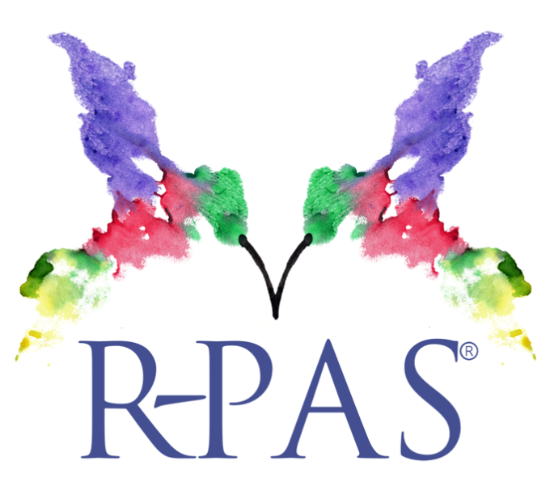

  - Thursday - May 31st _{9:30-17:00}

The Implications of Rorschach Derived Data for Treatment Planning

The workshop illuminates the relevance of scores coded from and processes observed during the Rorschach task for treatment planning. What people see, say, and do in the context of this novel, challenging visual-behavioral problem-solving task has direct implications for what they are likely to see, say, and do in daily life when confronted with similar challenges, ambiguities, and demands, including those encountered in psychological treatment. Identifying the unique contributions derived from the Rorschach task requires some appreciation of what this task can provide that other methods of assessment cannot or do not. As such, we situate Rorschach data in the context of multimethod assessment more generally, and characterize and differentiate it from alternatives in order to illustrate how distinct methods draw on distinct psychological processes, all of which have implications for case conceptualization and treatment planning. Building on this foundation, we review two cases with multimethod assessment data, leaving ample time for discussion with attendees.

  - Friday – June 1st _{9:30-17:00}

Rorschach Assessment of Personality Disorder

Current research and theory suggests the Rorschach is uniquely suited for assessing personality disorders, avoiding many of the problems that occur with self-report measures. This workshop presents an approach for using the Rorschach to describe and understand personality disorders, drawing largely upon both the 5th edition of the Diagnostic and Statistical Manual of Mental Disorders (DSM-5), though with reference to the 10th edition of the International Classification of Diseases (ICD-10). Topics include: 1) the categorical versus dimensional distinction for personality assessment, 2) the alternative DSM-5 Section III model of personality disorder, 3) research on the applicability of the Rorschach with various personality disorder syndromes, with an emphasis on new scales for assessing grandiose narcissism, 4) a review of functions related to other specific disorders (schizoid, schizotypal, paranoid, borderline, antisocial, avoidant, and dependent), and 5) variables that address the two fundamental dimensions of DSM-5 personality disorder – Self (identity and self-direction) and Interpersonal (empathy and intimacy).

Presenters

Gregory J. Meyer, Ph.D., is a Professor of Psychology at the University of Toledo. He is a Fellow of Division 5 (Evaluation, Measurement, & Statistics) of the American Psychological Association and of the Society for Personality Assessment and served as the Editor for the Journal of Personality Assessment from 2002 to 2013. His research focuses on psychological assessment, with an emphasis on the integration of assessment methods. Much of his work has addressed performance-based measures of psychological processes, most notably with the Rorschach and the development of the R-PAS (www.r-pas.org). With more than 80 peer-reviewed publications, he has made many contributions to the published literature in this area, as well as in psychometrics and assessment more generally, and received several Distinguished Contribution Awards for articles in the published literature. He regularly provides invited lectures and trainings internationally.

Joni L. Mihura, PhD, is Professor of Psychology at the University of Toledo, where she teaches personality assessment, advanced assessment, and psychodynamic/integrative psychotherapy. She is a Fellow and past board member of SPA, serves on the editorial boards of the Journal of Personality Assessment and Rorschachiana, and has published many articles and chapters on psychological assessment. She is a codeveloper of R-PAS and presents invited lectures and trainings internationally.

Practical Information

  - COSTS

€500 (€450 for members of the Dutch Flemish Society of the Rorschach and Projective Methods). Coffee/tea, lunch and documentation are included in this fee.

  - SUBSRIPTION & PAYMENT

Subscribe at www.rorschachvereniging.nl/agenda/rpas2018/ and remit the total amount on bankaccount IBAN NL59 INGB 0005 1271 54 (BIC-number: INGBNL2A) of the ‘NVVR’ in Vught, and mention ‘Rorschach (R-PAS) Workshop’ and your name and e-mail address.

  - ADDITIONAL INFORMATION

The workshop will be in English.
Accreditation for Dutch participants has been requested at the FGzPt.
Location: Boothstraat 7, Zaalverhuur7 (Kerkzaal),Utrecht Centrum (NL).
!!! Please note: Zaalverhuur7 has 2 locations in the Center of Utrecht. Your meeting is located at the Boothstraat !!!
For questions about the workshop: a.pieters58@chello.nl or hotels in Utrecht: denhollandersandra@gmail.com.

Workshop Schedule

  - Thursday - May 31st _{9:30-17:00}

The Implications of Rorschach Derived Data for Treatment Planning

The nature of the Rorschach task and the unique processes it engages.
The nature of alternative assessment methods and the processes they engage.
Cross-method interpretive principles and procedures focused on treatment planning.
Case 1: R-PAS in the context of a multimethod assessment.
Case 2: R-PAS in the context of a multimethod assessment.
Discussion and Questions.

Participants will
1) Understand the unique type of data that the Rorschach can obtain;
2) Learn how Rorschach data complement data from other methods of assessment;
3) Link the processes engaged by different methods to case conceptualization;
4) Understand how both cross-method convergent information and cross-method discrepant information
contribute meaningfully to treatment planning.

  - Friday – June 1st _{9:30-17:00}

Rorschach Assessment of Personality Disorder

Personality and the Official Personality Disorders.
Review of conceptually consistent and empirically validated Rorschach variables.
The Alternative Model for Personality Disorders (AMPD).
Review of variables consistent with AMPD features.
Practice coding of selected variables.
Review of scores applied to Wiggins’ (2003) Case of Madeline G.

Participants will
1) Understand the implications of the categorical-dimensional distinction for applied personality assessment;
2) Learn about current Rorschach research for personality disorders;
3) Understand how Rorschach variables can help describe the principal dimensions of personality disorders;
4) Learn how to apply and interpret Rorschach relevant PD scores to a case.

