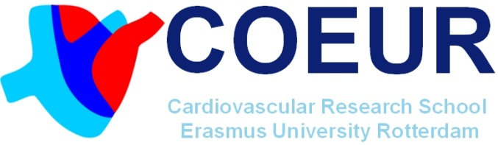

COEUR PhD Course
De patiënt centraal in onderzoek: verder kijken dan chirurgie, interventie of medicatie
Donderdag 16 Mei 2019, <locatie>

g
Course programme
09.00 - 09.30 | Registration, coffee/tea
09.30 - 09.40 | Opening and welcome  John de Heide, M ANP (Dept. of Cardiology)
09.40 - 10.10 | Joint decision making  Drs. Jonathan Etnel (Dept. of Cardiothoracic Surgery)
10.10 - 10.40 | Long term cohort studies  Dr. Annette Galema-Boers (Internal Medicine)
10.40 - 11.00 | Coffee/tea break
11.00 - 11.40 | Kwalititatief/kwantitief onderzoek en PCR  Dr. Marieke Groot (Department anesthesiology Radboud UMC)
11.40 - 12.20 | Working beyond age borders (transitions)  Dr. Margot Walter (Dept. of Rheumatology)
12.20 - 13.10 | Lunch break (Lunch included)
13.10 - 13.50 | Therapy adherence  Dr. Mirjam Tielen (Internal Medicine)
13.50 - 14.30 | Motivation, methods and measuring outcomes  Dr. Diane van der Biessen (Internal Medicine)
14.30 - 15.15 | Keynote Lecture: From patient centered to person centered research  Prof. Dr. Hanneke Takkenberg (Dept. of Cardiothoracic Surgery)
15.15 - 15.45 | Discussion and closure  John de Heide, M ANP (Dept. of Cardiology)
15.45 - … | Drinks, snacks and networking

Please register before 13 May via: coeur@erasmusmc.nl

