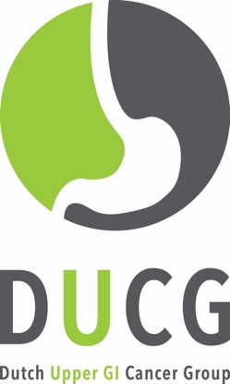
DUCG Congress 6 juli 2017
Supernova Jaarbeurs Utrecht

CLINICAL DILEMMA’S IN UPPER GI CANCER TREATMENT

8.30-09.00 Registration

09.00-09.10 Welcome

09.10-10.30 Epidemiological and Staging Dilemma’s

09.10-09.30 Patterns of care in upper GI cancer treatment in the Netherlands: are we improving?
09.30-09.50 MRI in staging and response assessment of esophageal cancer: future or reality?
09.50-10.10 Should PET and laparoscopy be performed in all gastric cancer patients?
10.10-10.30 Pathology of early esophageal cancer: a plea for a national expert panel?

10.30-11.00 Coffee Break

11.00-12.30 Perioperative Treatment Dilemma’s

11.00-11.20 Management of T2N0M0 oesophageal cancer: neoadjuvant treatment or primary surgery?
11.20-11.40 Neoadjuvant chemotherapy or chemoradiotherapy in GE junction tumours?
11.40-12.00 Does neoadjuvant treatment increase the risk of postoperative complications?
12.00-12.20 What are the indications for postoperative chemoradiotherapy in gastric cancer?

12.20-13.00 Key note Lecture
Krishna Moorthy & Venetia Wynter-Blyth (Imperial College, London)
Preoperative optimisation and patient engagement in peri-operative care

13.00-14.00 Lunch

14.00-15.00 Treatment Dilemma’s

14.00-14.20 Surgery or definitive chemoradiotherapy in elderly patients?
14.20-14.40 Can we do it without epirubicin in upper GI cancer treatment?
14.40-15.00 Metastasectomy in upper GI cancer: does it make any sense?

15.00-15.30 Tea Break

15.30-17.00 Quality and Research

15.30-15.50 What are adequate outcome parameters in upper GI cancer care?
15.50-16.10 DUCA and POCOP results 2016
16.10-17.00 New (DUCG) study proposals

