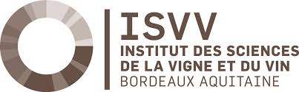
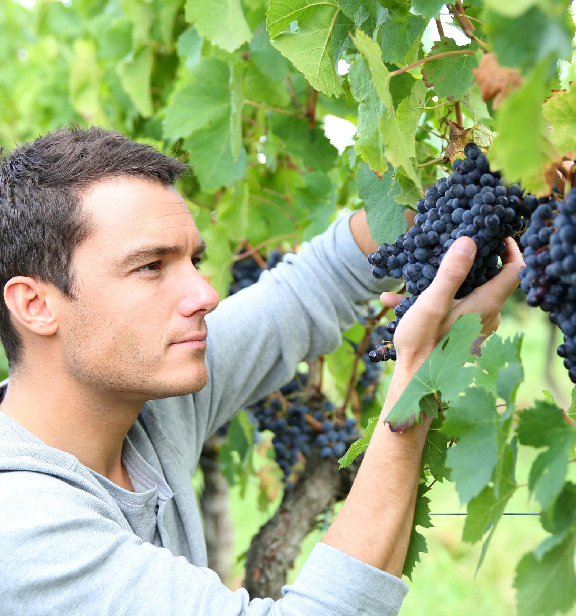
TERROIR & VINEYARD
MANAGEMENT
March 5th to 9th 2018 in Bordeaux Sciences Agro
An exclusive 5-day modular course !
New : optional extension of the terroir course in Burgundy : March 12th to 16th 2018

TERROIR & VINEYARD MANAGEMENT
March 5th to 9th 2018

The terroir in viticulture is not a mystic concept; it can be explained within the framework of agronomic interactions between the vine and its environment. This training course is designed for international professionals dealing with the concept of terroir and the way to manage the vineyard in order to optimize terroir expression.

CONTENTS
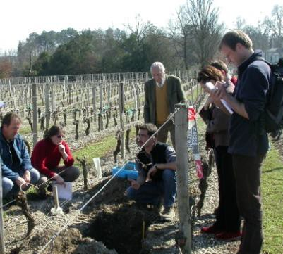 | - The concept of terroir in viticulture: definition and main factors involved  - Viticultural soils  - Viticultural climates  - Vine water status  - The role of nitrogen in terroir expression  - Choice of plant material  - Management practices to enhance terroir expression  - Scale issues  - The effect of soil and climate on terroir expression through different tasting sessions  - Soil pit studies  - Optimization of terroir expression via oenological practices
Our team of professors and professionals
is 100% dedicated to making your
training course a great learning experience.
WHO IS IT FOR ?
Students, wine estate managers, consultants in oenology and vineyard management, international wine consultants, wine company directors, oenology lab directors, researchers, etc.

FEES
2 000 € , including 3 lunches, field trips and tasting sessions.
Reduced rates for students and job seekers.
Accommodations not included.
Discount for trainees attending to Burgundy University :
short course second part in Burgundy more information on the following link
Kees VAN LEEUWEN,
Professor in Viticulture
vanleeuwen@agro-bordeaux.fr
Jean-Philippe ROBY,
Professor in Viticulture
jean-philippe.roby@agro-
bordeaux.fr

Registration Continuing Education Department formco@agro-bordeaux.fr
Tel : +33 (0)557 358 628

+ INFORMATIONS

ACCOMMODATION

You will need to reserve and pay for your own accommodation. We will provide you with a list of variously priced hotels

MORE INFORMATION
Ask for our detailed program and registration.
See our website.
Please contact us : formco@agro-bordeaux.fr

DETAILED PROGRAM  MONDAY  9:00-12:00  The concept of terroir in viticulture. Role of human factors  Kees Van Leeuwen, Bordeaux Sciences Agro  13:30-16:30  The effects of climate in terroir expression. Agroclimatic indices. Temperature and phenology. Climatic variability in the Bordeaux area  Benjamin Bois, University of Burgundy  16:30-18:00  Tasting session: sensory attributes in relation to soil type (example of Saint-Emilion)  Kees Van Leeuwen, Bordeaux Sciences Agro  TUESDAY  9:00 - 12:00  Water relations and terroir expression.  Tools for vine water status assessment  Kees Van Leeuwen, Bordeaux Sciences Agro  14:00 - 16:30  Optimization of terroir expression through the choice of plant material (variety and root- stock)  Jean-Philippe Roby, Bordeaux Sciences Agro  16:30 - 18:00  Tasting session: sensory attributes in relation to soil type (example of Medoc)  Jean-Philippe Roby, Bordeaux Sciences Agro  WEDNESDAY  09:00 - 12:00  Optimizing terroir expression through vineyard management practices  Jean-Philippe Roby, Bordeaux Sciences Agro  14:00 – 16:00  The role of nitrogen in terroir expression.  Tools to assess vine nitrogen uptake  Kees Van Leeuwen, Bordeaux Sciences Agro  16:00 - 17:30  Tasting session : sensory attributes in relation to climate and vintage  Jean-Christophe Barbe, Bordeaux Sciences Agro | 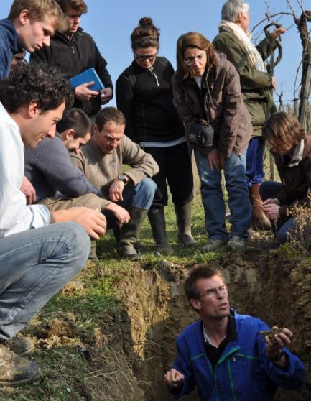  THURSDAY  9:00 - 12:00  Major soil types in Bordeaux  David Pernet, SOVIVINS  14:00 - 18:00  Field trip: study of soil pits, optimization of terroir expression through the implementation of appropriate management practices and the choice of plant material.  David Pernet, SOVIVINS  Kees Van Leeuwen, Bordeaux Sciences Agro  FRIDAY  09:00 - 10:30  Grape ripening dynamics in relation with terroir expression  Gregory Gambetta, Bordeaux Sciences Agro  10:30 – 12:00 New technologies in terroir studies  Gregory Gambetta, Bordeaux Sciences Agro  14:00 - 17:30  Visit of a Grand Cru Classé. Theme : optimisation of terroir expression through  oenological practices. Marketing of the terroir concept.  Isabelle Masneuf-Pomarède, Bordeaux Sciences Agro

REGISTRATION FORM 2018
For online registration please visit the following link

YOUR PERSONAL AND CONTACT DETAILS
First name (s)
Last name
Official name (as it appears on your passport/national identity card)
Title (eg Mr, Ms, Dr, Prof, etc) | Gender: Male Female
Position / Job Title | Company name
Nationality | Country of residence
Permanent home address (street address, town/city, county/state, postcode)
Email | Phone number (include full country and area code)

CURRENT EDUCATION AND TRAINING - Please list any courses you have completed or in which you are currently enrolled in the table below
Course name – Institution - State/Country - Year finished

Do you require assistance because of a disability, impairment or long term condition from a teacher/consultant for students with disabilities ? If yes, please specify :

COST OF COURSE - Will course costs be covered by your employer? If so, please complete the table below.
Company name
Address
Phone number website Email
CONTACT  formco@agro-bordeaux.fr  Tél :  +33 (0)557 358 628 | TERMS AND CONDITI ONS  - The number of participants is limited; enrollment will be processed on a first-come-first- served basis.  - 2. Registration will be validated after confirmation of your payment.  - Information collected via this application form will be used for the purposes of general student administration. All information will be held securely and disposed of securely when no longer needed.

