WELCOME TO BERGEN

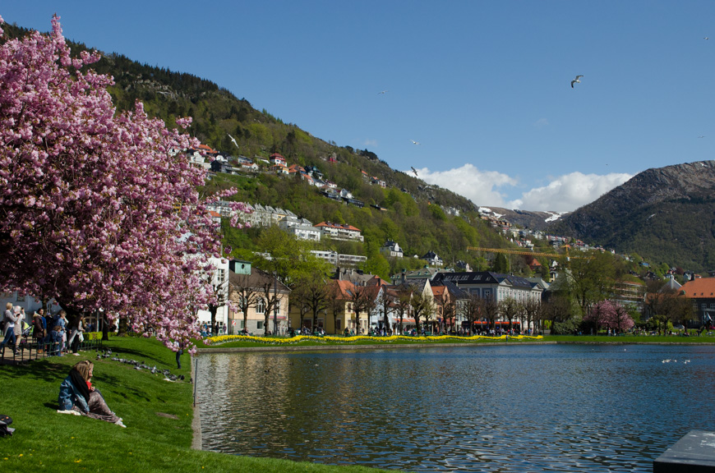

Frontiers in research:

The acute critical ill very old patients.

Research conference: Bergen 5-6 (Tuesday-Wednesday) June 2018

If you are interested in research in the critically ill elderly hospital patients, then this is the conference for you!

We will highlight present and future research in this group using a combination of state of the art presentations, with interactive discussion between course participants and faculty.

Important (partially) unanswered research question
- Which octogenarians should be offered intensive care?
- Prognostic factors important for predicting survival?
- Long-term outcomes
- Burden to caregivers in survivors after critical illness?
- Survival to what? Quality of life in octogenarian survivors.
- Cost of intensive care in octogenarians.
- Epidemiology and future development of intensive care in octogenarians
- End-of-life care as an integrated part of critical care in the very old.
- The role of a geriatrician in the care of critical ill elderly patient
- How to retrieve information about patient and family wishes
- Specific ICU treatments applied in the very old, recommendations
- End of life issues during intensive care of the very old
- ICU discharge criteria and post ICU location
- Geriatric tools to facilitate triage and alternatives to ICU admission

The VIP European network
We need to create strong networks between ICUs and countries in Europe to retrieve better epidemiological data, but also to initiate clinical studies in this population. The European Society of Intensive Care Medicine (ESICM) has in 2016 decided to give support to a research group working with such questions. This group has recently published the results from the so far largest prospective multicentre study in this field, with 5132 patients recruited from 311 ICUs in 21 European countries.

Agenda for the meeting
Six of the research questions outlined above will be discussed using a common format. The six most important will be chosen using a Delphi process within the network and participants (will be decided within April 1.)

- A short introduction and overview of what is known today (30 min)
- A framework for discussion (10 min)
- Small group discussions (60 minutes)
- Plenary discussion and conclusions (30 minutes). Total 2 h 10 minutes

The research question will be delivered by an international expert/researcher in the field

Day 1: (starting 12.00)
Research question 1
Research question 2

Day 2: (08-16.00)
Research question 3
Research question 4
Lunch
Research question 5
Research question 6

Format and conference size
1.5 day conference starting lunchtime Day 1, ending in the afternoon Day 2.
Venue: Bergen, Norway, at the Hospital Campus

Interested in joining the conference?
The conference itself is free of charge but we need a confirmation of your attendance. There will be a lunch on day 2. Travel and accommodation must be covered by the participants.

Hotels in Bergen are in different categories, please visit: https://www.booking.com/city/no/bergen.en-gb.html?

How to get here: Bergen have daily direct flights to several European hubs: Copenhagen, Amsterdam and London.

We have limited number of places, so please register by sending an e-mail to:
hans.flaatten@uib.no, mark your e-mail: Conference Bergen June 2018.
State your name, address and e-mail (if other than what you send from).

Confirmed Faculty (Jan. 2018)
Professor Bertrand Guidet, Sorbonne Universitets, Paris France
Ass. Professor Dylan DeLange, University medical Centre, University Utrecht, The Netherlands
Professor Rui Moreno. Hospital de São José, Centro Hospitalar de Lisboa Central, Faculdade de Ciência Médicas de Lisboa, Nova Médical School, Lisbon, Portugal
Alessandro Morandi, Department of Rehabilitation Hospital Ancelle di Cremona, Cremona, Italy. 5 Geriatric Research Group, Brescia, Italy.
Professor Christian Jung, Department of Cardiology, Pulmonology and Angiology, University Hospital, Düsseldorf, Germany
Senior lecturer Andrew Clegg University of Leeds, UK
Professor Timothy Walsh, Royal Infirmary of Edinburgh, UK
RN Johannes Mellinghoff, St Georges University Hospitals, London UK

Flaatten H et al: The impact of frailty on ICU and 30-day mortality and level of care in very elderly patients (≥80 years). Intensive Care Medicine 2017: DOI 10.1007/s00134-4940-8

