17.00 |  | GENERAL WELCOME AND PROGRAM OVERVIEW  Information program, sessions & speakers
 | 17.05 | Opening speech  Zehra Sayin, CEO Special Olympics Belgium
 | 17.10 | Building a Healthier Tomorrow – Inclusive Healthcare for Individuals with intellectual disabilities  Annemarie Hill, Vice President, Global Health Operations, Special Olympics International
17.15 |  | PRIME TOPIC
 | 17.15 | FROM INTERNATIONAL TO NATIONAL PERSPECTIVE. MEDICAL ASPECTS AND CARE FOR PEOPLE WITH INTELLECTUAL DISABILITIES  PhD-student Marian Breuer, Dr. Esther Bakker-van Gijssel, Dr Annie Nouwen
 | 17.45 | INTERACTIVE PANEL DISCUSSION 'How can we adapt medical care for patients with intellectual disabilities in such a way that it enables us to work together towards more inclusive healthcare?'
18.15 |  | BREAKOUT SESSIONS PART I
 |  | Please, pick one session to attend in real time. If you are interested in other topics of this part, you will be able to view them after the event (only available for participants who registered for the event).
Breakout session I.a:
MAKE IT SIMPLE BUT SIGNIFICANT – USING CORE VOCABULARY WORDS IN COMMUNICATION WITH PEOPLE WITH AN INTELLECTUAL DISABILITY
Dr. Karolin Schäfer

Breakout session I.b:
PRACTICAL GUIDANCE TO A HEALTHY LIFESTYLE FOR SPECIAL OLYMPICS ATHLETES; A CASE STUDY WITH SPECIALIZED DIETICIANS (or should we call them nutritionists?)
Romy van Hoevelaken, Diane Buekers
Breakout session I.c:
THE CHALLENGES AND OPPORTUNITIES FOR GENERAL PRACTITIONERS IN CARING FOR ELDER WITH AN INTELLECTUAL DISABILITY.
Dr. Birgitte Schoenmakers

18.45 |  | BREAKOUT SESSIONS PART II
 |  | Please, pick one session to attend in real time. If you are interested in other topics of this part, you will be able to view them after the event (only available for participants who registered for the event).
Breakout session II.a:
CONTINUITY OF CARE: TRANSITION FROM CHILD TO ADULT HEALTH SERVICES
Dr. AMW (Tonnie) Coppus
Breakout session II.b:
THE MENTAL HEALTH NEEDS AND WELLBEING FOR INDIVIDUALS WITH INTELLECTUAL DISABILITY (ID)
Dr Khaled Kadry
19.20 |  | WRAP UP
 | 19.20 | Closing speech  Ragna Schapendonk, CEO Special Olympics Netherlands
 | 19.25 | Goodbye

This event cannot promote inclusion of people with intellectual disabilities without hearing their voices. Special Olympics athletes will be intervening in every part of this program enabling us to understand their perspective on health and medical care.

Detailed information about the sessions:

From international to national perspective; medical aspects and care for people with intellectual disabilities
Because of the differences in many aspects of the lives of people with intellectual disabilities compared to the general population, the organization of care should be tailored to their specific needs.
The speakers will give you both an international and a national perspective on how medical care for people with intellectual disabilities is organized. Ongoing research will be highlighted, and information about medical and organizational approaches will be provided.
During the Q&A, speakers and participants will try and find answers to the question: 'How can we adapt medical care for patients with intellectual disabilities in such a way that it enables us to work together towards more inclusive healthcare?

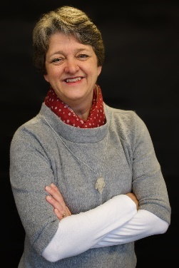
Esther Bakker-van Gijssel, MD (ID-physician), PhD is a science practitioner in the Department of Primary and Community care - Intellectual disabilities and health of the Radboud university medical center, and in the Academic Collaborative “Stronger on your own feet” in Nijmegen. In the Radboud university medical center she is appointed as principal clinician, who takes a leading role in innovative and integrative healthcare for people with intellectual disabilities. She is also medical director at Siza, a service care provider for people with disabilities in the beautiful surroundings of Arnhem, the Netherlands. Esther is currently chair of IASSIDD’s Health Issues Special Interest Research (SIRG) Group. Special Olympics International is represented by Ashlyn Smith on the Board of the Health SIRG.

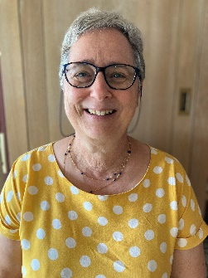
Annie Nouwen is a recently retired general qualified doctor, specialised in healthcare for youth and elderly, and healthcare for people with disabilities. She worked as a general practitioner, as a schooldoctor also in special needs schools, as a general practitioner in an institution with 400 people with mental disabilities. Many of them participated in the Special Olympics and doctor Annie volunteered as Red Cross doctor at the Special Olympics in 2017. From 2005 until 2021 she worked for the VAPH (Flemish Agency for People with Handicaps) and provided care, special devices and COVID-19 tests for people with disabilities.
As a parent and as a professional she has experience with dealing with people with disabilities. She always aimed to give everyone specific investigations, according to the nature or cause of the disability., and the proper healthcare. So, one can participate safe and sound on sports.

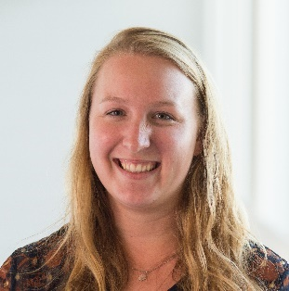
Marian Breuer is a PhD Candidate at Radboudumc and focuses on optimizing the medical care for people with intellectual and developmental disabilities (IDD). During her study period in health sciences, she worked at a day care center for people with IDD where her affinity with this group of people arose. Through her research, Marian aims to facilitate international learning by creating an inventory of the organization of medical care for people with IDD around the world.

Make it simple but significant – using core vocabulary words in communication with people with an intellectual disability
The most frequently used words in a language are called core vocabulary (e.g. not, you, me, I, have, can, do.) Each language has its own core vocabulary words, and yet these overlap in different languages. Core vocabulary words are used regardless of the situation - at home, at work, in leisure, in sports.... They appear everywhere.
Talking to other people in “simple” language does not mean simplifying sentences - it is the content that matters.
The presentation gives an overview of research findings on the use of core vocabulary among people with an intellectual disability and formulates suggestions for everyday conversations.
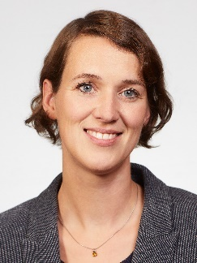
Karolin Schäfer is a speech and language therapist specialising in education of people who are deaf or hard of hearing and Augmentative and Alternative Communication. After studying rehabilitation sciences, she first worked in several clinical and speech therapy practices in Germany with children and adults with hearing loss or complex disabilities. Since 2017, she has been a junior professor at the University of Cologne, Germany. Her work and research focuses on communication and speech development in people with disabilities.

A look inside the practical guidance to a healthy lifestyle for our Special Olympics Athletes; a case study with specialized dieticians
After a short introduction of the Special Olympics Healthy Athletes program, we will discuss a case study in which a client with mild intellectual disability who is given the advice from his General Practitioner to lose weight and changes his eating habits, in order to prevent or to limit health issues.
We give an inside view on how we and his other care givers support this Athlete to achieve his (or her) goals, with all the possibilities and bottlenecks we come across.

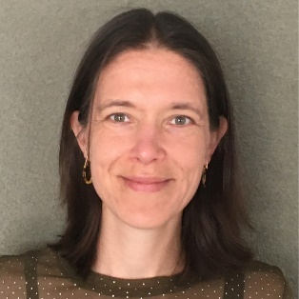
Romy van Hoevelaken is a dietician specialized in nutritional care in people with intellectual disability at all level and ages. Since 2009 she works for “Reinaerde”, a support and care facility in Utrecht, the Netherlands. She is part of a special team ‘Food and Weight’ that provides diagnosis and treatment for clients with eating disorders and/or obesity.
Romy is member of the Dutch Dietetic Association and the Dieticians Association Intellectual Disability. She commits to give more attention to the importance of nutritional care for this group of clients. Since 2019 she is Clinical Director Health Promotion for the Healthy Athletes program of Special Olympics Netherlands.
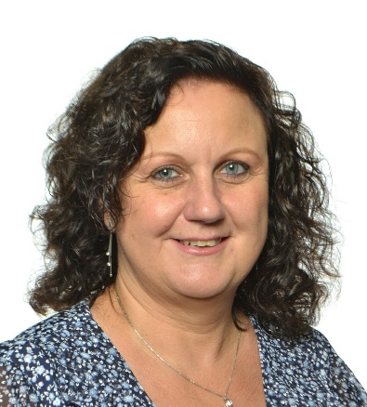

Diane Buekers is a dietitian specialised in nutrition care for people with multiple disabilities.
Due to her years of experience with this group of clients, she has her own practice and works together with multiple disciplines and services to provide her expertise in creating the best (adjusted) nutritional care for them.
Diane is member of the Flamisch Dietetic Association and founder and chairman of the Belgian Dietitians Association of Intellectual Disability Care. She also is member of the Dutch department for more than 20 years. Since 2016 she is Clinical Director Health Promotion for the Healthy Athletes program of Special Olympics Belgium.

The challenges and opportunities for general practitioners in caring for elder with an intellectual disability.
Almost every general practitioner (GP) cares for elder adults with intellectual disabilities (ID). This group represents 1-3% of the general population. During the training as a general practitioner, only limited attention is paid to the particular care needs of these patients. Consequently, the contact during consultations often runs difficult and care provision is not optimal. By means of this lecture, we want to make the GP more familiar with elder patients with ID and provide the GP with tools to facilitate the consultation and the follow up of these patients.

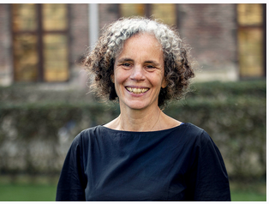
Prof Dr. Birgitte Schoenmakers is trained as a general practitioner and currently Head of the Academic Teaching Practice Leuven where she also performs clinical work. She is professor at the KU Leuven, Department of Public Health and Primary Care, and responsible for the curriculum and assessment in the Advanced Master in Family Medicine, Flanders. She coordinates the Continuous Medical Education program in Family Medicine. In research, she is specialized in home and elderly care in general and dementia care in particular, in diversity in care, in patient engagement, in practice management and in medical education.

Continuity of care: Transition from child to adult health services
In many countries the physical and mental health needs of children and young people with intellectual disabilities are met through mainstream primary care and paediatric services. Once an adult, care provision becomes more disparate and is often managed in a range of specialties. Continuity of care can be disrupted during this period.
Current services are often ill prepared to respond to the complex mental and physical health needs of young people with ID at the point of transition from pediatric to adult health care.
In this presentation we will highlights issues, concerns, and needs of young people with intellectual disabilities and their carers at the point of transition from paediatric to adult health care.

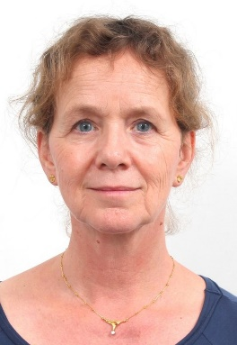
Dr. AMW (Tonnie) Coppus (MD, PhD) is a medical doctor specialized in intellectual disability medicine and an epidemiologist. Down syndrome care in the Netherlands is preferably concentrated in multidisciplinary Down teams for children. Therefore Dr. Coppus initiated a specialized multi-disciplinary outpatient department for persons with Down syndrome, aged 18 years and older. People with Down syndrome from the whole country are visiting this clinic. Coppus is one of the members of the national guideline committee for health care in children with Down syndrome and head of the guideline committee for adults with Down syndrome.
Her research at the Erasmus University Rotterdam and the Radboud University Nijmegen focuses on dementia and ageing in people with intellectual disabilities.

The Mental Health Needs and Wellbeing for Individuals with intellectual disability (ID)

The talk aims to highlight a framework for assessment and evaluation of mental health needs and emotional well-being for individuals with ID. We will explore common comorbidities and associated conditions in addition to a multidisciplinary interagency approach to the management of these presentation.

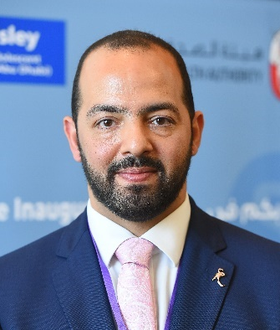
Dr Khaled Kadry is a consultant child and adolescent psychiatrist and Clinical Director for the Maudsley Health service in Abu Dhabi. Dr Kadry’s main clinical focus is children and young adults with neurodevelopmental conditions e.g. Autism Spectrum Conditions, Attention Deficit Hyperactivity Disorder and Learning Difficulties.

Dr Kadry has been involved with SOI since 2018. He led the first Strong Minds pilot program during the Abu Dhabi 2019 Special Olympics World Summer Games. Over the past 3 years, Dr Kadry has provided teaching and training for clinical directors, athletes, coaches and carers in the Strong Minds program and continues his work as a consultant to SOI to advance the development of the program.

