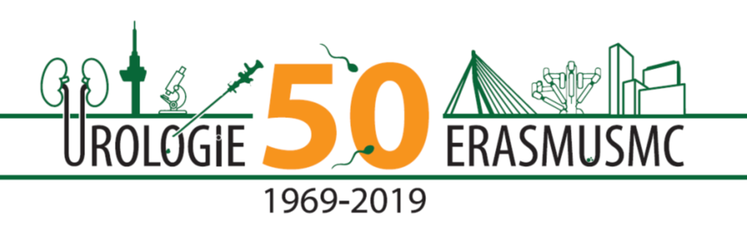
Op woensdag 2 oktober organiseren wij ter gelegenheid van het 50 jarig bestaan van onze afdeling het visiting professor evenement voor urologen in opleiding, urologen en preklinische wetenschappers. Wij hebben voor de gelegenheid 50 jaar urologie in het Erasmus MC niet één maar vier prominente Europese urologen uitgenodigd om met ons te discussiëren over hoe we de volgende 50 jaar in moeten gaan. Wij vinden het prachtig als u deel neemt aan die discussie: waar moet het heen? Waar kan het heen? En hoe moeten we daarmee starten? Het programma bestaat uit een ‘sandwich’ ontwerp: casuïstiek besprekingen en onderzoek besprekingen in de middag en na het diner de externe refereeravond met 4 voordrachten.

Hartelijke groeten, namens Gert Dohle en Chris Bangma

Visiting Professors

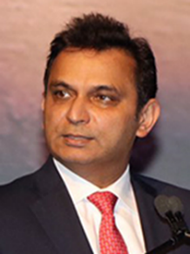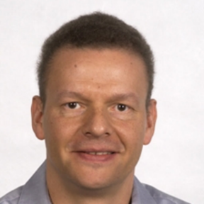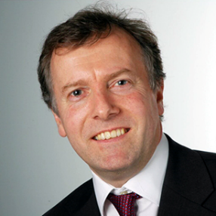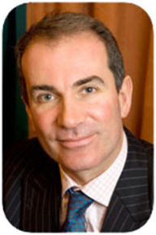
- Prokar Dasgupta is Professor and Chair of Urology at King's College London, Guy's Hospital, King's Health Partners. He was appointed as Consultant Urologist to Guy's Hospital in 2002 where he pioneered robotic urological surgery within the UK. He became the first Professor of Robotic Surgery and Urological Innovation at King's College London in 2009 and subsequently the Chairman of the King’s-Vattikuti Institute of Robotic Surgery. In 2010 and 2018 he was named one of the top ten prostate cancer surgeons in the United Kingdom by the Daily Mail.[4] His main basic research interest is in the immunology of prostate cancer. He has also contributed to educational excellence by leading surgical simulation within the UK and internationally. He is the current editor-in-chief of the BJU International (BJUI).
- Jürgen Pannek is Professor of Urology, Ruhr-Universität Bern since 2011, and since 2007 Head of the Department of Neuro-Urology, Swiss Paraplegic Centre, Nottwil, Switzerland. His main research interests are neuro-urology, functional bladder disorders, prevention of urinary tract infections, neuromodulation, female urology and reconstructive surgery. He was for several years chair of the EAU Guidelines committee on Neuro-Urology and is at present vice-chair of this committee.
- David J Ralph is Professor at the University College London Hospitals. His main interests are erectile dysfunction, penile reconstruction, Peyronie’s Disease, penile cancer and male infertility. He runs an erectile dysfunction service and is Director of the Erectile Dysfunction Clinical Trials Unit. He is the biggest implanter of penile prostheses in the UK with two clinical fellowship programmes to teach on this. An accomplished microsurgeon, Mr David Ralph established and teaches on the Royal College of Surgeons Microsurgery for Andrologists course. In clinical practice his microsurgery skills are of particular benefit to men requiring surgery for fertility problems or vasectomy reversal. He is Past-President of the Andrology Section of the British Association of Urological Surgeons.
- Tim O'Brien has been a Consultant Surgeon at Guy's and St Thomas' in London since 1999. His specialist areas of practice include complex kidney cancer surgery, retroperitoneal fibrosis, bladder cancer and testis cancer. He is a member of the EAU scientific congress office, and as such he contributed to the awareness within EAU for Rare Diseases; from 2010-2014 was chairman of the BAUS section of oncology and in 2009 was awarded the golden cystoscope by BAUS for his outstanding contributions to urology. He is the incoming president of BAUS 2019.

Programma:
14.00-16.00: carrousel casuïstiek bespreking met visiting professor en wetenschappelijk onderzoek bespreking, samen met AIOS en arts-onderzoekers urologie. AIOS en arts-onderzoekers uit het hele land zijn welkom om mee te doen. Onderwerpen zijn oncologie, functionele urologie en andrologie.
15.00 - 15.30: Koffie/thee pauze.
15.30 - 16.30: Deel 2 casuïstiek - wetenschappelijk onderzoek
17.30 - 19.00: Diner
19.00 – 21.30: Externe refereeravond
19.00 - 19.30: Prof Jürgen Pannek: the future of neuromodulation for urinary tract disorders
19.30 - 20.00: Prof Tim O’Brien: Professional networks in a changing health care system: care for rare diseases
20.00 - 20.30: Prof David Ralph: The future of andrology
20.30 - 21.00: Prof Prokar Dasgupta: New technologies in oncologic urology for the
next decade

21.00 - 21.30: Discussion. The future of Urology
21.30: Borrel

Er zijn geen kosten voor deelneming aan dit evenement verbonden voor deelnemers.
Bij de Nederlandse Vereniging voor Urologie is accreditatie aangevraagd.
Vergeet niet uw BIG-registratienummer in te vullen bij inschrijving.

