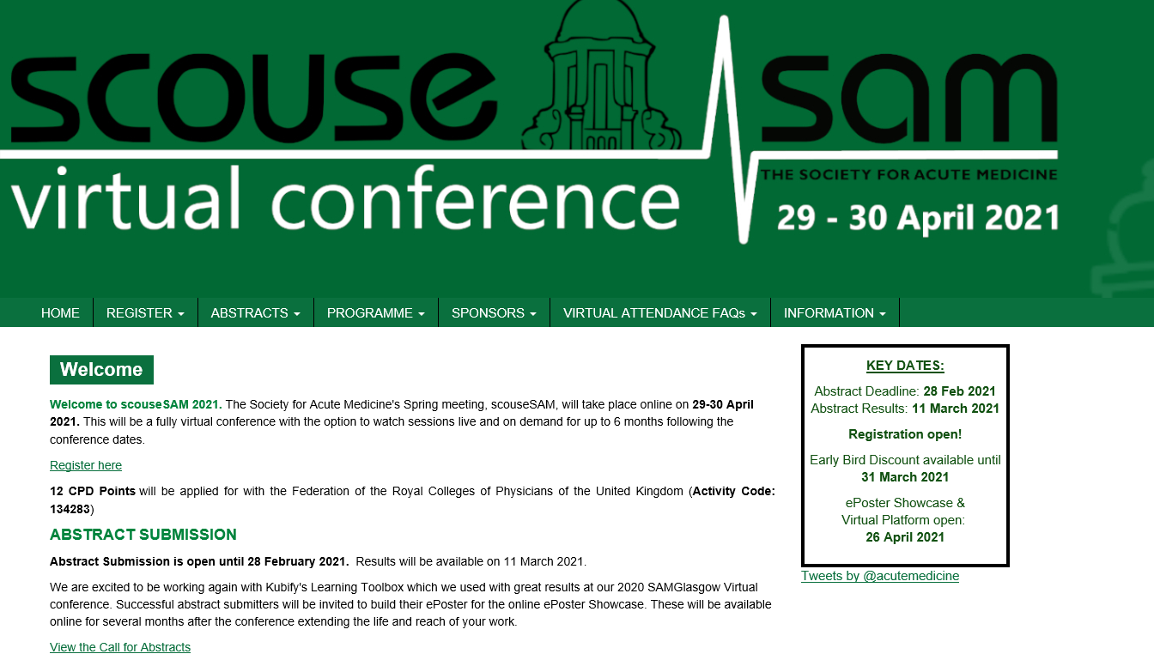

09:10 (Thursday 29 April 2021)
09:10 - 09:30
Get online!
09:30 (Thursday 29 April 2021)
09:30 - 11:00
Stream 1/Session 1: Opening Plenary: SAM = 'We Can Work It Out’
Stream 1
Chair: Sue Crossland
Engagement Lead: Vicky Price
0930-0940: Welcome to ScouseSAM: The Society for Acute Medicine 2021 Spring Meeting
0940-1000: Collaborative Working
Simon Bowers, Liverpool
1000-1020: Platelets – How Low Can You Go?
Tina Dutt, Liverpool
1020-1040: Update in Infectious Diseases
Stacy Todd, Liverpool
1040-1100: Panel Discussion
11:00 (Thursday 29 April 2021)
11:00 - 11:30
Break, ePosters & eExhibition Viewing
11:30 (Thursday 29 April 2021)
11:30 - 13:00
Stream 1/ Session 2: ‘The Air that I Breathe’ - Respiratory for Acute Physicians
Stream 1
Chair: Nick Scriven
Engagement Lead: Shamim Nassrally
1130-1155: Have You Got a Light Doc? Treating Tobacco Dependence in an Acute Hospital Setting
Gareth Jones, Liverpool
1155-1220: The Relevance of Updated Asthma Guidelines for Acute Physicians
Hassan Burhan, Liverpool
1220-1245: It’s Not Always COVID, Even in Winter 2020
Lisa Davies, Liverpool
1245-1300: Panel Discussion
11:30 - 13:00
Stream 2/ Session 2: 'One Fine Day' - Enhanced and Ambulatory Care/ FAMUS
Stream 2
Chair: Al Gilmore
Engagement Lead: Tash Kelly
1130-1155: Enhanced Care - What’s the Role in Smaller Units?
Sanjay Krishnamoorthy, London
1155-1220: FAMUS for Dinosaurs
Nick Smallwood, Surrey
1220-1245: Acute Hospital at home – What is the Role for Acute Medicine?
Dan Lasserson, Warwick
1245-1300: Panel Discussion
13:00 (Thursday 29 April 2021)
13:00 - 14:00
Break, ePosters & eExhibition Viewing
14:15 (Thursday 29 April 2021)
14:15 - 15:45
Stream 1/ Session 3: ‘Anyone Who Had a heart’ - Cardiology for the Acute Physician
Stream 1
Chair: Tim Cooksley
Engagement Lead: Elaine Clark
1415-1440: Management of Atrial Fibrillation, Easy as ABC
Gregory Lip, Liverpool
1440-1505: Chest Pain in the Cancer Patient
Rebecca Dobson, Liverpool
1505-1530: Heart Failure for the Acute Physician
Clare Hammond, Liverpool
1530-1545: Panel Discussion
14:15 - 15:45
Stream 2/ Session 3: 'You'll Never Walk Alone' - The Vulnerable Patient on the AMU
Stream 2
Chair: Patricia Cunningham
Engagement Lead: Michael Trimble
1415-1440: Learning Disability, Jennifer Shankland
1440-1505: Hope for Justice, Alister Bull
1505-1530: Speaker TBC
1530-1545: Panel Discussion
15:45 (Thursday 29 April 2021)
15:45 - 16:05
Break, ePosters & eExhibition Viewing
16:05 (Thursday 29 April 2021)
16:05 - 17:30
Stream 1/ Session 4: 'When I’m 64' - Caring for The Older Person on the AMU
Stream 1
Chair: Mike Wheble
Engagement Lead: Damien Dooey
1605-1630: Silver Trauma
Dan Thomas, Liverpool
1630-1655: The Role of Community Geriatrics in the NHS Long Term Plan and the Ageing Well Agenda
Cindy Chu
1655-1720: Update on Acute Stroke Management
Debbie Lowe
1720-1730: Panel Discussion
16:05 - 17:30
Stream 2/ Session 4: ‘With a little help from my Friends’ - Pick and Mix on the AMU
Stream 2
Chair: Dan Beckett
Engagement Lead: TBC
1605-1630: Rheumatology for the Acute Physician
Constanta Amoasii
1630-1655: Does this Patient have Intracranial Hypertension?
Anita Krishnan, Liverpool
1655-1720: Dermatology for Acute Medics
Stuart Cohen, Liverpool
1720-1730: Panel Discussion
17:45 (Thursday 29 April 2021)
17:45 - 18:30
'Ticket to Ride' SAM EGM
Zoom meeting
08:00 (Friday 30 April 2021)
08:00 - 08:50
Early 1: ‘Free as a bird’ - Do you have Capacity?
Stream 1
Chair: Vicky Price
Catherine Gribbin, Liverpool
Cecil Kullu
Katherine Fisher
08:00 - 08:50
Early 2: 'Paperback Writer' - The ACP Curriculum
Stream 2
Chair: Sheryl Henry & Elaine Clark
Speaker: Ollie Phipps
09:00 (Friday 30 April 2021)
09:00 - 09:15
Get online!
09:15 (Friday 30 April 2021)
09:15 - 10:50
Stream 1/ Session 5: ‘I Feel Fine' - Infection & Public Health: The Bigger Picture
Stream 1
Chair: Chris Hodcroft
Engagement Lead: Jan Basey
0915-0940: Why We Never Learn: Improving Health and Care Systems After COVID-19
Sally Sheard, Liverpool
0940-1005: Title TBC
Angie Hyder-Wright, Liverpool
1005-1030: Speaker TBC
1030-1050: Panel Discussion
09:15 - 10:50
Stream 2/ Session 5: 'A Hard Day’s Night' - COVID-19: Still Causing Destruction
Stream 2
Chair: Nick Scriven
Engagement Lead: Vicky Price
0915-0940: A Personal View
Richard Hay, Liverpool
0940-1005: A Palliative View
Andrew Khodabukus
1005-1030: A Journalist’s View
Shelagh Fogarty, London
1030-1050: Panel Discussion
10:50 (Friday 30 April 2021)
10:50 - 11:20
Break, ePosters & eExhibition Viewing
11:20 (Friday 30 April 2021)
11:20 - 12:45
Stream 1/ Session 6: 'Do you Want to Know a Secret?' - Pitfalls of Acute Medicine
Stream 1
Chair: Nick Scriven
Engagement Lead: Michael Wheble
1120-1145: A Morning on AMU
Vicky Price, Liverpool
1145-1210: Learning From a Case
Peter Ng, Liverpool
1210-1235: Getting it Right After Getting it Wrong
Sir Terence Stephenson, London
1235-1245: Panel Discussion
11:20 - 12:45
Stream 2/ Session 6: ‘Come Together’ - Trainees in AIM
Stream 2
Chair: Shamim Nassrally
Engagement Lead: Damian Dooey
1120-1145: Title TBC
Nik Sharma, Liverpool
1145-1210: It’s Not a Weakness To Be Kind
Katrina Sheikh, London
1210-1235: Title TBC
Lara Alloway, Hampshire
1235-1245: Panel Discussion
12:45 (Friday 30 April 2021)
12:45 - 14:00
Break, ePosters & eExhibition Viewing
14:00 (Friday 30 April 2021)
14:00 - 15:45
Stream 1/ Session 7: Closing Plenary: 'All you Need is Love'
Stream 1
Chair: Sue Crossland
Engagement Lead: Tim Cooksley
1400-1430: Rick Body, Manchester
1430-1500: Cheng-Hock Toh, RCP
1500-1515: Panel Discussion
1515-1545: Closing Remarks, Sue Crossland

