Welcome to e-Day - HEMODYNAMIC MONITORING!
DATE
01/06/2021
Presentations will be available for current and newly registered participants until May 31, 2022.
ORGANIZATION
Chairman
Jean-Louis Vincent
Co-Chairman
Fabio S. Taccone
Manager
Véronique De Vlaeminck
Staff
Colette Dutillieu
Estelle Flament
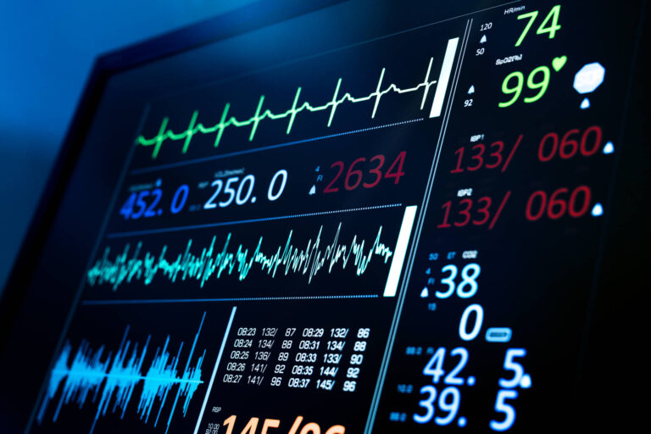
Description
In this one-day virtual symposium, leading experts in the field will cover all aspects of hemodynamic monitoring in critically ill patients, including basic physiological concepts; interpretation of specific variables such as cardiac output, blood lactate and venous oxygenation; optimal monitoring in conditions such as ARDS and sepsis; and use of monitoring to guide therapeutic interventions, such as fluid administration, vasopressor therapy and ECMO.
Learning objectives
At the conclusion of this activity, the participant will be better able to:
- understand the rationale for monitoring the different hemodynamic variables in critically ill patients
- select the best monitoring method(s) in specific patient groups or for particular goals and discuss their advantages and limitations
- appreciate how to integrate multiple variables to optimally monitor a patient’s hemodynamic status
- interpret and apply the data obtained to ensure appropriate management of individual patients

