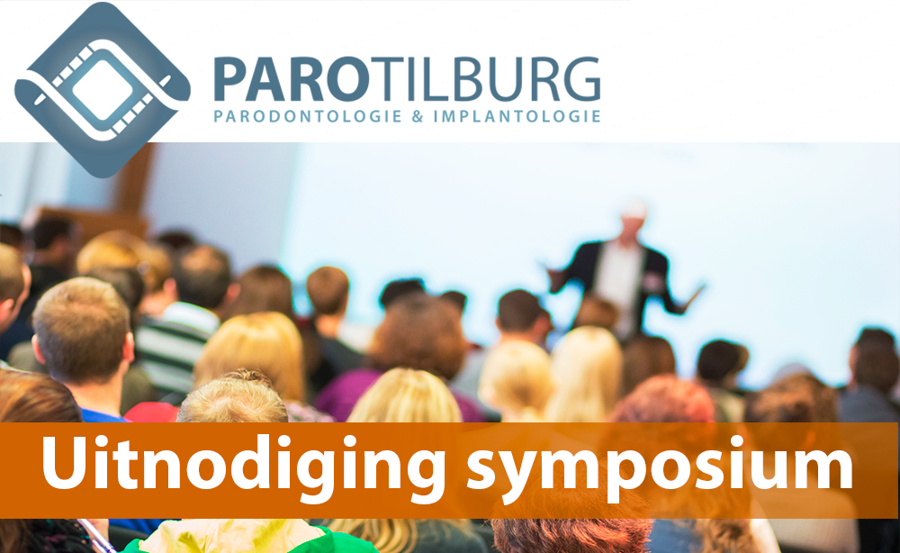

|  |  |  |  |  |  |  |  |  |  |  |  |  |  |  |  |  |  |  |  |  |  |  |  |  |  |  |  |  |  |  |  |  |  |  |  |  |  |  |  |  |  |  |  |
| --- | --- | --- | --- | --- | --- | --- | --- | --- | --- | --- | --- | --- | --- | --- | --- | --- | --- | --- | --- | --- | --- | --- | --- | --- | --- | --- | --- | --- | --- | --- | --- | --- | --- | --- | --- | --- | --- | --- | --- | --- | --- | --- | --- |
| |  |  |  |  |  |  |  |  |  |  |  |  |  |  |  |  |  |  |  |  |  |  |  |  |  |  |  |  |  |  |  |  |  |  |  |  |  |  |  |  |  |  |  | | --- | --- | --- | --- | --- | --- | --- | --- | --- | --- | --- | --- | --- | --- | --- | --- | --- | --- | --- | --- | --- | --- | --- | --- | --- | --- | --- | --- | --- | --- | --- | --- | --- | --- | --- | --- | --- | --- | --- | --- | --- | --- | --- | | |  |  |  | | --- | --- | --- | | |  |  | | --- | --- | | |  | | --- | | **Symposium donderdag 1 november**  Begin november is het weer zover, de Praktijk voor Parodontologie en Implantologie Tilburg organiseert opnieuw een symposium. Hierbij nodigt de praktijk alle tandartsen en mondhygiënisten van uw praktijk uit om dit unieke programma bij te wonen op donderdag 1 november.  **Programma:**  **18.00 – 19.00        Ontvangst met broodjes en soep.**  **19.00 – 19.15        Introductie. (Hans Keestra)**  **19.15 – 20.00        Endodontologie. (Richard Hakse)**  **20.00 – 20.30        Pauze met een drankje en snacks.**  **20.30 – 21.00        Orthodontie. (Eveline Feberwee)**  **21.00 – 21.30        Endo-paro problemen. (Richard Koop)**  **21.30 – 22.30        Afsluitende borrel.** | | |  |  |  |  | | --- | --- | --- | | |  | | --- | | **Symposium: Endodontologie, Orthodontie en Parodontologie**  Op 1 november willen wij jullie kennis laten maken met de disciplines die nauw met elkaar zijn verbonden; endodontologie, orthodontie en parodontologie. Richard Hakse, Eveline Feberwee en de nieuwe Parodontoloog Richard Koop zullen voor u de lezingen verzorgen. | | https://gallery.mailchimp.com/ae62f6b95c4a2b2adc6b94cec/images/80f0e543-6228-42b7-95b6-2e1ba16833b3.png | |  |  |  |  |  |  | | --- | --- | --- | --- | --- | | |  |  |  |  | | --- | --- | --- | --- | | |  | | --- | | https://gallery.mailchimp.com/ae62f6b95c4a2b2adc6b94cec/images/26ad4b00-56f1-4d31-a9c1-97b3f7fead52.jpg | | |  | | --- | | https://gallery.mailchimp.com/ae62f6b95c4a2b2adc6b94cec/images/17789d02-36bf-4df6-b5d8-2fae4f3167d2.jpg | | |  |  |  |  | | --- | --- | --- | | |  |  | | --- | --- | | |  | | --- | | Voor deze lezing zijn KRT en KRM punten aangevraagd.  In verband met de planning zien wij uw aanmelding graag **voor 22 oktober**tegemoet. Wilt u het symposium bijwonen klikt u dan op aanmelden symposium. | | |  |  |  |  | | --- | --- | --- | | |  |  | | --- | --- | | |  | | --- | | **[https://gallery.mailchimp.com/ae62f6b95c4a2b2adc6b94cec/images/1c2ee4c5-03f6-4d7f-9eb0-8d2da0d437b2.jpg](https://parotilburg.nl/aanmelden-symposium/)** | | |  |  |  |  | | --- | --- | --- | | |  |  | | --- | --- | | |  | | --- | | De lezing vindt plaats in het **van der Valk Hotel Tilburg**. Het van der Valk Hotel is gelegen aan de **Dr. Bloemenlaan 8, 5022 KW te Tilburg**. De locatie is per auto, fiets en OV eenvoudig te bereiken. Er is voldoende parkeergelegenheid aanwezig. Zie routebeschrijving. | | |  |  |  |  |  | | --- | --- | --- | --- | | |  |  |  | | --- | --- | --- | | |  | | --- | | https://gallery.mailchimp.com/ae62f6b95c4a2b2adc6b94cec/images/8a47b335-1b34-4afd-8529-cd9005fc6c5a.jpg |  |  | | --- | |  | | |  |  |  | | --- | --- | | |  | | --- | | https://gallery.mailchimp.com/ae62f6b95c4a2b2adc6b94cec/images/d9ede2c1-7d0b-4c14-85aa-c47e79314856.jpg | |  |  |  |  |  |  | | --- | --- | --- | --- | --- | | |  |  |  |  | | --- | --- | --- | --- | |  | |  |  | | --- | --- | | |  | | --- | | Dit symposium wordt mede mogelijk gemaakt door onze sponsoren: Dentaid   |   EMS   |   Oral B   |  Hu-Friedy    E-medis   |   GSK   I   Karssen Financieel | | | |  |  |  | | --- | --- | | |  | | --- | | https://gallery.mailchimp.com/ae62f6b95c4a2b2adc6b94cec/images/af15fe80-3b84-4ef0-be14-73b7ebc7aaf7.jpg | |  |  |  |  |  | | --- | --- | --- | --- | | |  |  |  | | --- | --- | --- | | |  | | --- | | https://gallery.mailchimp.com/ae62f6b95c4a2b2adc6b94cec/images/9cb0d3fd-1fc1-4b09-a955-0fefe390559f.jpg |  |  | | --- | |  | | |  |  |  |  | | --- | --- | --- | | |  |  | | --- | --- | | |  | | --- | | **AUTO** **Vanuit richting Breda en Eindhoven/Den Bosch via A58:** Afrit 10 Hilvarenbeek, bij eerste verkeerslicht links (kempenbaan) en bij eerstvolgende verkeerslicht weer links (dokter Bloemenlaan). **Vanuit Waalwijk via N261-Burgemeester Bechtweg:** Afslag ring Tilburg A65 / A58 naar Breda nemen. Afrit 10 Hilvarenbeek, bij eerste verkeerslicht rechtdoor (dokter Bloemenlaan).  **OPENBAAR VERVOER** Vanaf NS-station Tilburg CS naar bushalte “ETZ Elisabeth Busstation, via streekbuslijn 2. Ongeveer nog 15 min. lopen naar dokter Bloemenlaan. Zie ook [**www.9292.nl**](http://www.9292.nl/) | | |  |  |  | | --- | --- | | |  | | --- | | https://gallery.mailchimp.com/ae62f6b95c4a2b2adc6b94cec/images/215d628a-9ed4-4b3c-80f9-82047f02de0c.jpg | | | |

|  |  |  |  |  |  |  |
| --- | --- | --- | --- | --- | --- | --- |
| |  |  |  |  |  |  | | --- | --- | --- | --- | --- | --- | | |  |  | | --- | --- | | |  | | --- | |  | |  |  |  |  | | --- | --- | --- | | |  |  | | --- | --- | | |  | | --- | | *Praktijk voor Parodontologie en Implantologie Tilburg Professor Gimbèrelaan 130 5037 EN Tilburg 013-4637329*  **Ons e-mail adres is:** [congres@parotilburg.nl](mailto:congres@parotilburg.nl)  Want to change how you receive these emails? You can [update your preferences](https://parotilburg.us14.list-manage.com/profile?u=ae62f6b95c4a2b2adc6b94cec&id=4be900ebd1&e=%5bUNIQID%5d) or [unsubscribe from this list](https://parotilburg.us14.list-manage.com/unsubscribe?u=ae62f6b95c4a2b2adc6b94cec&id=4be900ebd1&e=%5bUNIQID%5d&c=fea2120abf) | | | | |