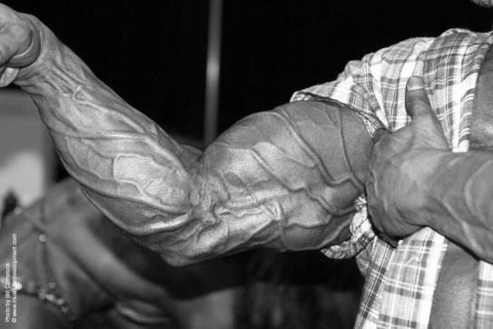Afbeeldingsresultaat voor braun sharing expertise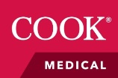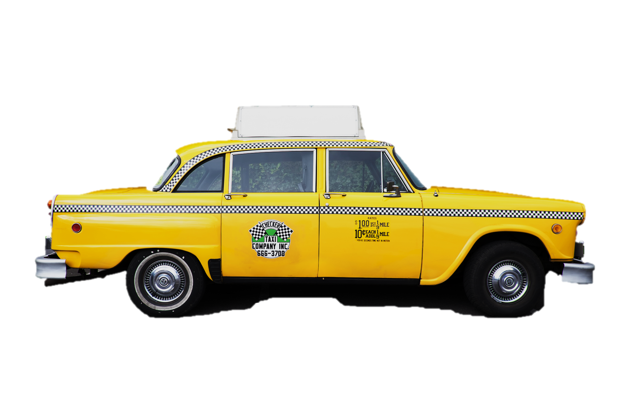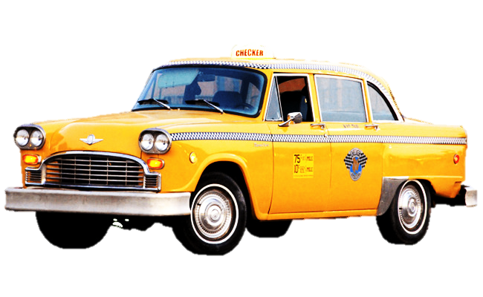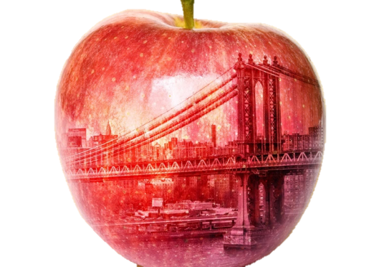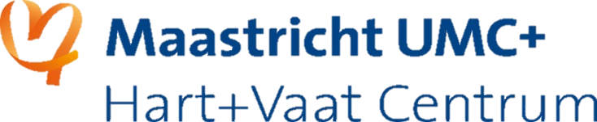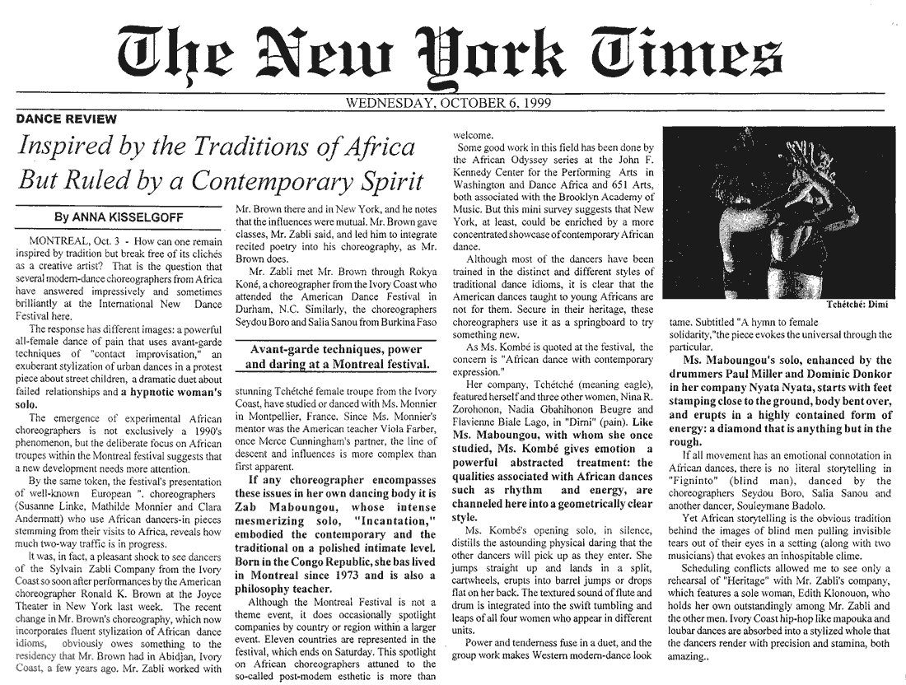

***DECEMBER 19, 2018***

**18:00 - 18:30 Welcome**

**18:30 - 20:00 Highlights from   
Veith Symposium 2018  
presented by our own Faculty :**Prof. M. van Sambeek, Prof. M. Jacobs,   
Prof. C. Wittens, Prof. GW. Schurink,   
Dr. H. Jalaie Dr. B. Mees,

**20:00 - 21:00 New York Ribeye**

**21:00 Drinks**

***TO HARRY’S!*** *Lage Barakken 10  
6221 CJ Maastricht*[*043 325 4433*](https://www.google.com/search?q=beaumont+maastricht&client=firefox-b-ab&source=lnms&sa=X&ved=0ahUKEwjy5cufotvdAhXBxIUKHdt_BHYQ_AUICSgA&biw=1680&bih=979&dpr=1)

**VASCULAR ROUND  
 2018**

**Accreditatie: NVvH 2 punten  
Organisatie: afdeling vaatchirurgie**

**DECEMBER 19, 2018**