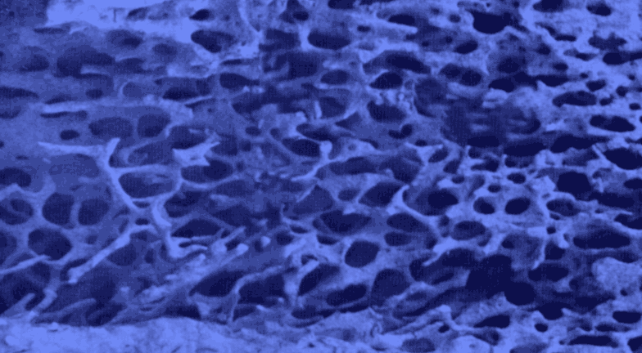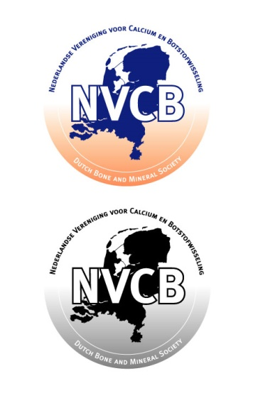

**28th Annual Meeting of the**

**Dutch Society for**

**Calcium and Bone Metabolism**

Zeist, the Netherlands

November 15-16 November 2018



***SPONSORS***

**xx**

**xx**

**xx**

**yy**

**yy**

**yy**

**Program and Abstracts**

28th Annual Meeting of the Dutch Society for Calcium and Bone Metabolism

### ……

##### Woudschoten Conference Centre

Woudenbergseweg 54, Zeist

The Netherlands

🕿 + 31 343 492492 - Fax +31 343 492444 – www.woudschoten.nl

#### *Organisation*

#### Dutch Society for Calcium and Bone Metabolism

Natasha Appelman-Dijkstra, President

Astrid Bakker, Secretary

Nathalie Bravenboer, Treasurer

Secretary: Astrid Bakker

Dept Oral Cell Biology

ACTA – VU University Amsterdam

Gustav Mahlerlaan 3004 – 1081 LA Amsterdam - The Netherlands

 +31 20 5980224 – www.nvcb.nl

e-mail: a.bakker@acta.nl

###### Donderdag, November 15, 2018

|  |  |  |
| --- | --- | --- |
| **9.00-10.00** | ***Registration and coffee*** |  |
| **10.00-10.10** | ***Opening by chair: Natasha Appelman-Dijkstra*** |  |

**SESSION I: Selected abstracts**

Chair:

|  |  |  |
| --- | --- | --- |
| 10:10-11:10 | 4 short orals on Osteoporosis: clinical and translational  2 short orals on marrow adiposity |  |
| 11:10-11:30 | ***Break*** |  |
| 11.30-12.15 | **Key-note lecture:**  To be decided: proposed topic basic talk Marrow Adipose Tissue and Bone  **Dr. Annegreet Veldhuis Vlug AUMC Amsterdam** |  |
| **12.15-13.30** | ***Lunch*** |  |
|  | **SESSION II:**  Chair |  |
| 13:30-15:00 | oral presentation Thesis award winner tba  7 Short orals on osteogenic differentiation and tissue engineering |  |
| **15.00-15:30** | ***Coffee/tea break*** |  |
| 15:30-16:10 | 4 Short orals on osteoclastogenenis |  |
| 16:10-17:00 | **Key-note lecture:**  Fybrodysplasia preclinical research  **Prof Mara Riminucci**  **Sapienza University, Italy** |  |
| **17.15-18:15** | ***General Assembly NVCB*** |  |
|  |  |  |
| **18:15-19:00** | ***Drinks*** In de hal aan statafels bij de sponsoren |  |
|  |  |  |
| **19:00** | ***Diner*** |  |
|  |  |  |

**Friday, November 16, 2018**

|  |  |  |
| --- | --- | --- |
| **07.30-09.00** | ***Breakfast*** |  |
|  |  |  |
| **08.00-09.00** | ***Registration*** |  |

**SESSION III: Osteoporosis**

Chair:

|  |  |  |
| --- | --- | --- |
| 9:00-9:40 | 4 Orals on genetics of bone diseases |  |
| 9:40-10:00 | **Panel Discussion: Osteoporosis screening, diagnosis and treatment strategies**  Coen, Sandrine, Joop, Willem, Huisarts?(Petra of Thomas iom Coen), |  |
| 10:00-10:50 | **Key-note lecture:**  Diabetes and Bone  **Prof. Bruno Lapaauw, MD, PhD**  University of Ghent, Belgium |  |
| **10.50-11.20** | ***Coffee/tea break*** |  |
| 11.20-12.30 | 7 Orals on rare metabolic bone diseases |  |
| **12.30-13.30** | ***Lunch*** |  |

**SESSION V**

Chair:

|  |  |  |
| --- | --- | --- |
| 13.30-14.00 | 3 Orals on mechanobiology |  |
|  |  |  |
| 14:00-14.50 | **Key-note lecture:**  Update on Clinical research in Bone  **Prof Willem Lems, AUMC Amsterdam Dept Rheumatology**  VUMC, Amsterdam the Netherlands |  |
|  |  |  |
| 14.50-15.10 | ASBMR Fracture Initaitive  **Sanderine Bours, Dept Rheumatology, MUMC Maastricht** |  |
| **15:10-15.30** | ***Awards*** |  |
|  |  |  |
| **15:30** | ***Adjournment*** |  |
|  |  |  |