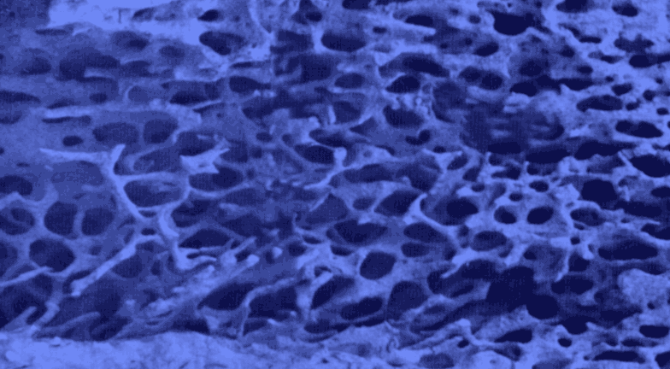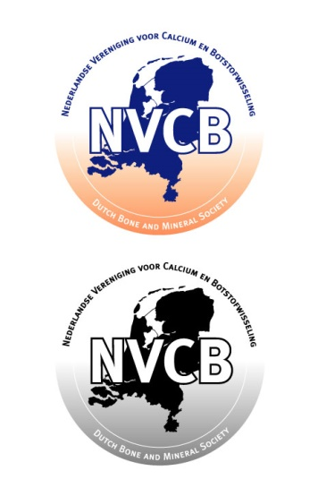

**27th Annual Meeting of the**

**Dutch Society for**

**Calcium and Bone Metabolism**

Zeist, the Netherlands

November 8-9, 2017



***SPONSORS***

**xx**

**xx**

**xx**

**yy**

**yy**

**yy**

**Program and Abstracts**

27th Annual Meeting of the Dutch Society for Calcium and Bone Metabolism

### November 8-9, 2017

##### Woudschoten Conference Centre

Woudenbergseweg 54, Zeist

The Netherlands

🕿 + 31 343 492492 - Fax +31 343 492444 – www.woudschoten.nl

#### *Organisation*

#### Dutch Society for Bone and Calcium Metabolism

Carola Zillikens, President

Astrid Bakker, Secretary

Nathalie Bravenboer, Treasurer

Secretariat: Dept Oral Cell Biology

ACTA – VU University Amsterdam

Gustav Mahlerlaan 3004 – 1081 LA Amsterdam - The Netherlands

 +31 20 5980224 – www.nvcb.nl

e-mail: a.bakker@acta.nl

###### Sponsors

The Dutch Society for Calcium and Bone Metabolism is grateful for the generous support of the following companies:

###### Corporate sponsors

**Silver sponsors**

PROGRAM

**Wednesday, November 8, 2017**

|  |  |  |
| --- | --- | --- |
| **9.00-10.00** | ***Registration and coffee*** |  |
| **10.00-10.10** | ***Opening by chair: Carola Zillikens*** |  |

**SESSION I: selected abstracts**

Chair:

|  |  |  |
| --- | --- | --- |
|  |  |  |
| 10.10-10.20 | Scientific abstract | *p. 14* |
|  |  |  |
| 10.20-10.30 | Scientific abstract | *p. 14* |
|  |  |  |
| 10.30-10.40 | Scientific abstract | *p. 15* |
|  |  |  |
| 10.40-10.50 | Scientific abstract | *p. 15* |
|  |  |  |
| 10.50-11.00 | Scientific abstract | *p. 16* |
|  |  |  |
| 11.00-11.10 | Scientific abstract | *p. 16* |
|  |  |  |
| 11.10-11.20 | Scientific abstract | *p. 17* |
|  |  |  |
| 11.20-11.30 | Scientific abstract | *p. 17* |
|  |  |  |
| 11.30-12.15 | **Key-note lecture:**  Bone biology update  **Bram van der Eerden**  EUR Rotterdam |  |
|  |  |  |
| 1**2.15-13.30** | ***Lunch***  **SESSION II: Rare bone diseases I**  Chair: |  |
| **13.30-14.20** | **Key-note lecture:**  Osteogenesis Imperfecta  **Anton Franken**  Isala Klinieken Zwolle |  |
| 14.10-15.30 | 4 Case reports | *p. 18* |
|  |  |  |
| **15.30-16.00** | ***Coffee/tea break*** |  |
|  |  |  |
| 16.00-16.50 | **Key-note lecture:**  Hypophosphatasia  **TBA** | *p. 20* |
|  |  |  |
| 16.50-17.30 | Scientific abstracts | *p. 20* |
|  |  |  |
|  |  |  |
| **17.30-18.15** | ***Drinks*** |  |
|  |  |  |
| **18.15-20.00** | ***Dinner*** |  |
|  |  |  |
| **20.00-21.00** | ***Business meeting*** |  |
|  |  |  |
|  |  |  |
|  |  |  |
|  |  |  |
|  |  |  |
|  |  |  |
|  |  |  |
|  |  |  |
|  |  |  |
|  |  |  |
|  |  |  |
|  |  |  |
|  |  |  |

**Thursday, November 9, 2017**

|  |  |  |
| --- | --- | --- |
| **07.30-09.00** | ***Breakfast*** |  |
|  |  |  |
| **08.00-09.00** | ***Registration*** |  |

**SESSION III: Rare diseases II**

Chair:

|  |  |  |
| --- | --- | --- |
| **09.00-09.50** | **Key-note lecture:**  Hypoparathyroism  **Carola Zillikens** **(NL)**  EUR Rotterdam |  |
|  |  |  |
| 09.50-10.30 | 4 Case reports |  |
|  |  |  |
| **10.30-11.00** | ***Coffee/tea break*** |  |

|  |  |  |
| --- | --- | --- |
| 11.00-11.50 | **Key-note lecture:**  Hypophosphatemic Rickets  **Aline Martin (USA)**  Northwestern University Clinical and Translational Sciences Institute (NUCATS), Chicago, USA | *p. 23* |
|  |  |  |
| 11.50-12.00 | Research abstracts | *p. 24* |
|  |  |  |
| 12.00-12.10 |  | *p. 25* |
|  |  |  |
| 12.10-12.20 |  | *p. 25* |
|  |  |  |
| 12.20-12.30 |  | *p. 26* |
|  |  |  |
| **12.30-13.30** | ***Lunch*** |  |

**SESSION IV: selected abstracts**

Chair:

|  |  |  |
| --- | --- | --- |
|  |  |  |
| 13.30-13.40 | Scientific abstracts | *p. 26* |
|  |  |  |
| 13.40-13.50 |  | *p. 27* |
|  |  |  |
| 13.50-14.00 |  | *p. 27* |
|  |  |  |
| 14.00-14.10 |  | *p. 28* |
|  |  |  |
| 14.10-14.20 |  | *p. 28* |
|  |  |  |
| 14.20-14.30 |  | *p. 29* |
|  |  |  |
| 14.30-14.40 |  | *p. 29* |
|  |  |  |
| 14.40-15.50 |  |  |
|  |  |  |
| **14.50-15.10**  **15.10-15.25** | ***Coffee/tea break***  ***Awards*** |  |
|  |  |  |
| **15.25-15.30** | ***Adjournment*** |  |
|  |  |  |
|  |  |  |
|  |  |  |