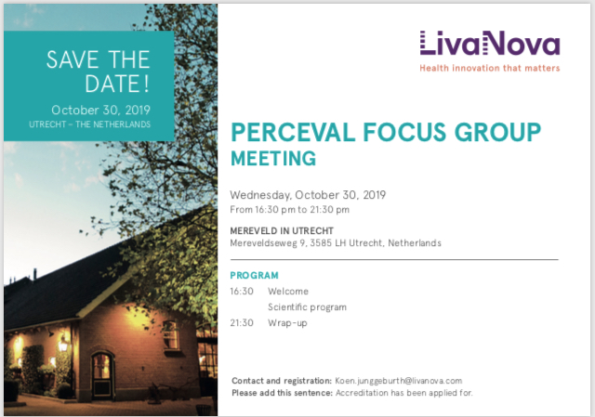

**Program Perceval Focus Group Meeting, October 30st, Mereveld in Utrecht**

Chairman: prof. dr. M.A. Mariani

* Recent literature overview (Sara Gaggianesi) (20 min)
* *Preliminary results Persist trial (Roberto Lorusso). (30 min, presentatie 20- discussie 10)*
* 12 years Perceval in University Hospital Leuven: lessons learned and difficult cases (Bart Meuris) *(30 min, presentatie 20- discussie 10)*
* Het aanbod “vandaag” voor de patiënt met Aorta klep stenose. (Prof. Dubois, University hospital Leuven. (20 min.)

coffee break

* Implantation technique and sizing: tips&tricks to avoid failure in the learning curve (Kayan Lam) *(30 min, presentatie 20- discussie 10)*
* MICS in AVR: where we are and where we go (Wilson Li?) *(30 min, presentatie 20- discussie 10)*
* Evolution of a MICS program (from mini-sternotomy to RAT) (Vikash Hindori) *(30 min, presentatie 20- discussie 10)*
* Perceval PLUS (Marketing) *(20 min)*
* GENEREAL DISCUSSION AND CLOSING REMARKS