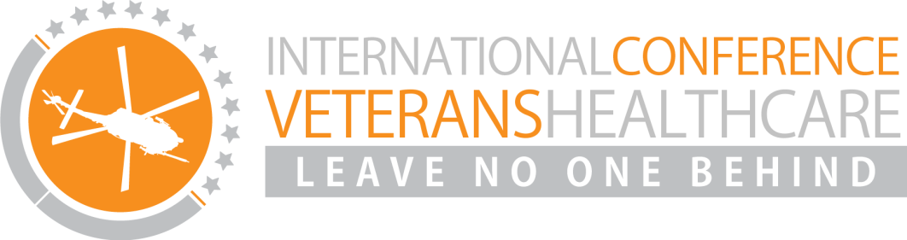 

**Date: 4, 5, 6 April 2018**

**Location: Marine Etablissement Amsterdam: Kattenburgerstraat 7, 1018 JA Amsterdam**

**Program**

**Day 1 - Wednesday April 4: The Dutch approach and international perspectives on families and the veterans support system**

The morning of the first day of the conference will be about the Dutch approach to the national health care system for veterans and about international perspectives on that approach. Keynote speakers and veteran ambassadors will inspire and inform you about the objectives and themes that shape veterans health care systems. In the afternoon families and partners will take the stage and share their experiences. Renowned international keynote speakers will share their views on the veterans support system, offering opportunities to strengthen our systems of care, cure and policy making. At the end of the day there will be a buffet in the Scheepsvaartmuseum and an outstanding performance of an ex-marine singing opera.



**Day 2 - Thursday April 5: International approaches**

On the second day of the conference international experts will reflect on the Dutch approach and share their own outstanding practices and expertise. Multiple Dutch military missions and the deployment and vital experiences in the lives of Dutch veterans will be discussed. In the afternoon international representatives will discuss their national strategies in the field of veteran mental healthcare, ranging from research, policy and practice. The most effective strategies will be identified by the public.



**Day 3 - Friday April 6: Innovations**

On the third day of the conference it is all about innovations. What is new in veterans mental health and PTSD? Where can we see breakthroughs? Is it in technology or in the introduction of service dogs, what are novel approaches in psychotherapy or for instance in big data? A ‘carrousel of pitches’ will provide an easy access to capturing the latest novel research themes, interesting new tools and instruments as well as new topics that are currently being investigated.

