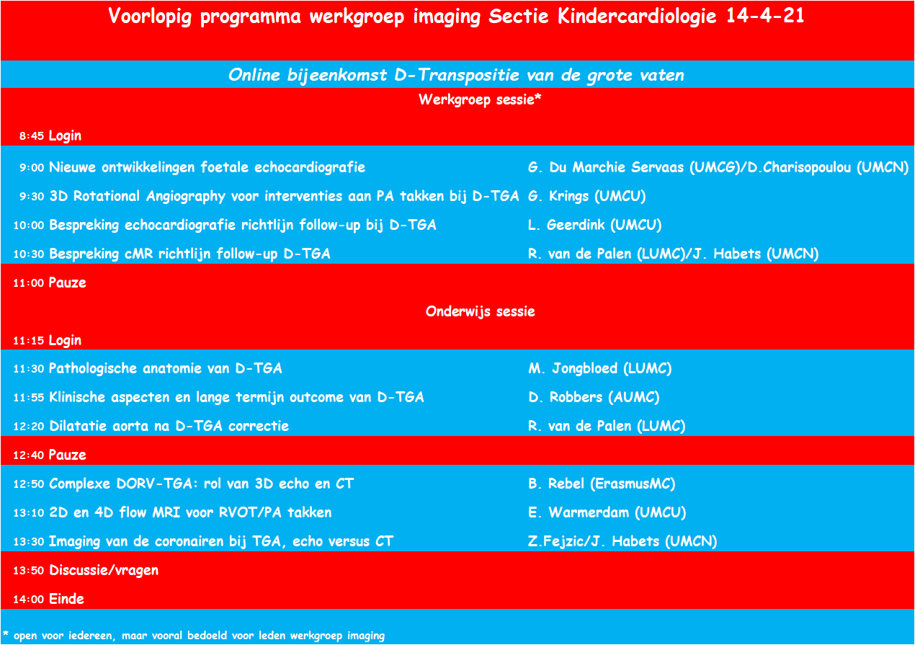

|  |  |
| --- | --- |
|  | Met vriendelijke groet, |
|  | |
|  | **Dr. Laurens P. Koopman** |
|  | *Kindercardioloog* |
|  | Subafdeling Kindercardiologie |
|  | |
|  | |
| Erasmus MC | |
|  | |
|  | Postbus 2060, 3000 CB Rotterdam |
|  | Bezoekadres: Dr.Molewaterplein 40, 3015 GD Rotterdam |
|  | E-mail [l.koopman@erasmusmc.nl](mailto:l.koopman@erasmusmc.nl) | Telefoon 010 704 07 04 | Zoemer *836294 |
|  | [www.erasmusmc.nl](http://www.erasmusmc.nl) |
|  | [LinkedIn](https://www.linkedin.com/company/erasmus-mc?trk=hb_tab_compy_id_7394)     [Twitter](https://twitter.com/erasmusmc)     [Facebook](https://www.facebook.com/erasmusmc)     [YouTube](http://www.erasmusmc.nl/youtube)     [Instagram](https://instagram.com/erasmusmc/) |