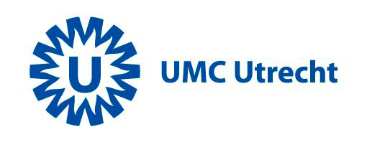

Announcement
There have been major advances in neuro-imaging and brain monitoring in high risk newborns. To share knowledge, the neonatal neurology group in Utrecht has the pleasure to welcome you for the fourth time to a two day MRI course ‘from basics to bedside’. We have the privilege to do this in collaboration with several European experts in the field. There is also an opportunity to present your own clinical work. The two day course will be held in the University Medical Center Utrecht. We will be delighted to see you in Utrecht in April 2019.

Manon Benders
Floris Groenendaal
Jeroen Dudink
Linda de Vries

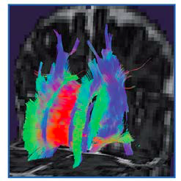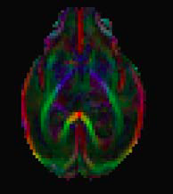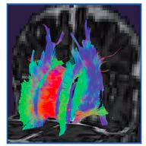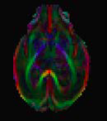

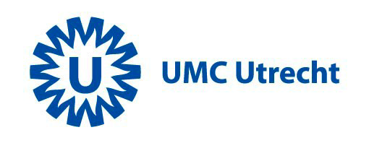

‘MRI of the neonatal brain’

A two day course of neonatal brain imaging, followed by a morning of 2 workshops on 3rd-5th of April 2019

Organization: Department of Neonatology, UMC Utrecht/Wilhelmina Children’s Hospital, The Netherlands
https://www.hetwkz.nl/neonatalmri

Contact:
- email: neonatology@umcutrecht.nl
- phone: +31 88 7554545
- fax: +31 88 7555320

Registration:
MRI of the neonatal brain
Registration will be accepted until March 25. Registration will be handled by order of receipt of payment.

Fees:
€ 450,- two days course (3-4 April)
€ 75, - workshops (5 April)

Residents in paediatrics and PhD students:
€225,- two days course (3-4 April) Student proof is needed and will be asked for.
€ 75, - workshops (5 April)

Payment can be made to:
Stichting Neonatale Neurologie Utrecht te Houten Rek.nr: 69.92.09.005
BIC: FVLBNL22
IBAN: NL75FVLB0699209005
Please mention: MRI in the neonatal brain, April 2019

Presentations:
There will only be oral presentations, no poster presentations are accepted. The organization will make its choice among the submissions for the free presentations.

Abstracts:
Abstracts (one page, calibri 11) can be sent to neonatology@umcutrecht.nl before 15th March 2019.
Abstract books will be available at registration.

Programme Wednesday 3rd -April 2019

9.00 - 9.30 h Registration and coffee

Chair Manon Benders
9.30 - 10.00 h Maarten Lequin: Standard MRI techniques
10.00 - 10.30 h Gerda van Wezel-Meijler: Normal brain development
10.30 - 11.00 h Gregor Kasprian: Fetal MRI of abnormal brain development
11.00 - 11.30 h Coffee

Chair Floris Groenendaal
11.30 - 12.00 h Jeroen Dudink: Quantifying the neonatal brain
12.00 - 12.30 h Jessica Dubois: Normal brain development using quantitative techniques
12.30 - 13.00 h Serena Counsell: DTI in the preterm brain: correlations with early outcome
13.00 - 14.00 h Lunch

Chair Jeroen Dudink
14.00 - 14.30 h Manon Benders: White matter injury in the preterm brain
14.30 - 15.00 h Linda de Vries: haemorrhage in the preterm brain
15.00 - 15.30 h Sylke Steggerda: cerebellar haemorrhages and outcome
15.30 - 16.00 h Tea

Chair: Sylke Steggerda
16.00 - 16.30 h Manon Benders: Use of MRI as biomarker of neurodevelopment
16.30 – 17.00 h Alexander Leeman: DTI
17.00 - 17.30 h Petra Huppi: longitudinal imaging in preterm infants

Dinner in town 19.00

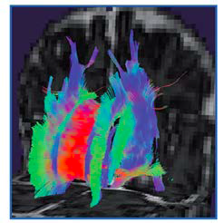

Thursday 4th-April 2019

Chair: Gerda van Wezel-Meijler:
8.30 - 9.15 h Floris Groenendaal: MRI and MRS in the full-term infant with perinatal asphyxia
9.15 - 9.45 h Jeroen Dudink: Perinatal stroke
9.45 - 10.15 h Dominico Tortora: Perfusion based imaging

10.15 - 10.45 h Coffee

Chair: Manon Benders
10.45 - 12.00 h 4 free presentations

12.00 - 12.30 h Domenico Tortora: MRI and metabolic disorders
12.30 - 13.00 h Linda de Vries: MRI changes after perinatal infections

13.00 - 14.00 h Lunch

Chair Linda de Vries
14.00 - 14.30 h Jeroen Vermeulen: Migrational disorders
14.30 - 15.00 h Luca Ramenghi: Sinovenous thrombosis

15.00 - 15.30 h Tea

Chair Jeroen Vermeulen
15.30 - 16.00 h Martijn van den Heuvel: Resting state fMRI
16.00 - 16.30 h Chiara Nosarti: preterm babies grown up: functional MR findings

16.30 h end

Satellite workshops (choose 2 out of 3)

Friday 5th April 2019

UMC Utrecht

9.00 - 10.30 h workshop 1

10.30 - 11.00 h change location and coffee

11.00 - 12.30 h workshop 2

Workshop subjects:

- Amplitude-integrated EEG in the neonate
Mona Toet and Maria-Luisa Tataranno

- Near-infrared spectroscopy: a clinical perspective
Frank van Bel and Petra Lemmers

- DTI workshop
Alexander Leemans and Jeroen Dudink

General information:
https://www.hetwkz.nl/neonatalmri

Symposium Language:
English

Accreditation NVK: is pending
Accreditation NVN: is pending
Accredidation NVvR: is pending

Location course:
Q building, University Medical Center, Utrecht, The Netherlands (3-5th April 2019)

Food and drinks are included, dietary wishes can be sent to the above email address. Hotel bookings:
http://www.hampshire-hotels.com/en/malie-hotel-utrecht-hampshire-classic http://www.apollohotelsresorts.com/
Mother Goose hotel
Court hotel
Eye hotel
Malie Hotel
Museumkwartier Hotel

