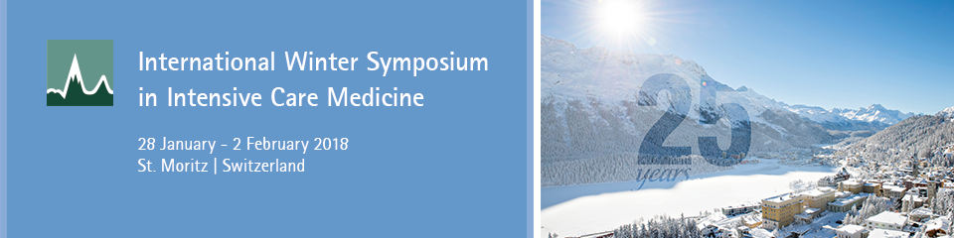

Program
The program of the symposium will contain lectures, pro-con debates, round table discussions, case presentations and meet-the-expert sessions.
These will be the main topics day by day.

Sunday, 28 January 2018
Afternoon Session | ICU Monitoring in 2050

Monday, 29 January 2018
Morning Session | ARDS and mechanical ventilation
Afternoon Session | ECMO and ECCO2-R

Tuesday, 30 January 2018
Morning Session | Traumatic and non traumatic brain injury
Afternoon Session | The cardiac patient in the ICO

Wednesday, 31 January 2018
Morning Session | Sepsis
Afternoon Session | Multiorgan support in 2050

Thursday, 1 February 2018
Morning Session | Ethiks and and of live decision making
Afternoon Session | Nutrition and Endocrinology

Friday, 2 February 2018
Morning Session | Taking Care of the critically ill patient in 2050

Speakers
We are pleased to welcome the following speakers to the International Wintersymposium in St. Moritz:
Prof. Jacques Duranteau, Paris ,FR
Prof. Luciano Gattinoni, Göttingen , DE
Prof. Alexander Mebazaa, Paris, FR
Prof. Frédéric Michard, Nyon, CH
Prof. Francesco Mojoli, Pavia, IT
Prof. Juan B. Ochoa, US
Prof. Mauro Oddo, Lausanne, CH
Prof. Michael Quintel, Göttingen, DE
Prof. Kathy Rowan, London, GB
Prof. Charles Sprung, Israel
Prof. Peter Suter, Genf, CH
Prof. Jukka Takala, Bern, CH
Prof. Greet van den Berghe, Rotterdam, NL
Prof. Jean-Louis Vincent, Brussels, BE
© 2017 IMK Institut Medicine and Communication Ltd
About

