- ESMO
- CONFERENCES
- ESMO ACADEMY 2019
- Programme

ESMO Academy 2019: Programme
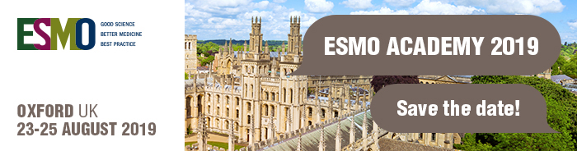

ESMO strives to deliver excellence in education and to develop valuable educational resources and meetings which accompany oncologists throughout all career stages.
With the rising incidence of cancer cases and the rapid changes taking place in oncology, it is vital for professionals to remain up to date.
Access the ESMO Academy 2019 Programme

Scientific Co-Chairs
- Andrés Cervantes, Valencia, Spain
- Viviane Hess, Basel, Switzerland

Main themes
The ESMO Academy 2019 is designed as a preparation course for the ESMO Examination and for medical oncologists in need of a refresher course. Expert speakers offer a general overview of:
- Colorectal Cancer
- Prostate Cancer
- Sarcoma & GIST
- Lung Cancer
- Breast Cancer
- Gynaecological Cancer
- Renal & Testicular Cancer
- Melanoma
- Head & Neck Cancer
- Brain Tumours
- Upper GI & Non-Colorectal Cancer
- Haematology & Lymphoma
- Pharmacokinetics & Drug Interactions
- Supportive care
The format is highly interactive and facilitate face to face contact with the experts.

Target Audience
The purpose of this annual educational meeting is to offer a general, yet in depth update on the major topics in medical oncology today.
Medical Oncology:
- Residents / Trainees / Fellows
- Practitioners who are preparing the ESMO Examination or are interested in a general overview across tumour types

Conference objectives
- To understand the examination process and questions format
- To learn/update participants about the current standard of care for the main malignancies and the supporting clinical trials
- To learn about the pharmacokinetics of systemic therapies for the management of cancer and the interactions of these drugs
- To identify gaps in an individual’s knowledge for review and improvement
- To learn from the integrated assessments and question reviews with individual speakers and the speaker panel

Travel grants
Attendees registered for the 2019 ESMO Examination can also apply for financial support for travel to Oxford.

Webcasts
The ESMO Academy webcasts include all sessions of the official programme where speaker permission is granted. ESMO members can also access the webcast via OncologyPRO.

Accreditation
ESMO-MORA: The ESMO Academy 2019 programme is going to be accredited with ESMO MORA points. Recertification is necessary for medical oncologists to remain professionally certified by ESMO. It also guarantees that a certified medical oncologist has continued to update her/his knowledge and still possesses the necessary skills and standards for the practice of medical oncology.
See here for further details.

