AUTOLOGOUS GROWTH FACTORS IN BONE AND TISSUE REGENERATION.
Experience meets evolution.
Horizontal and vertical ridge increases with heterologous Bone-rings
Concentrated Growth Factors.
The Science of Autologous Blood Concentrates CGF/Phlebotomy workshop.
Introduction to partial extraction therapy /socket shield.
Course aims:
- You will learn how to venepuncture
- How to use Concentrated growth factors in a safe and reliable methodology
- Liquid phase concentrated growth factors
- How to use Medifuge and Round-Up
- Field of applications of platelet precipitate
- Introduction to partial extraction therapy: when and how to use.
- Clinical cases
Blood Derived Growth Factors have many advantages including physical properties, handling characteristics, autologous bioactive nature, incorporated growth factors and influence on site healing.
This course covers the clinical usage and protocols for science and biology, preparation of these materials and their clinical applications. Enhanced healing of extraction sites prior to implant placement, sinus grafting, soft tissue healing and facial rejuvenation techniques will also be discussed.
Endorsed by a variety of medical specialists including sports and exercise medicine doctors as well as cosmetic and general practice dentists, a growing body of evidence finds that when a patient’s blood derived growth factors are re-injected into a wound site, it enhances healing and reduces recovery time. Bone grafts, implants, sinus lifts, ridge augmentation and the closure of cleft lips are just some of the procedures it is helping augment.
The course also provides a hands-on session and so that participants become proficient in the use of venepuncture and use of these growth factors .
Link to the course:
https://www.eventbrite.com/e/autologous-growth-factors-with-prof-ezio-gheno-tickets-36715313491?utm-medium=discovery&utm-campaign=social&utm-content=attendeeshare&utm-source=strongmail&utm-term=listing

Course program:
Friday 6th of October
8:30 registration
9:00 -12:00
9:00-11:00 Theoretical part CGF ; Prof. Dr Ezio Gheno
- what are concentrated growth factors
- the use of CGF in the clinical practice
- state of art analysis of different techniques of isolation of growth factors
- CGF and LPCGF
- Use of Medifuge and Round-Up
- Fields of application
11:00-12:00 Introduction to partial extraction therapie ; Drs Hanan Abdo
- Indication
- benefits
- How to perform
- Contra indications
- Critical points
- Clinical cases
- Discussion end questions
12-13:30 lunch
13:30 -17:00 Venus drawing Workshop:
- Locating sites suitable for venous collection
- Anatomical evaluation
- Materials and methods
- Venous sampling exercises between participants
- Practical experience of Medifuge separation process for CGF/LPCGF and intrinsic homogenization with Round-Up;
17:00- 19:00 borrel

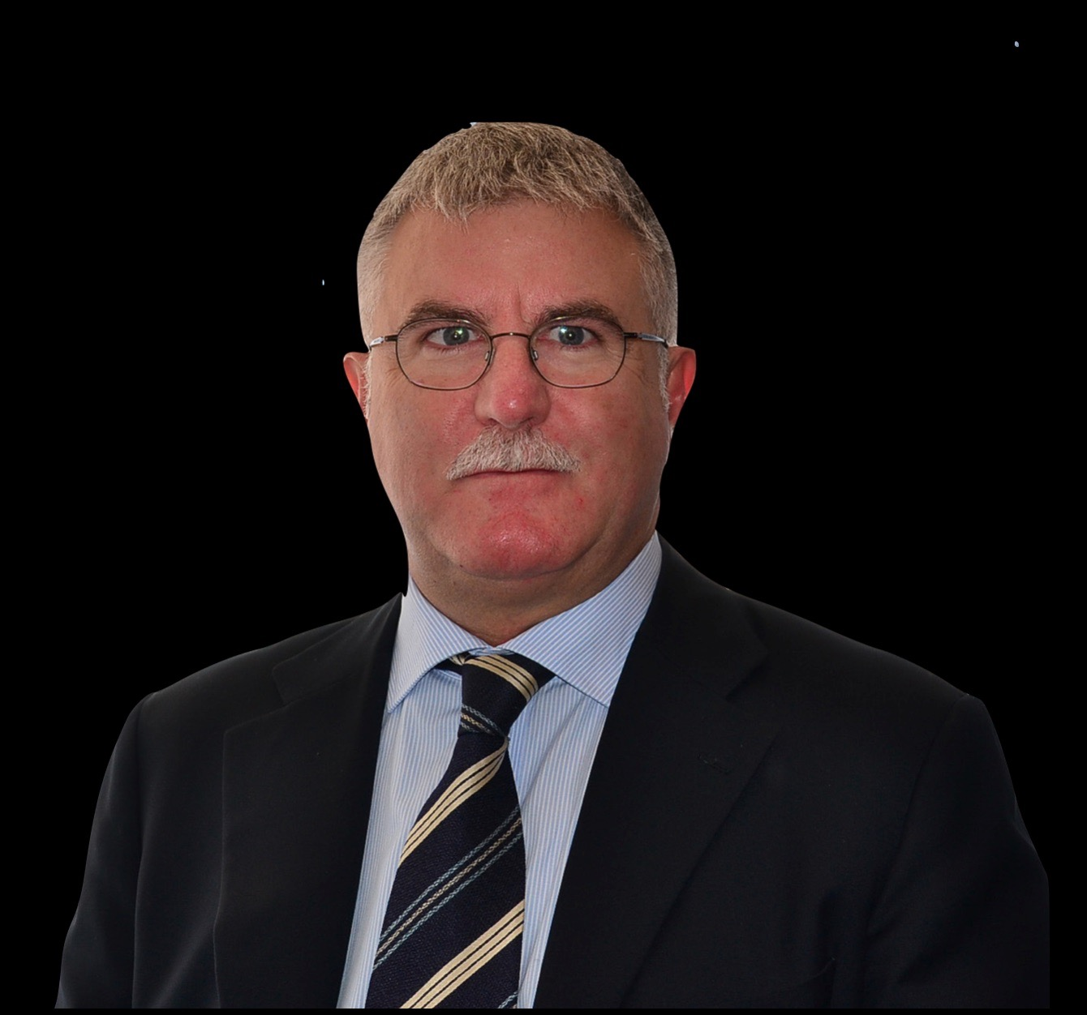

Dr. Ezio Gheno MD, DDS
Dr Ezio Gheno is a dental implantology and oral surgical expert from Varese, Italy and author of several bone regeneration papers. As a lecturer and academic, Dr Gheno has held a variety of positions throughout Italy and the United Kingdom.
Dr Gheno has been a professor at BPP University City of London Dental School where he taught bone regeneration and cadaver dissection, and was also a professor at University of Bari, ranked among the most prestigious universities in the world.
In addition to research, teaching and lecturing engagements, Dr Gheno is well versed in direct patient care having served as a staff doctor at the maxillofacial surgery department at Niguarda Hospital in Milan.
A 1985 graduate from the University of Pavia with a degree in Medicine and Surgery, Dr Gheno furthered his postgraduate studies at the University of Modena. Dr Gheno maintains active membership in several dental organizations: the World Academy of Ultrasonic Piezoelectric Bone Surgery, the European Academy of Oral Surgery and Implantology, and the Antech Academy of Non Transfusional Hemo-Components.
Today Dr. Gheno maintains a private practice in Somma Lombardo and is accredited by the Swiss Confederation and the Medical Council of Malta.

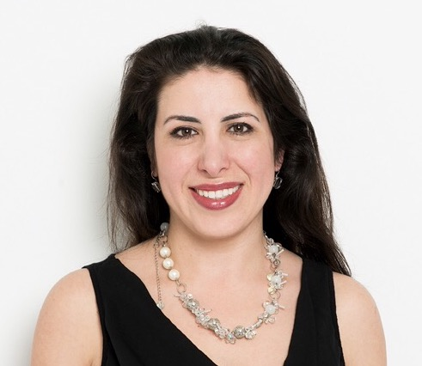
Drs Hanan Abdo
Graduated in 1999 from the Radboud University of Nijmegen faculty of dentistry.
After graduation worked in several private practices.
In 2005 started with an advanced implant education, in an implantology practice.
Followed several implantology courses since 2005.
Private practise since 2005.

