Wednesday October 2nd 2019
Oligometastases in prostate cancer: is it time for change ?

Noordelijke Refereeravond Radiotherapie
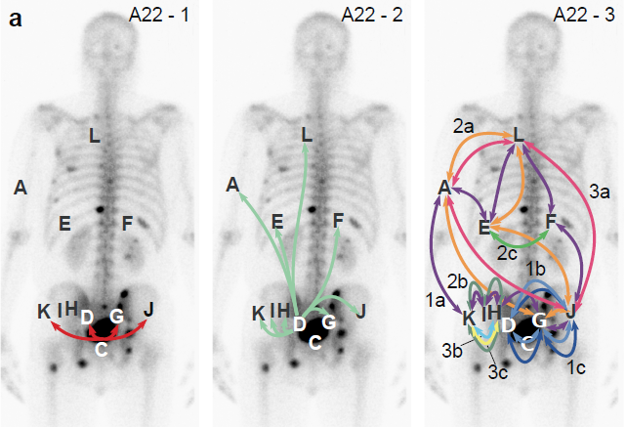

Program:
Chair:
17.30 - 17.55 Welcome and registration (sandwiches will be served at 17.30)
17.55 - 18.00 Introduction
Name TBD
18:00 - 18:20 Oligometastatic prostate cancer: surgical aspects
Dr. Henk van der Poel, urologist, NKI/AVL Amsterdam
18:20 – 18:25 Q&A
18:25 – 18:50 Imaging in oligometastatic prostate cancer
Prof. dr. Fred Verzijlbergen, nuclear physicist, Radboud UMC Nijmegen
18:50 – 19:00 Q&A
19:00 – 19:15 Coffee Break
19:15 – 19:35 The patient’s experience
Dhr. Gijs van Banning, Prostate Cancer Association
19:35 – 19:55 Stereotactic radiotherapy for oligometastases
Dr. Bojan Štrbac, medical physicist radiotherapy, UMCG
19:55 – 20:00 Q&A
20:00 – 20:25 Overview and studies in oligometastatic prostate cancer
Dr. Shafak Aluwini, MD, PhD, Radiation Oncologist, UMCG
20:25 - 20:30 Q&A
20:30 – 20:40 Closing remarks / drinks

