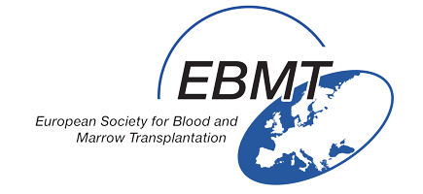
MATH2017
10:00 | Welcome coffee
 | Keynote lecture
10:30 - 11:10 | Immune check-point inhibitors  M.A. Perales, USA
 | SESSION 1 - PHARMACOLOGICAL IMMUNOMODULATION (CHAIRS: TBD)
11:10 - 11:35 | Hypomethylating agents in MDS  I. Yakoub-Agha, France
11:35 - 12:00 | HDAC inhibitors in AML  J. Cornelissen, The Netherlands
12:00 - 12:25 | Monoclonal antibodies in ALL  A. Nagler, Israel
12:25 - 12:50 | FLT3 inhibitors in AML  A. Bazarbachi, Lebanon
13:00 - 14:00 | Lunch break
 | SPECIAL LECTURE
14:00 - 14:40 | Optimal conditioning for haplo-identical transplantation  M. Mohty, France
 | SESSION 2 - CELLULAR THERAPIES (CHAIRS: TBD)
14:40 - 15:05 | Redirecting T cells using bispecific T cells and CAR T cells  H. Einsele, Germany
15:05 - 15:30 | Gamma-delta T cells in lymphoid disases  J. Kuball, The Netherlands
15:30 - 15:55 | NKT cells in GVHD  F. Malard, France
15:55 - 16:20 | TK cells for enhanced immune recovery  A.L. Ruggeri, France
16:20 - 16:30 | Conclusions and meeting adjourn  M. Mohty, France

