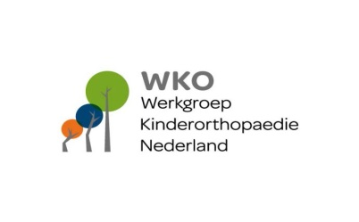

WKO-BAPO Paediatric trauma and sports injuries

Location: OLVG-oost Amsterdam
Adres: Oosterpark 9
1091 AC Amsterdam

Program:

9.30 Coffee and Entrance
10.00 Dr. P. Struijs; talus lesions
10.30 A. Michielsen; pediatric FT: sports participation in children with reduction
defect and using a prosthesis
11.00 Coffee
11.30 Drs. D. Kempink; registration in NL fractures in children paediatric surgeons and
traumatologists
12.00 Dr. A. Zeegers; SPOQ registration paediatric orthopaedics the Netherlands with
Knee specialists and rehabilitation doctors
12.15 Dr. A. Weir; CAM lesions and pubic apofysitis

13.00 Lunch
14.00 Dr. F. Chotel; Anterior cruciate ligament injuries and other knee trauma

15.00 Free papers

17.00 Closing remarks
17.15 Drinks and Bitterballen

18.00 Diner

