Echo BachelorClass Course
24 chapters that will bring you to the next level

Chapters
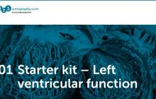

Starter Kit - Left ventricular function
00:24:33 1 credit Chapter 1
Your entry gate to the world of echocardiography. Assessment of cardiac function made easy.
Read more
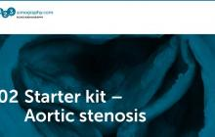

Starter kit – Aortic stenosis
00:21:02 1 credit Chapter 2
Learn how to detect the most common form of valvular heat disease. Echo is easier than using the stethoscope.
Read more
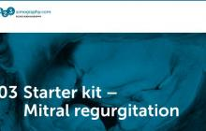

Starter kit – Mitral regurgitation
00:24:28 1 credit Chapter 3
Your first introduction to anatomy and function of the mitral valve. Learn how to use color Doppler to detect his important pathology.
Read more
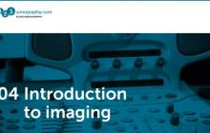

Introduction to imaging
00:27:49 1 credit Chapter 4
Getting to the core of things: Instrumentation, components of an echo exam and much more…
Read more
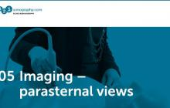

Imaging – parasternal views
00:23:15 1 credit Chapter 5
The parasternal view – how can you find it and which views should you display.
Read more
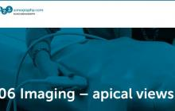

Imaging – apical views
00:25:42 1 credit Chapter 6
The apical window- probably the most important view to the heart. A chapter full of tips and tricks.
Read more
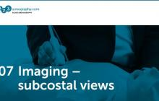

Imaging – subcostal views
00:17:31 1 credit Chapter 7
Problems with positioning your patient? The subcostal view is a perfect alternative that allows you to also see additional structures of the heart.
Read more
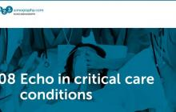

Echo in critical care conditions
00:37:29 1 credit Chapter 8
This chapter will definitely change the way you manage critical care patients. Get into the driving seat of medical decision making.
Read more
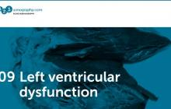

Left ventricular dysfunction
00:40:59 1 credit Chapter 9
Here we dig deeper into the essentials of quantifying left ventricular function. A chapter full of practical examples.
Read more
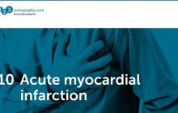

Acute myocardial infarction
00:17:01 1 credit Chapter 10
The ECG is still first – but once you watch this chapter you will realize important echocardiography is in patients with chest pain.
Read more
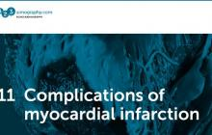

Complications of myocardial infarction
00:19:52 1 credit Chapter 11
This chapter will help you save lives. You will need echo for Risk assessment and the diagnosis of myocardial rupture, ischemic VSD, right ventricular infarct and thrombi.
Read more
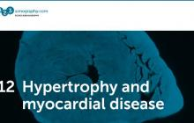

Hypertrophy and myocardial disease
00:22:16 1 credit Chapter 12
Hypertrophy - A frequent finding. But how do you quantify it and what are the causes? We will provide a simple roadmap.
Read more
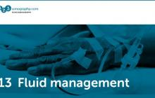

Fluid management
00:38:10 1 credit Chapter 13
Should I give fluids or not? Echocardiography will provide the answer.
Read more
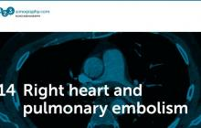

Right heart and pulmonary hypertension
00:33:59 1 credit Chapter 14
Learn how to quantify pulmonary pressure. Right heart disease is more common than you think and echo will lead you the diagnosis. From pulmonary embolism and right heart failure to tricuspid regurgitation.
Read more
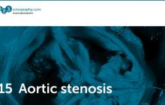

Aortic stenosis
00:14:32 1 credit Chapter 15
The sequel to chapter 2, now you will also learn how to quantify aortic stenosis. We will show you how to use spectral Doppler here.
Read more
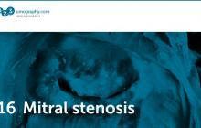

Mitral stenosis
00:16:51 1 credit Chapter 16
A common disease in many parts of the world and one of the easiest diagnosis you can make. But only if you have an echo machine.
Read more
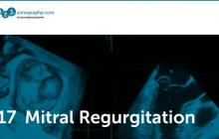

Mitral regurgitation
00:34:27 1 credit Chapter 17
In chapter 3 we already dealt with mitral regurgitation. Here you will see many more examples and learn why patients develop mitral regurgitation in the first place.
Read more
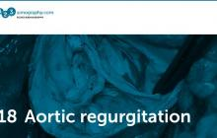

Aortic regurgitation
00:27:14 1 credit Chapter 18
One you know how to use color Doppler it is easy to detect aortic regurgitation. But there is more you should know about this entity if you want to manage your patients.
Read more

Transesophageal echocardiography
00:96:27 1 credit Chapter 19
Transesophageal- and transthoracic echo belong together. Learn when and how to use it. Your first step into an important modality that is not only used in cardiology.
Read more
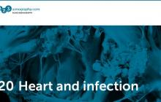

Heart and infection
00:18:17 1 credit Chapter 20
If you don’t want to miss an endocarditis-, myocarditis or pericarditis then you will need to watch this chapter. Learn more about the incredible power of both transthoracic and transesophageal echo.
Read more
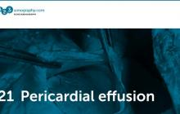

Pericardial effusion
00:27:08 1 credit Chapter 21
Detection of a pericardial effusion is one of the easiest tasks in echocardiography. This chapter will show you how to make the diagnosis and which additional information it provides.
Read more
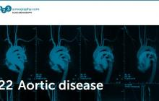

Aortic disease
00:19:05 1 credit Chapter 22
Don’t forget to image the aorta. This lecture will explain you how and why it can save lives.
Read more
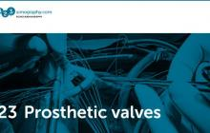

Prosthetic valves
00:42:10 1 credit Chapter 23
Over 250.000 prosthetic valves are implanted worldwide each year. So you will definitely see such patients. But how can you tell if prosthetic function is normal? We will show you in this chapter.
Read more
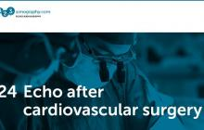

Echo and cardiovascular surgery
00:43:29 1 credit Chapter 24
Do you know how to assess the risk for surgery with echo? Which factors influence the postoperative outcome and what to look for in patients who underwent cardiovascular surgery? These are some of the topics discussed in this chapter.
Read more

