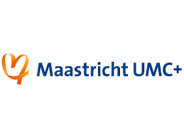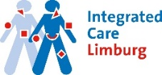

Farewell symposium: Idealized Integrated Pelvic Care MECC Maastricht, 12 January 2022
18 21 Workshop
‘ 3D Anatomy: Functional and dynamic anatomy of the pelvic floor’

Paulo Palma
Farewell symposium: Idealized Integrated Pelvic Care MECC Maastricht, 13 January 2022
Moderator morning: Marijke Slieker
9 9.10 Opening symposium Marijke Slieker
9.10 9.30 Update of functional pelvic anatomy for the PT Paulo Palma
9.30 9.50 High quality research predictor of real level PT? Kari Bo
9.50 10.10 My ideal management for OAB Ph Van Kerrebroeck
10.10 10.30 CPP guidelines and their implementation Bert Messelink
10.30 10.50 Breaking news: electrotherapy: dazzling novelties George Billard
10.50 11.20 coffee break
11.20 11.40 Functional training: importance of wireless feedback Abdallahi N’Dongo
11.40 12 My ideal team & management of POP Kim Notten
12 12.20 The ideal mobile application for home training Maura Seleme
12.20 12.40 The brain as commander in chief for PFD G van Koeveringe
12.40 13 The ideal pelvic care center in Brazil: fact or fiction? Tadeu Tamanini
13 14 Lunch break
Moderator afternoon: Nicole van Bergen
14 14.20 My ideal team & management for fecal incontinence Jenneke Kaldijk
14.20 14.40 Idealized Integrated Pelvic Care: IUGA perspectives Huub van der Vaart
14.40 15 Idealized Integrated Pelvic Care: ICS perspectives John Heesakkers
15 15.20 Idealized Integrated Pelvic Care & the GP Doreth Teunissen
15.20 15.40 Idealized Integrated Pelvic Care & health insurance Marco Persoons
15.40 16.10 coffee break
16.10 16.30 Idealized Integrated Pelvic Care in Belgium Hedwig Neels
16.30 17 Patient selection in Integrated Pelvic Care: Panel: Hedwig, Kari, John, , Paulo
17 17.20 Farewell presentation Bary Berghmans
17.20 17.30 Closing symposium Bary Berghmans

