Full Program
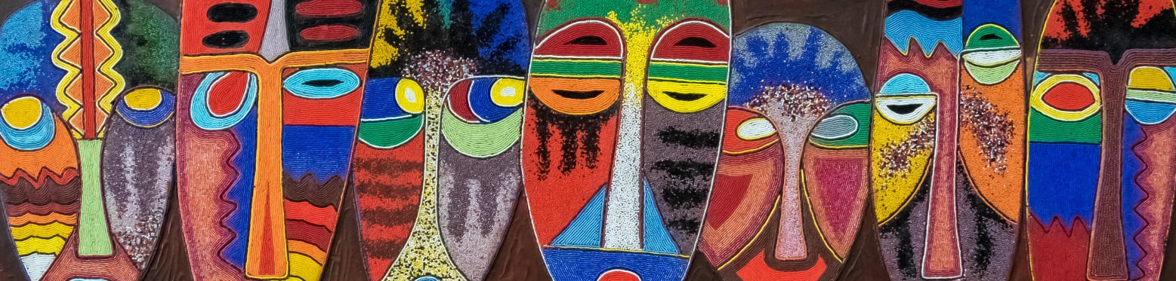

Program of 11th INTEREST Workshop (2017)
The Committees of the 11th INTEREST WORKSHOP is currently working hard on developing a high-quality program. Please find the preliminary program below.
16th May 2017

8:00 am - 9:00 am
Registration More info
9:00 am - 10:30 am
Official Opening Session Sam Phiri, DCM, MSc, PhD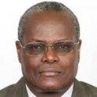 Elly Katabira, MD, FRCP More info
10:30 am - 11:00 am
Refreshment break and poster viewing More info
11:00 am - 12:30 pm
Symposium I: Treatment sequencing for the future – [AbbVie] 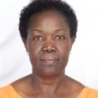Sylvia Ojoo Francesca Conradie, MBChB, DTM&H, Dip HIV Man, Dip Epidemiology More info
12:30 pm - 1:30 pm
Lunch and early career investigator meet the expert (register for specific lunch tables) More info
1:30 pm - 2:00 pm
Lessons from HIV drug accessibility and prices Catherine Hankins Andrew Hill, MD More info
2:00 pm - 3:00 pm
Symposium II: Differentiated care: What’s all the hype about? – [IAS] More info
2:30 pm - 3:30 pm
Oral abstracts presentations I Debrework Zewdie More info
3:00 pm - 3:30 pm
Refreshment break and poster viewing More info
4:30 pm - 5:30 pm

17th May 2017

Opening Day Formal Debate (Oxford Rules) Mark Nelson, MD François Venter, MD, FCP More info
5:30 pm - 7:00 pm
Opening Day Reception More info
17th May 2017
7:00 am - 7:50 am
Early morning sessions I More info
8:00 am - 8:30 am
Pre-exposure prophylaxis: PrEP in real life and new PrEP technologies More info
8:30 am - 9:30 am
HIV risk, prevention, and young African women in 2017 More info
9:30 am - 10:00 am
Mini-oral abstract presentations I More info
10:00 am - 10:30 am
Refreshment break and poster viewing More info
10:30 am - 12:00 pm
Symposium III: Hepatitis B and co-infection: is Africa doomed? – [GILEAD] More info
12:00 pm - 12:30 pm
Prevention of mother-to-child transmission and Option B+ More info
12:30 pm - 12:45 pm
Conference Picture More info
12:45 pm - 1:30 pm
Lunch and early career investigator meet the expert (register for specific lunch tables) More info
1:30 pm - 2:30 pm
Underserved, marginalised, stigmatized, and criminalised key populations in Africa, including transgender persons Elly Katabira, MD, FRCP More info
2:30 pm - 3:30 pm
Mini-oral abstract presentations II More info
3:30 pm - 4:00 pm
Refreshment break and poster viewing More info
4:00 pm - 5:00 pm
Update on HIV vaccine strategies, cure and acute infection Guido Ferrari Anna Laura Ross Merlin Robb, MD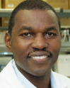 Thumbi Ndung’u, BVM, PhD More info
5:00 pm - 5:30 pm
Tuberculosis in 2017 Serge Eholie Robin Wood, MD More info

18th May 2017
7:00 am - 7:50 am
Early morning sessions II More info
8:00 am - 8:30 am
HIV testing in 2017 More info
8:30 am - 9:00 am
HIV treatment among adults in Africa in 2017 Judith Currier More info
9:00 am - 10:00 am
Symposium IV: Turning Failure into Success: Current Concepts of 2nd and 3rd line ART in Paediatrics and Adolescents – [Johnson & Johnson] 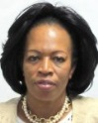Chewe Luo, MD, PhD Victor Musiime More info
10:00 am - 10:30 am
Refreshment break and poster viewing More info
10:30 am - 11:00 am
Palliative and end-of-life care in Africa François Venter, MD, FCP More info
11:00 am - 12:00 pm
Symposium V: Advancing HIV Care in Resource-Limited Settings (RLS): New Approaches in 1st Line ART – [Johnson & Johnson] Sam Phiri, DCM, MSc, PhD Michelle Moorhouse, MB BCh More info
12:00 pm - 1:00 pm
Lunch and early career investigator meet the expert (register for specific lunch tables) More info
1:00 pm - 2:00 pm
Oral abstract presentations II More info
2:00 pm - 3:00 pm
Symposium VI: The journey of diagnostics: the impact of diagnostics in the fight against HIV – [Roche] More info
3:00 pm - 3:30 pm
Refreshment break and poster viewing More info
3:30 pm - 4:30 pm
Mini-oral abstract presentations III More info
4:30 pm - 5:30 pm
Symposium VII: Women and adolescent girls: Reasons to accelerate access to innovative ARVs – [ViiV] More info
5:30 pm -
Conference Dinner More info

19th May 2017
7:00 am - 7:50 am
Early morning sessions III More info
8:00 am - 8:30 am
Mini-oral abstract presentations IV More info
8:30 am - 9:00 am
Treatment optimization: advocate perspectives More info
9:00 am - 10:00 am
Symposium VIII: Can Africa lead Europe and North America in going digital? Digital innovation and the science of delivery – [Joep Lange Institute] More info
10:00 am - 10:30 am
Refreshment break and poster viewing More info
10:30 am - 11:30 am
Evidence for action: population-based impact assessments in Malawi, Zambia, and Zimbabwe More info
11:30 am - 12:30 pm
Countries and cities look to the future Debrework Zewdie Elly Katabira, MD, FRCP More info
12:30 pm - 12:45 pm
Conference Co-chairs: Reflections on 2017 and perspectives for 2018 More info
12:45 pm -
Closure of INTEREST 2017 More info

