International Master Class
Autologous Breast Reconstruction using
Sensate LTP and DIEP flap

September 17⁻18 2018, Maastricht UMC+

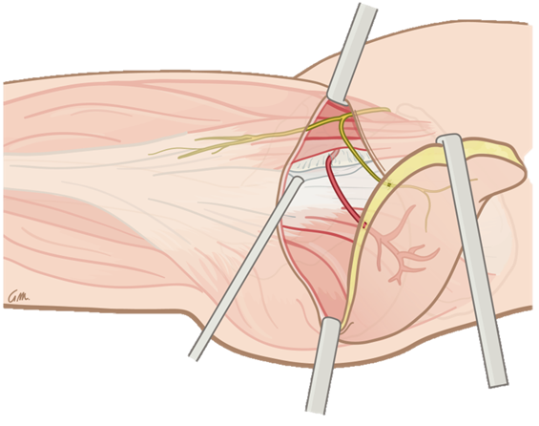
Dear colleagues,

It is our pleasure to invite you to our first International Master Class on Autologous Breast Reconstruction using the Sensate LTP and DIEP Flap, which will be held in Maastricht, the Netherlands, on September 17th and 18th next.

The two day master class will focus on the practical anatomy of both sensate Lateral Thigh perforator flap and Deep Inferior Epigastric Perforator flap. Participants are given the opportunity to follow live surgeries which will also be complemented by demo cadaver models.

Please note that the number of participants is only limited to 25!
Course fee: €1400, which includes a faculty diner.

For further program information and registration please contact: secretariaat.plastischechirurgie@mumc.nl

We are looking forward to welcome you in September next!

Stefania Tuinder , René van der Hulst
Plastic surgeon Maastricht UMC+ Plastic Surgeon & Head of department Maastricht UMC+

Dear colleagues,
On behalf of the organizing committee, I would like to welcome you in the MUMC + for the
It is a unique opportunity for forensic medicine and plastic surgery to collaborate in the reconstruction of the face.

Faculty
A. Lataster - Department of Anatomy and Embryology, Maastricht University, the Netherlands
S. Tuinder- Department of Plastic Surgery, MUMC+ Maastricht, the Netherlands
R. van der Hulst - Department of Plastic Surgery, MUMC+ Maastricht, the Netherlands
R. Allen – Centre for microsurgical breast reconstruction, New York and New Orleans, USA
A. Spiegel - Methodist Hospital, Houston, USA

Location
MUMC+ Maastricht
Address: P. Debeyelaan 25, 6229 HX Maastricht

Registration
Mailadress: secretariaat.plastichechirurgie@mumc.nl

Accreditation
Accredited for plastic surgeons in the Netherlands

Payment
Early bird registration (on or before 15-06-2018) : 1400 Euro
Normal or on-site registration (after 15-06-2018): 1500 Euro

Payment must be received by 01-08-2018 on NL INGB 0654 8526 42 (BIC code: INGBNL2A), department of Plastic Surgery , International Master Class on Autologous Breast Reconstruction using the Sensate LTP and DIEP Flap

Program Monday 17-09

9.00-9.30 welcome and opening

9.30-12.30 live surgery. Sensate LTP

9.30-12.30 anatomy LTP and LCFN on cadavers.

10.00-10.30 recovery of sensibility with sensate LTP flap: our results

13.30-16.00 live surgery. Sensate LTP

14.00-14.30 sensibility for different donor sites

13.30-16.00 anatomy LTP and LCFN on cadavers.

16.00 16.30 Evolution of autologous breast reconstruction (Bob Allen)

16.30-17.00 autologous breast reconstruction in Houston (Aldona Spiegel)

Program Tuesday 18-09

9.00-12.30 live surgery. Bipedicled sensate DIEP

9.00-12.30 anatomy of the sensory innervation of the abdomen en chest Wall.

10.00-10.30 recovery of sensibility with sensate DIEP flap.

11.00-11.30 the patient speaking

13.30-16.00 live surgery and anatomy ( the same than the morning)

14.00-14.30 mapping with a 7T MRI of the breast on the somatosensory cortex

15.00-15.30 correlations between quality of life and feeling in the breast.

16.00-17.00 round table : autologous breast reconstruction in 20 years time.(Bob Allen, Aldona Spiegel, Stefania Tuinder, Rene van der Hulst

